
Foreword

For each unit three types of tasks are included:
- Extended investigation – an investigation; the preparation activity of which could be done in class or in the student’s own time followed by an in-class validation. Solutions are provided where practicable for the preparation activity/investigation. For the in-class validation, there are solutions and marking keys, which identify the mathematical behaviours that students may exhibit.
- In-class investigation – an investigation for which no prior preparation is required. Solutions and marking keys are provided.
- Investigative questions – a series of short questions, which test the student’s ability to apply their learning, to justify their conclusions, to investigate and to generalise, or to solve problems. Such questions could be included in a response or examination assessment. Solutions and marking key are provided.

Screen shots have been produced using the CASIO ClassPad II emulator

Most graphs and diagrams have been produced using efofex software.

The syllabus dot points are reproduced here under a licence agreement with the SCHOOL CURRICULUM AND STANDARDS AUTHORITY. The Authority is acknowledged as the owner of all dot points from the Year 11 Mathematics Applications syllabus.

© The investigations and solutions in this publication are for the sole use of staff and students of the purchasing school. It is a breach of copyright to distribute them in whole or part in any form now or in the future to any other school, company or person.

Students should not be given copies of the validation parts or the solutions to the investigations to take home.

Contents

MATHEMATICS APPLICATIONS: Year 11

  - Consumer arithmetic

Task 1: Extended investigation: Payments 3
Task 2: In-class investigation: Paying tax 15
Task 3: Investigative questions 24

  - Algebra and matrices

Task 4: Extended investigation: Using matrices 30
Task 5: In-class investigation: Matrices for connections 46
Task 6: Investigative questions 55

  - Space and measurement

Task 7: Extended investigation: Applications of Pythagoras’ Theorem 61
Task 8: In-class investigation: Effects of scaling on volume 74
Task 9: Investigative questions 83

2.1 Univariate data analysis and the statistical investigation process

Task 10: Extended investigation: Statistical investigations 89
Task 11: In-class investigation: Making it fair 100
Task 12: Investigative questions 111

2.2 Applications of trigonometry

Task 13: Extended investigation: Similarity and trigonometry 117
Task 14: In-class investigation: Exploring trigonometric ratios 132
Task 15: Investigative questions 143

2.3 Linear equations and their graphs

Task 16: Extended investigation: Linear with a difference 149
Task 17: In-class investigation: Applying linear relationships 166
Task 18: Investigative questions 176

TASK 1: PAYMENTS

Extended investigation

Unit 1

Topic 1.1: Consumer arithmetic

Course-related information

The concepts and skills developed in this investigation relate to the following dot points within the WA Mathematics Applications syllabus:
    - calculate weekly or monthly wage from an annual salary, wages from an hourly rate, including situations involving overtime and other allowances, and earnings based on commission or piecework
    - calculate payments based on government allowances and pensions

Background information

In this investigation students are provided with the opportunity to learn more about the workforce and the earning conditions that they may themselves experience. There are also opportunities for students to reflect on their own future payments and those of other groups within the community.

Task conditions

This task consists of an investigation activity followed by an in-class validation. Students will need some time to investigate the terminology and to determine answers to questions in the preparation activities. Class discussion of the answers to the questions posed could provide students with an opportunity to check the results of their investigation and to share their findings. Students will need to bring these findings to the validation to assist with their comprehension of the questions asked and to access some of the data required to answer them. Solutions based on current rates and regulations are provided: teachers need to be aware that these may have changed.

Payments

Extended investigation Part 1: Preparation activities

During the in-class validation component of this investigation, students will need to be familiar with / have access to the knowledge and understandings that they develop during the preparation activities.

Assumed knowledge
The following terms should be already familiar to students.
annual fortnight salary employer employee tax

Activity 1

Investigate the meaning of each of the following terms. They describe working conditions with respect to time.

casual permanent temporary full-time unemployed
part-time flexi-time overtime time and a half shift work

For each of these terms consider the following questions.

- Are the hours regular?
- Is the rate of pay fixed?
- Is the employee entitled to personal (sick) leave?
- Is the employee entitled to annual leave?
- Does the employee get paid for public holidays when they do not work?
- Is there a fixed numbers of hours worked each week?
- Is the work ongoing?
- Are these terms mutually exclusive? Can two or more terms apply to the same position? For example, can an employee be a temporary full-time worker
- What are some examples of jobs for which the term applies?
- Why might employees prefer to be employed on a particular basis? For example, casual rather than permanent or full time rather than part time.

Activity 2

The rules for employing children in Australia vary between the states. Consider the following questions as they apply to the rules within your state.
- Can children work during school hours?
- Can a 5-year old child star in a TV commercial?
- What is the earliest time a 10-year old child can start delivering pamphlets?
- Do parents need to give permission for their 11-year old child to deliver newspapers after school?
- If you are 14 years old, are you allowed to work in a supermarket?
- At what time of the day must children aged 13 or 14 finish work?
- Can a parent be fined for allowing their child to work at illegal times?
- What is the maximum fine a business might have to pay if they break the laws for employing children?
Activity 3

Investigate the following as they relate to employment and pay.

1. Youth Allowance
- What is the “Youth Allowance”? Who pays it? Who is eligible to receive it?
- How is it funded?
- How old does one have to be to receive it? What is the maximum age you can be and still receive the Youth Allowance?
- What is the current maximum fortnightly payment for a single person who is living at home and is under 18?
- For some people the allowance is means tested. What does this mean?

2. Minimum wage
- What is meant by the “federal minimum wage”?
- How much is it?
- Which employees can be paid less than this minimum wage?
- Why does the government set a minimum wage?
- How many hours in a working week?

3. Allowances from employers
- What allowances are employees likely to receive?
- Why are employees given allowances?
- Provide examples of allowances that are specific to certain types of work.

4. Deductions
- What deductions are made from an employee’s salary?
- What is the difference between gross pay and net pay?
- Who receives the tax deducted from a person’s pay? What is it used for?
- What happens to the superannuation deducted from employees’ salaries?

5. Salary caps
- What types of contracts involve salary caps?
- Who imposes the salary cap?
- What penalties are applied for infringing the salary cap?
- Why is a salary cap applied?

6. Jobseeker’s allowance
- Why do we have a jobseeker’s allowance?
- What is the current rate of this benefit in Australia?
- Is this benefit rate higher in Australia than in other countries?
- Where does the money for the jobseeker’s allowance originate?

7. Age pension
- Who is eligible?
- How much are they paid?
- Where does the money come from to pay this pension?
- Are all people receiving the Age pension paid the same amount?
Payments

Extended investigation Part 2: In-class validation (50 marks)

Question 1 (10 marks)
(a) Nick is 10 years old and is allowed to deliver charity-run advertisements between 6.00 am and 7.00 pm but not during school hours. He will need to be home each morning by 7.15 am to get ready for school. He finishes school at 3.30 pm, goes for a run, does his homework and is able to start his delivery again at 5.15 pm. He is paid $5.50 per hour for his work. If Nick does not work on the weekend but otherwise works as many hours as he can, what is the maximum amount he can earn in a week? (3)

(b) Tom and Mary each receive an Age pension of $580 every fortnight. The pension is reduced by 50c for every dollar earned over $150 per fortnight. (3)
(i) As a couple, how much do they currently receive each year?

(ii) If Mary takes on a job, which pays $280 per fortnight, by how much, is her pension reduced?

(iii) Tom finds work for two days and his pension is reduced for that fortnight to $500. How much did Tom earn?

(c) The total salary cap for each club in a national baseball competition is set at nine million dollars. On average there are 50 contracted players in each club. The governing body has offered a $300 000 rise to the salary cap but the clubs have asked for a 5% increase. (4)
(i) How much increase have the clubs asked for?

(ii) What is the percentage increase the governing body has offered?

(iii) What will be the average salary increase for a contracted player if the offer from the governing body is accepted?

Question 2 (5 marks)
In 2014, eligibility for a Youth Allowance depended on circumstances and age.
The following groups of young people were considered eligible and in some cases a means test applied.
Age |  | Circumstances
From | To
16 | 21 | Looking for full-time work
18 | 24 | Full-time student
16 | 17 | Considered independent
16 | 24 | Full-time apprentice

The payment was made fortnightly and, for students under 18, it was sometimes made to their parents. This table below shows the maximum amounts that could be paid in different categories of eligibility.
Category of eligibility |  |  | Maximum
Has children | Age | Living
No | Under 18 | At home | $226.80
No | Under 18 | Away from home | $414.40
No | 18 or more | At home | $272.80
No | 18 or more | Away from home | $414.40
Yes |  |  | $542.90

Use the tables above to determine the maximum fortnightly allowance for the following young people who do not have any children.
(a) Ben, who is 16, lives at home and is apprenticed to a local electrician. (1)

(b) Amy is a student in Year 11, who is considered independent because she has had to move away from home so that she could finish school. She is only 17. (1)

(c) Josh, who will be eligible to vote next year, has left school and has left home. He is looking for full-time work. (1)

(d) Gerry turned 30 last year. He lives away from home and is a full-time apprentice. (1)

(e) Julia is a full-time student, who will be 25 in two years time. She lives at home with her parents and grandparents. (1)

Question 3 (13 marks)
Help Frank to calculate his pay.
Frank
- works from 8.15 am to 5.30 pm on weekdays
- has morning tea (paid time) and lunch (45 minutes which is unpaid)
- is paid $32.10 per hour.
- works 4 hours overtime (at time and a half) on Saturdays
- receives a uniform allowance of $35 per week.
- pays $8.50 each fortnight for morning tea
- has $50 taken out of his pay for superannuation each week
- pays tax at a rate of 10c for every dollar he earns (allowances excluded)
- is paid $25 each week for petrol
- receives a $10 bonus each fortnight

(a) For working Monday to Friday (3)
(i) How many hours of paid work does Frank do?

(ii) How much does he earn?

(b) For his overtime work each Saturday (2)
(i) What is Frank’s hourly rate of pay?

(ii) How much does he earn?

(c) How much tax does Frank pay on his week’s earnings? (2)

(d) Calculate Frank’s total weekly allowances. (2)

(e) Calculate Frank’s total weekly deductions. (2)

(f) Calculate Frank’s (2)
(i) gross pay

(ii) net pay
Question 4 (16 marks)
(a) What is the current federal minimum wage? State your answer as an hourly rate.
(1)

Unless otherwise indicated, assume all employees mentioned in this question are paid the Federal minimum wage.
Note: If you do not have the data for part (a) use the value for 2008 i.e., $14.31 per hour.

(b) Suella works 25 hours in a particular week (no overtime), what payment should she receive? (1)

(c) Hanna wants to earn at least $600 each fortnight. She works the same hours each week and is only paid for full hours. What is the minimum number of hours she will need to work each week? (3)

(d) Delia works part-time for 0.5 of a working week. (2)

(i) How many hours does she work?

(ii) How much should she be paid each hour?

(e) Lila is a casual employee who has a 25% loading on the hourly pay rate. (4)
(i) What is a casual employee?

(ii) What would be Lila’s hourly rate of pay?

(iii) Give one reason why casual employees receive this loading.

(f) An employee support group wants a 5% rise to the federal minimum wage. What would be the hourly pay rate if this were to occur? (2)

(g) Since 2008, the hourly rate has increased. (3)

(i) By how much has it increased?

(ii) By what percentage has it increased?

Question 5 (6 marks)
In a private hospital a job is classified as full-time if the number of hours (including lunch and morning tea) of working time is 35. Using one or more terms from the list below, describe the working classifications of the six nurses.

casual permanent temporary full-time
part-time flexi-time shift work unemployed

Nurse | Description
Kath works from 9.00 am to 4.00 pm every Monday to Friday and her position is ongoing.
Michelle works on weekdays from 8.00 am to 3.00 pm one week and then from 1.00 pm to 8.00 pm the following week. She has a guaranteed position.
Jessa is filling in for 3 months for Tina who works the same hours as Kath.
Felicia only works 3 days a week and she works from 8.00 am to 5.00 pm on those days. She has been at the hospital for 10 years.
Sarah works “on call” for an agency. She is called in when one of the regular nurses takes leave emergency leave .
Beth finished her nursing qualifications last year and then worked for three months. At the moment she is looking for a position because she does not have any work.

End of questions
Payments

Extended investigation Part 1: Preparation activities
Solutions

Activity 1
Casual
- Working irregular hours when the opportunity is there.
- The employer is not obliged to provide ongoing work hours
- Payment is for hours worked – no regular weekly or fortnightly wage.
- No entitlement to sick leave, holidays or holiday pay.
- Often paid at a higher hourly rate (15% - 25%) than permanent workers.
Permanent
- Work that is ongoing and intended to last.
- The position is guaranteed and can be full-time or part-time.
- Wages are regular for a set number of hours.
- Employees are entitled to sick leave and holiday pay.
Temporary
- Work is allocated for a few weeks or months and is not guaranteed to last.
- Can be full-time or part-time. Hours are usually regular.
Full-time
- Working all the hours specified for a week for that particular job.
- A person can be a full-time casual if they work for a set number of weeks.
Part-time
- Working only some of the hours specified for a week for that particular job.
- The position may be classified by the fraction of the full time hours e.g. 0.1, 0.8.
- Work can be permanent or temporary
Flexi-time
- The hours are set but there is some opportunity to vary the time at which the hours are worked.
- Can be permanent, full-time, part-time
- For some people, going to work early and leaving later can result in one day off each fortnight.
Shift work:
- Hours are organised out in blocks; worker changes blocks from time to time
Overtime: Working beyond the normal working day or more than full time hours
Time and a half: a rate of pay when overtime is worked; 1.5 times normal hourly rate
Unemployed: Not working

Rates of pay are usually fixed for a position and a classification. They cannot vary from one day to the next unless the individual works overtime.

Leave: personal and annual leave are generally paid to all employees except those who are casual; part-time workers receive pro-rata for their award or agreement. Similarly casual workers are not paid for public holidays.

Activity 2
Current regulations in WA indicate
- No
- Yes
- 6.00 am
- Yes.
- Yes
- 10.00 pm
- Yes
- $120 000

Activity 3
1. Youth allowance
The government provides financial help for people aged 16-24 if they are studying, apprenticed, sick or looking for work. It is funded through government taxes. Maximum for a single person under 18 and living at home is $226.80 (July 2014) and the amount paid depends on the parents’ income (means-tested).

2. Minimum wage
This is the lowest amount that workers not on awards or agreements should be paid. It is currently $16.87 per hour but apprentices and juniors are paid lower amounts. This is set by the government to ensure employers pay their employees fairly.
There are 38 hours in a working week.

3. Allowances from employers
- Uniform, petrol, bonuses, rental assistance, air-conditioning, remote area
- To attract people to country positions
- Teaching in the Kimberley region attracts a remote area allowance

4. Deductions
- Tax, superannuation, tea money, health insurance, salary sacrifice
- Gross – deductions = net
- Government – for services in the community e.g., roads, pensions.
- Superannuation is held (invested) by a superannuation fund until the employee retires.

5. Salary caps
Salary caps refer to the maximum amounts that organisations, often sporting clubs, are allowed to pay in salaries to players who are listed as playing for their clubs. The amount is set by the governing body of the sport which imposes fines or loss of points to clubs who breach the salary cap. It is done to promote fairness between clubs.

6. Job seeker’s allowance
This benefit is to help those who cannot find work. In Australia the current rate is about $500 per fortnight (single, no children) which is better than paid by many other countries. It is funded through government taxes.

7. An Age pension is for people aged 65 or over who have low incomes. It varies according to their current income and assets and is funded through government taxes.
Payments

Extended investigation Part 2: In-class validation
Solutions

Question 1
 | Solution | Marking key/mathematical behaviours | Marks
(a) |  | - Calculates total hours per day  - Calculates total hours per week  - Calculates pay | 1  1  1
(b)  (i)  (ii)  (iii) |  | - Calculates annual income  - Calculates reduction in pension  - Calculates amount earned | 1  1  1
(c)  (i)  (ii)  (iii) |  | - Calculate % of amount  - provides rise as a fraction of all  - converts fraction to %  - Calculates average salary rise | 1  1  1  1

Question 2
 | Solution | Marking key/mathematical behaviours | Marks
(a) | $226.80 | - Reads and relates numeric data from two tables | 1
(b) | $414.40 | - Reads and relates numeric data from two tables | 1
(c) | $414.40 | - Reads and relates numeric data from two tables | 1
(d) | 0 | - Reads and relates numeric data from two tables | 1
(e) | $272.80 | - Reads and relates numeric data from two tables | 1

Question 3
 | Solution | Marking key/mathematical behaviours | Marks
(a)  (i)  (ii) |  | - Calculates total hours per day  - Removes 45 mins (unpaid)  - Calculates pay | 1  1  1
(b) (i)  (ii) |  | - Calculates hourly rate  - Calculates overtime pay | 1  1
(c) |  | - Adds both work hours  - Calculate 10% of total | 1  1
(d) |  | - Identifies all 3 bonuses  - Adds to determine total | 1  1
Question 3 (cont’d)
(e) |  | - Identifies all 3 deductions  - Adds to determine total | 1  1
(f) |  | - Adds allowances to total pay  - Subtracts deductions from gross | 1  1

Question 4
 | Solution | Marking key/mathematical behaviours | Marks
(a) | Currently $16.87 (July 2014) | - Communicates the results of an investigation | 1
(b) |  | - Calculates weekly pay | 1
(c) |  | - Divides hours by rate  - Converts to weekly hours  - Answers with whole number | 1  1  1
(d) (i)  (ii) | $16.87 | - Halves hours in normal week  - Shows hourly rate is the same | 1  1
(e) (i)  (ii)  (iii) | Works variable hours  Compensate for no sick leave | - Reports results of investigation  - Calculates 25%  - Increases the rate by 25%  - Reports results of investigation | 1  1  1  1
(f) |  | - Calculates 5%  - Increases the rate by 5% | 1  1
(g) (i)  (ii) |  | - Determines difference in rate  - Provides proportion as fraction  - Converts fraction to percentage | 1  1  1

Question 5
Solution
Kath permanent, full-time
Michelle permanent, full-time, shift work
Jessa temporary, full-time
Felicia part-time, permanent
Sarah casual
Beth unemployed
Marking key/mathematical behaviours | Marks
Student has investigated the meaning of the terms provided and applied their findings to categorise each nurse’s working position. | 6

TASK 2: PAYING TAX

In-class investigation

Unit 1

Topic 1.1: Consumer arithmetic

Course-related information

The concepts and skills covered in this investigation relate particularly to the following section of the Consumer arithmetic topic within the WA Mathematics Applications syllabus:
Applications of rates and percentages

Students are required to interpret mathematical information relating to consumer arithmetic and to demonstrate an understanding of the concepts and techniques for calculating with rates and percentages in financial situations.

Background information

Students should already know that people need to pay tax on the amount they earn and that the government uses this money to provide services for the people. Students will not need to have started Topic 1.1 to complete this investigation but a basic knowledge of rates and percentages is assumed. Prior experience in calculating tax from tax tables is not expected.

Task conditions
It is assumed that students have access to calculators for this investigation but CAS and spreadsheet capabilities are not required. This investigation has been written in the expectation that students would be able to complete it in a 45-55 minute lesson. There are 40 marks in total. Students may need to be reminded that it is important to read the page of notes and study the examples provided in the introduction.

Paying tax

In-class investigation Total marks 40

Note:
- In this assessment, an individual’s income is rounded down to whole dollars and the tax owed on taxable income is presented to two decimal places.
- Taxable income is the income on which tax is calculated.
- Tax on the income is determined by the calculation provided.
- The tax rate for an individual is the number of cents per dollar paid in tax e.g., an individual earning $90 000 is on a tax rate of 37c in the dollar. (See table below)
- The financial year starts on 1 July and finishes on 30 June the following year.
- All references to income and amount earned refer to taxable income.

The tax table shows the rules for calculating tax for the 2013-2014 financial year
Taxable income | Tax on this income
$1 – $18,200 | Nil
$18,201 – $37,000 | 19c for each $1 over $18,200
$37,001 – $80,000 | $3,572 plus 32.5c for each $1 over $37,000
$80,001 – $180,000 | $17,547 plus 37c for each $1 over $80,000
$180,001 and over | $54,547 plus 45c for each $1 over $180,000

Some examples of calculating tax are provided.

Example 1: Eva’s taxable income for 2013-2014 was $35 000.
Eva’s tax = (35 000 – 18 200) x 0.19 = $3192.00

Example 2: Rocky earned over $250 000 and he had to pay tax on $220 000.
Rocky’s tax = $54 547 + (220 000 – 180 000) x 0.45 = $72 547.00

Example 3: Mal received an income of $85 000 on which he had to pay tax.
Mal’s tax = $17 547 + (85 000 – 80 000) x 0.37 = $19 397.00

** Check these answers using your calculator.

OR
To calculate Mal’s tax
- Locate the correct row of the table (second last row)
- Determine the starting amount ($17 547)
- Calculate the difference between Mal’s income and what the taxable income is “over” ($85 000 – $80 000= $5000)
- Multiply this difference by the rate (37) and then divide the answer by 100 to convert to dollars. ($5000 x 37 = 185 000c = $1850)
- Add this to the starting amount. ($17 547 + $1850 = $19 397.00)

The information above will be needed to answer the following questions.
Question 1 (10 marks)

(a) What was the highest income an individual could have and not pay tax? (1)

(b) What was the tax rate for an individual who earned over $180 000? (1)

(c) What incomes were possible for individuals who were on a tax rate of 19c in the dollar? (1)

(d) At what income did the tax rate change from 37c in the dollar to 45c in the dollar?
(1)

(e) In 1989-1990, the tax on an income of $95 000 was calculated as follows. (6)

Tax owed = $16 157 + ($95 000 - $50 000) x 0.48

(i) Calculate the tax owed.

(ii) How much tax would a person earning $50 000 have had to pay?

(iii) What was the lowest amount of tax that a person earning $50 000 or more had to pay?

(iv) What was the tax rate for incomes over $50 000?

(v) Did individuals on an income of $95 000 in 2013-2014 pay a lower or higher rate of tax than individuals in 1989-1990?
Justify your answer.

(vi) Give the date of the last day in the 1989-1990 financial year for which income would have been included.

Question 2 (5 marks)

Using the table for the 2013-2014 financial year, calculate the tax owed on these taxable incomes.

(a) $7569 (1)

(b) $60 000 (2)

(c) $120 000 (2)

Question 3 (6 marks)

The percentage tax paid by an individual can be calculated as follows:
Percentage Tax = Tax paid ÷ Taxable income x 100

For example: In 2002 the tax owed on a taxable income of $30 000 was $5379.90
Percentage Tax = $5379.90 ÷ 30 000 x 100 = 17.93%

Calculate the Percentage Tax paid on the following taxable incomes in 2013-2014.
Round answers to 1 decimal place (1)
(a) $15 000 (1)

(b) $30 000 (2)

(c) $60 000 (1)

(d) $120 000 (1)

Question 4 (14 marks)

The Percentage Tax paid by individuals earning various amounts over the years from 2006-2007 to 2012-2013 is shown in the table below.

 | Income | $15,000 | $30,000 | $60,000 | $120,000
Financial year
 | 2013-2014
 | 2012-2013 | 0.0% | 7.5% | 18.4% | 27.0%
 | 2011-2012 | 9.0% | 12.0% | 19.3% | 27.0%
 | 2010-2011 | 9.0% | 12.0% | 19.3% | 27.0%
 | 2009-2010 | 9.0% | 12.0% | 19.8% | 27.5%
 | 2008-2009 | 9.0% | 12.0% | 20.0% | 28.3%
 | 2007-2008 | 9.0% | 12.0% | 21.0% | 29.3%
 | 2006-2007 | 9.0% | 14.5% | 22.3% | 29.9%

(a) Complete the table by filling in the data from Question 3 for 2013-2014. (1)

(b) Based on the data provided in the table, provide TWO statements summarising the trends in Percentage Tax paid as time passes or as incomes increase. (2)

(c) Fred paid 18.4% tax in 2012-1013 and discovered that his Percentage Tax increased the following year. Explain how this is most likely to have happened. (1)

(d) Explain why the following statement is incorrect. (3)

In 2011-2112, an individual who earned $120 000 paid three times as much tax as a person who earned $15 000.

(e) The table shows the Percentage Tax paid in 2013-2014 by the three people whose calculations are given on the first page and some data for other individuals. (7)

 | Taxable income | Tax owed | %Tax
Eva | $35 000 | $3192 | 9.1%
Mal | $85 000 | $19 397 | 22.8%
Rocky | $220 000 | $72 547 | 33.0%
Rick | $25 500 | $1387
Brodie | $56 000 |  | 17.4%
Shannon |  | $23 097 | 24.3%

(i) Calculate the missing values and add them to the table.

(ii) Is the following statement TRUE or FALSE? Justify your conclusion.
All individuals who earned between $37 001 and $80 000 paid 9.1% in tax.

(iii) Is the following statement TRUE or FALSE? Justify your conclusion.
All individuals earning over $100 000 in 2013-2014 paid the same Percentage Tax.

Question 5 (5 marks)

The tables provided show the tax calculations for some of the financial years in recent times.
Taxable income | Tax on this income in 2013-2014
1 – $18,200 | Nil
$18,201 – $37,000 | 19c for each $1 over $18,200
$37,001 – $80,000 | $3,572 plus 32.5c for each $1 over $37,000
$80,001 – $180,000 | $17,547 plus 37c for each $1 over $80,000
$180,001 and over | $54,547 plus 45c for each $1 over $180,000
Taxable income | Tax on this income in 2010-2011
1 – $6,000 | Nil
$6,001 – $37,000 | 15c for each $1 over $6,000
$37,001 – $80,000 | $4,650 plus 30c for each $1 over $37,000
$80,001 – $180,000 | $17,550 plus 37c for each $1 over $80,000
$180,001 and over | $54,550 plus 45c for each $1 over $180,000
Taxable income | Tax on this income in 2008-2009
$1–$6,000 | Nil
$6,001–$34,000 | 15c for each $1 over $6,000
$34,001–$80,000 | $4,200 plus 30c for each $1 over $34,000
$80,001–$180,000 | $18,000 plus 40c for each $1 over $80,000
$180,001 and over | $58,000 plus 45c for each $1 over $180,000

State whether you AGREE or DISAGREE with the following statements. Use data from the tax tables above to JUSTIFY YOUR CONCLUSIONS.

- If the tax owed in 2010-2011 was $4650 then the taxable income was $40 000.(1)

(b) Tax paid on $37 100 was higher in 2013-2014 than in 2010-2011. (2)

(c) Tax paid on $200 000 was less in 2013-2014 than in 2008-2009. (2)

End of questions
Paying tax

In-class investigation
Solutions and marking key

Question 1
 | Solution | Marking key/mathematical behaviours | Marks
(a) | $18 200 | - Locates correct value in table | 1
(b) | 45c in the dollar | - Provides rate in appropriate terms | 1
(c) | From $18 201 to $37 000 | - States range including end values | 1
(d) | $180 001 | - Indicates starting value for range | 1
(e) | (i) $37 757  (ii) $16 157  (iii) $16 157  (iv) 48c in the dollar  (v) Lower rate. 37c compared to 48c  (vi) 30 June 1990 | - Uses calculation model provided  - Provides correct value  - Interprets starting value  - Identifies rate in calculation  - Compares and provides data from two tables  - States last day of financial year | 1  1  1  1  1  1

Question 2
 | Solution | Marking key/mathematical behaviours | Marks
(a) | 0 | - Reads table accurately | 1
(b) | (60 000 - 37 000) x 0.325 + $3572  =$11 047 | - Substitutes into formula provided  - Calculates tax owed | 1  1
(c) | (120 000 - 80 000) x 0.37 + $17 547  =$32 347 | - Substitutes into formula provided  - Calculates tax owed | 1  1

Question 3
 | Solution | Marking key/mathematical behaviours | Marks
 |  | - Rounds all % to 1 decimal place | 1
(a) | 0 | - Equates 0 tax with 0% | 1
(b) | (30 000-18 200 x 0.19 = $2242  $2242 x 100 ÷ 30 000 = 7.5% | - Calculates tax owed  - Calculates tax to income as a % | 1  1
(c) | 11 047 ÷ 60 000 x 100 = 18.4% | - Calculates tax to income as a % | 1
(d) | 32 347 ÷ 120 000x100 = 27.0% | - Calculates tax to income as a % | 1

Question 4
 | Solution | Marking key/mathematical behaviours | Marks
(a) | See Question 3 | - Adds the data to the table | 1
(b) | The higher the income, the greater the %Tax.  For a fixed income %tax is decreasing slightly as time passes. | - Summarises the relationship between income and % tax.  - Summarises the relationship between % tax and time for a fixed income | 1  1
(c) | He earned more | - Identifies the change in the base for the % | 1
(d) | 27% of 120 000 ($32 400) is more than 3 times 9% of $15 000 ($1350) | - Identifies that % is a proportion rather than an absolute amount and that the amounts are different in this example  - Gives evidence of the difference in tax owed | 1  1  1
(e)  (i) | Rick:  %Tax=1387÷25 500 x 100 = 5.4%  Brodie:  17.4% of $56 000 = $9744  Shannon:  24.3% = $23 097, 100% = $95 049 | - Expresses fraction as %  - Determines correct process  - Calculates % of amount  - Determines correct process  - Finds 100% when given a different % | 1  1  1  1  1
(e)  (ii) | False. Brodie earned $56 000 and paid 17.4% | - Comments on evidence in table above. | 1
(e)  (iii) | False. Rocky paid 33% but the person earning $120 000 paid 27% | - Uses data from earlier table to make the comparison | 1

Question 5
 | Solution | Marking key/mathematical behaviours | Marks
(a) | DISAGREE. The rate has not been applied to amounts over $37 000. | - Reads $4650 as amount to be added. | 1
(b) | DISAGREE. The base rate is over $1000 less in 2013-2014 and the $100 extra would only generate an extra 2.5c per $ and this would not exceed $1000. | - Identifies the much lower amount to be added.  - Identifies the higher rate is to be applied to a small amount. | 1  1
(c) | AGREE. The rate was the same but the amount to add was lower in 2013-2014. | - Identifies same rate  - Identifies lower amount to add | 1  1

TASK 3

Investigative questions

Unit 1

Topic 1.1: Consumer arithmetic

Course-related information

The concepts and skills covered in these investigative questions relate to the following dot points within the WA Mathematics Applications syllabus:
1.1.4 compare prices and values using the unit cost method
1.1.7 calculate the dividend paid on a portfolio of shares given the percentage dividend or dividend paid for each share, and compare share values by calculating a price-to-earnings ratio
1.1.8 use a spreadsheet to display examples of the above computations when multiple or repeated computations are required; for example, preparing a wage-sheet displaying the weekly earnings of workers in a fast food store where hours of employment and hourly rates of pay may differ, preparing a budget, or investigating the potential cost of owning and operating a car over a year

Background information

It is assumed that the students have already covered the dot points described above.

Task conditions

These questions are independent of each other and are written so that they may be incorporated into a test or examination. Student access to a graphical/CAS calculator is assumed. The time required to complete each question is left to the discretion of the teacher but the intention is that each question may be completed within 15 minutes.

Investigative questions for Topic 1.1

Question 1 (10 marks)

Two packets of the same breakfast cereal were different weights.
Packet A weighed 400 g and cost $3.41.
Packet B weighed 680 g and cost $5.01.
By showing the cost per gram of different brands and different sizes, it is possible for the consumer to decide which product represents better value for money.

(a) Calculate the cost per gram for each packet, correct to 4 decimal places and write your results in the table provided. (3)

Packet | Weight | Cost | Cost per gram (dollars) | Cost per gram (cents)
A | 400 g | $3.41
B | 680 g | $5.01

(b) In Australia, the cost per 100 gram is shown on supermarket products. (3)

(i) How many lots of 100 g are there in Packet B?

(ii) What is the cost per 100 g of Packet B in dollars?

(iii) What is the cost per 100 g of Packet B in cents?

(c) In another country, the intention is to show the cost per kilogram on products on supermarket shelves. (3)

(i) How many kilograms in Packet B?

(ii) What would be the “cost per kilogram” of Packet B in dollars?

(iii) What would be the “cost per kilogram” of Packet B in cents?

(d) Most supermarket products show the price in cents per 100 gm. (1)
Suggest one reason, based on the numeric characteristics of your answers to parts (a)-(c), that explains why it is better for consumers to compare products using cents per 100 gm than cents per gram.

Question 2 (9 marks)

The table below shows part of a spreadsheet that Fran has created to store data about her shares. Column B shows the number of shares she has in 10 different companies: Codes are in column A and the dividend paid per share (in cents) is stored in columns D and G.
 | A | B | C | D | E | F | G | H
 | Name | No. | Date | Dividend  per share | Income | Date | Dividend per share | Income
30 | ABC | 50 | Sep-13 | 102.53 | $51.27 | Dec-13 | 99 | $49.57
31 | DEF | 43 | Mar-14 | 99 | $42.57 | Jun-14 | 100 | $43.00
32 | GHI | 2200 | Oct-13 | 26.5 | $583.00 | Apr-14 | 32 | $704.00
33 | JKL | 345 |  |  | $0.00 |  |  | $0.00
34 | MNO | 2494 | Sep-13 | 64.3789 | $1,605.61 | Mar-14 | 65 | $1,614.20
35 | PQR | 2998 | Oct-13 | 13.5 | $404.73 | Apr-14 | 14 | $404.73
36 | STU | 200 | Oct-13 | 17 | $34.00 | Apr-14 | 17 | $34.00
37 | VWX | 1343 | Sep-13 | 11 | $147.73 | Mar-14 | 11 | $147.73
38 | YZA | 2361 | Jul-13 | 2.1 | $49.58 | Dec-13 | 5 | $118.05
39 | BCD | 1444 | Nov-13 | 7 | $101.08 | Apr-14 | 6 | $86.64
41 |  |  |  |  | $2,976.99 |  |  | $3,158.92

Some companies paid dividends twice between 1 July 2013 and 30 June 2014.

(a) Show the calculations by which the data in E32 is calculated. (1)

(b) For which company was the increase in the dividend the greatest?
Justify your answer. (2)

(c) For which company was the proportional increase in the dividend the greatest?
Justify your answer. (2)

(d) Fran wants to increase her income from dividends by buying more shares. (4)
(i) On the evidence presented in the table, for which company should she definitely not buy any more shares?

(ii) On the evidence presented in the table, for which company(s) is her income likely to decrease if current trends continue?

(iii) Name TWO items of share data that are not shown on the table and would be useful to help her make a decision?

Question 3 (9 marks)

Matt was in charge of calculating the profit on bread in the bakery. Some data from his spreadsheet are provided. Data in columns are as follows
A: Type of bread B: Number of loaves ordered
C: Cost per loaf to make D: Sale price of a loaf

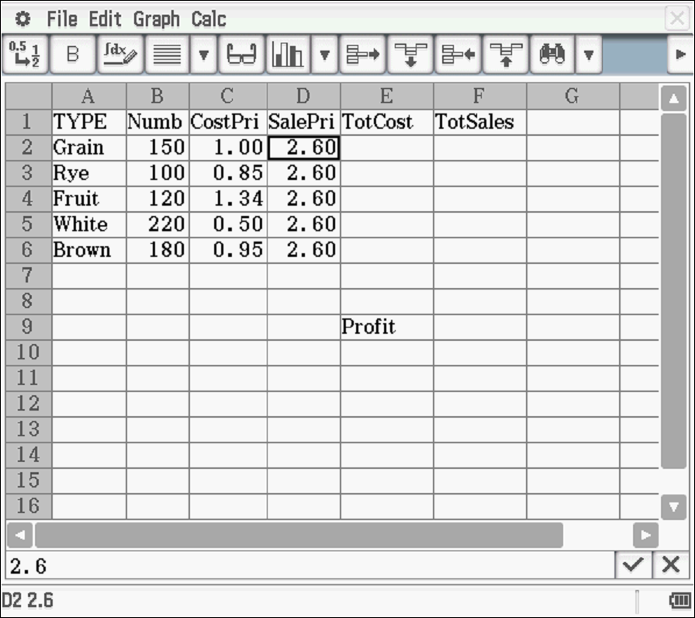

(a) For each type of bread, calculate the total cost of making the loaves in the bakery. Write the data in column E. (1)

(b) For each type of bread, calculate the total money paid to the bakery if all loaves are sold at the sale price. Write the data in column F. (1)

(c) Calculate the totals for columns E and F and store the data in row 8. (2)

(e) What is the total profit if all loaves are sold? Show the value in F9 (1)

(f) Matt wants to increase the profit by increasing the sale price. (4)

(i) When he changes the price to $2.90, what is the new profit?

(ii) He wants the profit to be at least $2000. What is the lowest price (to the nearest 10c) that he needs to charge for each loaf to reach this profit?
Explain how you determined your answer.

Investigative questions in Topic 1.1
Solutions and marking key

Question 1
 | Solution | Marking key/mathematical behaviours | Marks
(a) | 0.0085 0.8525  0.0074 0.7368 | - Divides weight by dollars  - Calculates cost per gram  - Rounds to 4 decimal places | 1  1  1
(b) (i)  (ii)  (iii) | 6.8  $0.7368  73.68c | - Determines number of 100s  - Calculates cost (dollars)  - Calculates cost (cents) | 1  1  1
(c) (i)  (ii)  (iii) | 0.68  $7.368  736.8 | - Determines number of 1000s  - Calculates cost (dollars)  - Calculates cost (cents) | 1  1  1
(d) | The number produced can be rounded to a 2-digit whole number which is better for comparison than a 1-digit number or a number with significant digits only after the decimal. | - Compares numbers produced in terms of likely consumer preference | 1

Question 2
 | Solution | Marking key/mathematical behaviours | Marks
(a) | 2200 x 26.5 ÷ 100 | - Determines dividend amount | 1
(b) | GHI  The increase in dividend is largest (5.5 cents) | - Estimates size of change  - Determines largest estimate | 1  1
(c) | YZA  Only company where dividend more than double | - Estimates proportional change  - Explains or calculates the proportional increase | 1  1
(d) (i)  (ii)  (iii) | JKL  ABC BCD  Price of shares  Previous rates | - Indicates zero rate  - Indicates decline in rates  - Cost of the shares  - Previous dividend rates | 1  1  1  1

Question 3
Solution

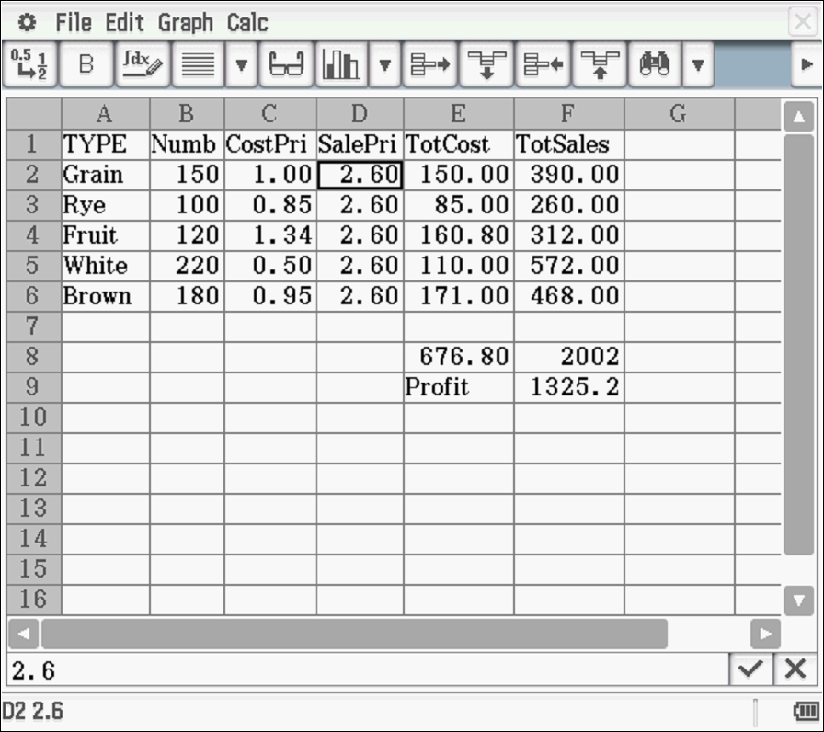

(f) (i) $1556.20
(ii) Price = $3.00 Profit = $1633.20
Price = $4.00 Profit = $2403.00
Price = $3.50 Profit = $2018.00 **

Marking key/mathematical behaviours | Marks
- Calculates total costs for each category  - Calculates total value of sales for each category  - Calculates total cost for all categories  - Calculates total value of sales for all categories  - Calculates total profit  - Determines new profit  - Determines new sale price  - Shows two extra attempts to determine profit based on reaching $2000 | 1  1  1  1  1  1  1  2

TASK 4: USING MATRICES

Extended investigation

Unit 1

Topic 1.2: Algebra and matrices

Course-related information

The skills and concepts developed in this extended investigation relate to the following dot points within the WA Mathematics Applications syllabus:
1.2.4 use matrices for storing and displaying information that can be presented in rows and columns; for example, databases, links in social or road networks
1.2.5 recognise different types of matrices (row, column, square, zero, identity) and determine their size
1.2.6 perform matrix addition, subtraction, multiplication by a scalar, and matrix multiplication, including determining the power of a matrix using technology with matrix arithmetic capabilities when appropriate
1.2.7 use matrices, including matrix products and powers of matrices, to model and solve problems; for example, costing or pricing problems, squaring a matrix to determine the number of ways pairs of people in a communication network can communicate with each other via a third person

Students will have the opportunity to further develop their capacity to choose and use technology efficiently.

Background information

It is assumed that students will have covered matrices and matrix operations. They should be able to determine power of matrices using technology but may not have wide experience of using matrices to model and solve problems.

Task conditions

The preparation activities could be completed within a week and the time allocation for the in-class validation is 45 – 55 minutes. Students need to prepare a page of notes summarising their work from the preparation activities and bring it to the in-class validation. Calculators with the facilities to compute matrix operations are needed for the in-class validation.
Using matrices

Extended investigation Part 1: Preparation activities

These preparation activities will provide support and guidance for the in-class validation of this investigation. A page of notes summarising the solutions to these activities and the processes by which the solutions are determined should be prepared and brought to the in-class validation.

Activity 1: The DETERMINANT of a matrix

For the matrix A the determinant of A is denoted by |A|.
The determinant is a value (not a matrix).
Only square matrices have determinants.

If A = then |A| = ad – cb. The formula is not given for 3 x 3 matrices.

In this investigation, the process by which the determinant is calculated is not emphasised; how the determinant is used is considered. Students should be able to use their calculators to calculate the determinant.

Use your technology to confirm the following determinants.

For A = |A| = -2 For B = |B| = 0

For C = |C| = 20 For D = |D| = 0

Activity 2: The TRANSPOSE of a matrix

The transpose of a matrix is formed by rearranging the elements. The rows of the original matrix become the columns of the transposed matrix and the columns of the original matrix form the rows of the transposed matrix.

The transpose of matrix C is and the transpose of is

Determine the transpose matrices for matrices A, B and D as defined previously.

Activity 3: The INVERSE of a matrix

The inverse of a matrix A is denoted by A⁻¹; it is the matrix which multiplies A to form the identity matrix. So A x A⁻¹ = I. Only square matrices have an inverse but not all square matrices will have an inverse.

Examples: If A = then A⁻¹ =

If C= then C⁻¹ =

Question 1

Given the following matrices
D = E = F =

Determine

(a) D⁻¹ (b) E⁻¹ (c) F⁻¹

(d) DD⁻¹ (e) EE⁻¹ (f) FF⁻¹

(g) D⁻¹D (h) E⁻¹E (i) F⁻¹F

Question 2

(a) What matrix is formed when a matrix is pre-multiplied by its inverse matrix?

(b) What matrix is formed when a matrix is post-multiplied by its inverse matrix?

(c) What will be the dimensions of the matrix formed when a matrix is pre-multiplied by its inverse matrix?

Question 3

For any square matrix A for which A⁻¹ exists, determine the following products where I is the identity matrix with the same dimensions as A

(a) AI (b) AA⁻¹I (c) A⁻¹AI
Activity 4: Using matrices to determine the area of a triangle
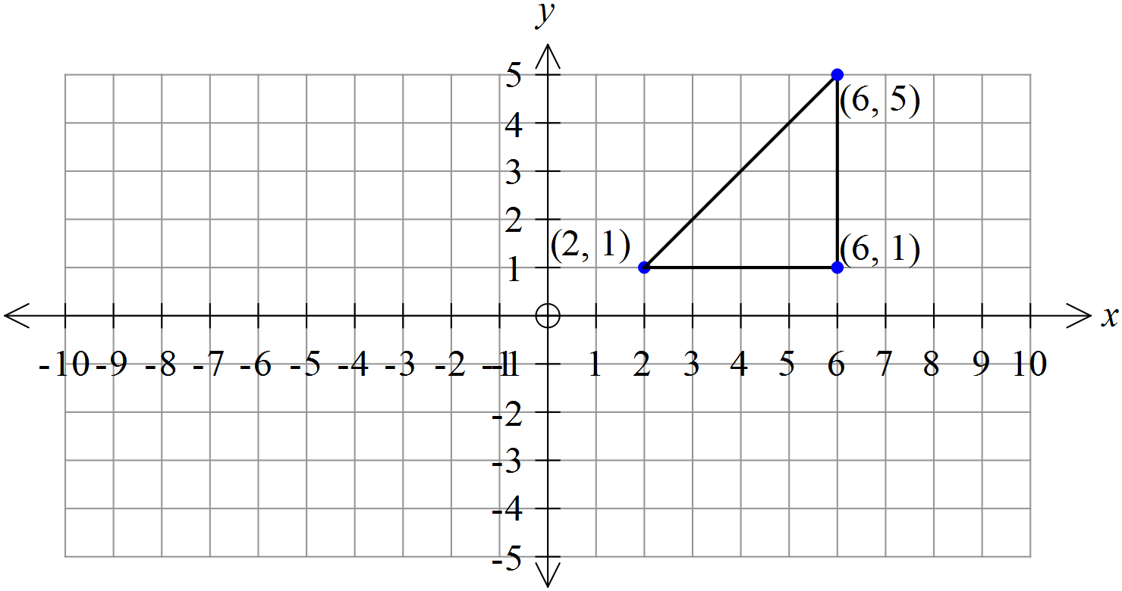

Using matrices

The right-angled triangle drawn on the grid has vertices at (2, 1), (6, 1) and (6, 5).

(a) Using Area = 0.5 x base x height, calculate the area of the triangle.

Matrices can be used to calculate the area when the coordinates of the vertices are known.
Firstly a matrix is formed by
- placing the x values of the coordinates in the first column
- placing the corresponding y values in the second column
- placing the number 1 in each row of the third column

For this triangle the matrix, T, would be T =
Then Area = ± 0.5 |T| (take the positive value of half the determinant of T)

(b) Check this expression gives the same answer as for part (a).

(c) For the following triangle

(i) Draw the triangle marked by vertices (-2, 2), (-8, 2) and (-8, 4) on the grid.

(ii) Using Area = 0.5 x base x height, determine the area.

(iii) Use the matrix method to determine the area.

(d) Why is the ± symbol used?
Extended investigation Part 2: In-class validation (47 marks)

Question 1 (16 marks)
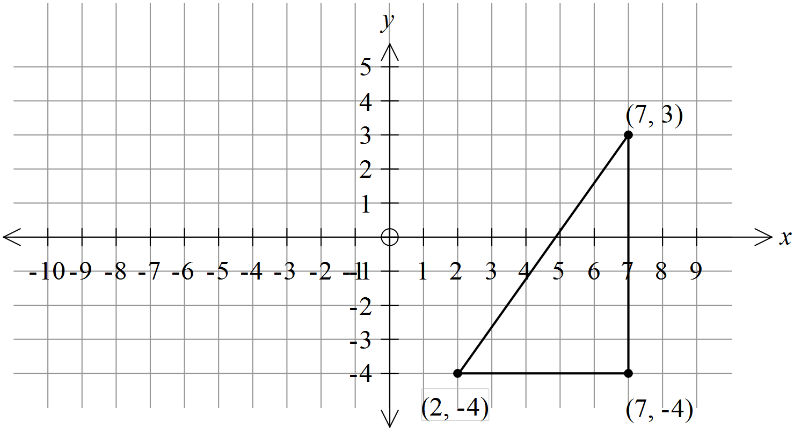

Matrices can be used to determine the area of a triangle.

The right-angled triangle drawn on the grid has vertices at (7, 3), (7, -4) and (2, -4).

(a) Using Area = 0.5 x base x height, calculate the area of the triangle. (2)

(b) Use a matrix method to determine the area of the triangle. (3)

(c) (i) On the grid, draw a triangle bounded by the following coordinates:
(-4, -3), (-8, 0) and (-5, 4). (2)

(ii) Use a matrix method to determine the area of the triangle drawn in (i). (3)

(d) Use a matrix method to determine the area of the figures with vertices at these three coordinates: (0.5, 2), (-1, -7) and (2, 11).
What can you say about these coordinates? (3)

(e) Describe how you could use a matrix method to determine the area of the figure bounded by these four coordinates: (1, 4), (-2, 2), (1, -3) and (3, 1). (3)

Question 2 (14 marks)

The gird below shows the following points.
A (2, 3) B (2, -4) C (5, 0) D (4, -6) E (-5, 6)
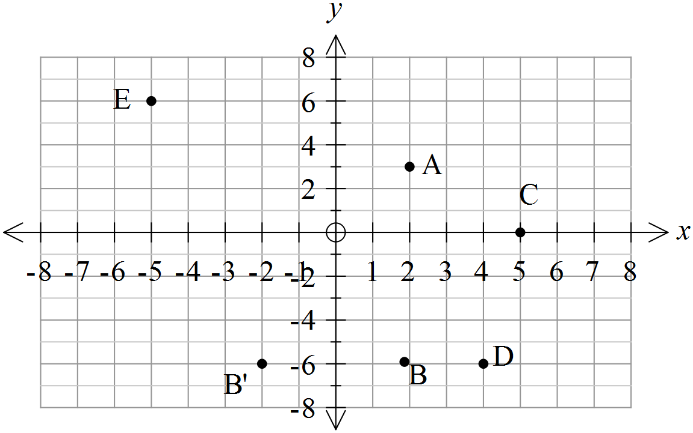

For point A, the column matrix with the x value in row 1 and the y value in row 2 is .
This column matrix is pre-multiplied by and the product is
This is written as x =
The column matrix formed is considered as a point. is the point (-2, 3) where the value in row 1 is the x value and the value in row 2 is the y value.

(a) Plot the point (-2, 3) and mark it as A’. (1)

(b) (i) Determine x
(ii) Plot the product of (b) (i) as the point (x, y) and label it C’. (2)

(c) For point D (3)

(i) Create a column matrix in the form of
(ii) Pre-multiply it by

(iii) Plot the product as the point D’
(d) For point E (3)

(i) Create a similar column matrix

(ii) Pre-multiply it by

(iii) Plot the product as the point E’

(e) Describe the position of points A’, B’, C’, D’ and E’ relative to A, B, C, D and E.
(1)

(f) Determine the inverse of the matrix . (1)

(g) K represents the matrix that was used in the pre-multiplication above.

represent the column matrices formed by the points A’, B’, C’, D’ and E’.
Where will the points defined by the products be located?
Explain your decision. (3)

Question 3 (17 marks)

The following matrix shows the scores for 5 different students in 10 multiple choice questions. The score is 1 for a correct answer and 0 for an incorrect answer.

S =

(a) Describe clearly what each row represents. (2)

(b) Describe clearly what each column represents. (2)

(c) Where in the matrix is the student with the worst score located? (1)

(d) Where in the matrix are the more difficult questions more likely to be located? (2)

(e) If W = , determine the product SW. (1)

(f) Describe what each row of SW represents. (1)

(g) The transpose of matrix S is denoted by S^{T}. (5)
(i) Determine S^{T}

(ii) Describe what each row of S^{T} represents.

(iii) What would the matrix 2S^{T} represent?

(h) Show how you can use a matrix product to generate a column matrix containing the numbers of students who are correct for each question. (4)

(i) Is it true to say that (SW)^{T} = S^{T}W^{T}, where T represents the transpose of the matrix? Justify your conclusion. (2)

End of questions
Using matrices

Extended investigation Part 1: Preparation activities
Solutions

Activity 2

The transpose of A is
The transpose of B is
The transpose of D is

Activity 3
Question 1

(a) |  | (b) |  | (c)
(d) |  | (e) |  | (f)
(g) |  | (h) |  | (i)

Question 2

(a) | Identity matrix
(b) | Identity matrix
(c) | Same dimensions as the original matrix

Question 3

(a) | A
(b) | I
(c) | I
Activity 4

(a) | Area = 0.5 x 4 x 4 = 8 sq. units
(b) | |T| =16 so yes
(c) | (i)  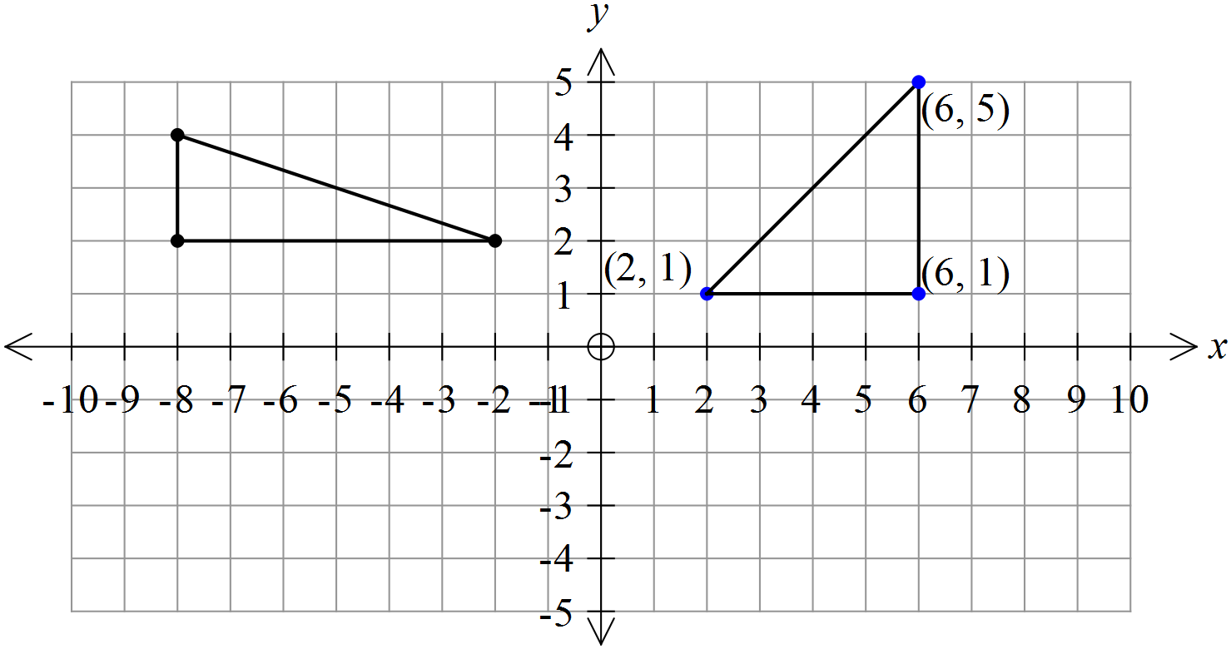  (ii) Area = 0.5 x 6 x 2 = 6 sq. Units  (iii) T =  |T| = -12  Area = -(-12) x 0.5 = 6 sq units
(d) | To make the answer positive because area cannot be negative

Using matrices

Extended investigation Part 2: In-class validation
Solutions and marking key

Question 1
 | Solution | Marking key/mathematical behaviours | Marks
(a) | Area = 0.5 x 5 x 7 = 17.5 sq units | - Substitutes into formula for area  - Calculates area | 1  1
(b) | T =  |T| = -35  Area = -(-35) x 0.5 = 17.5 sq units | - Determines matrix of coordinates  - Determines determinant  - Halves determinant and makes positive | 1  1  1
 | 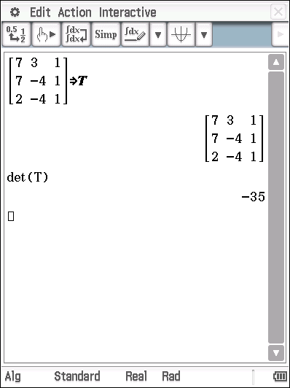
(c) | (i)  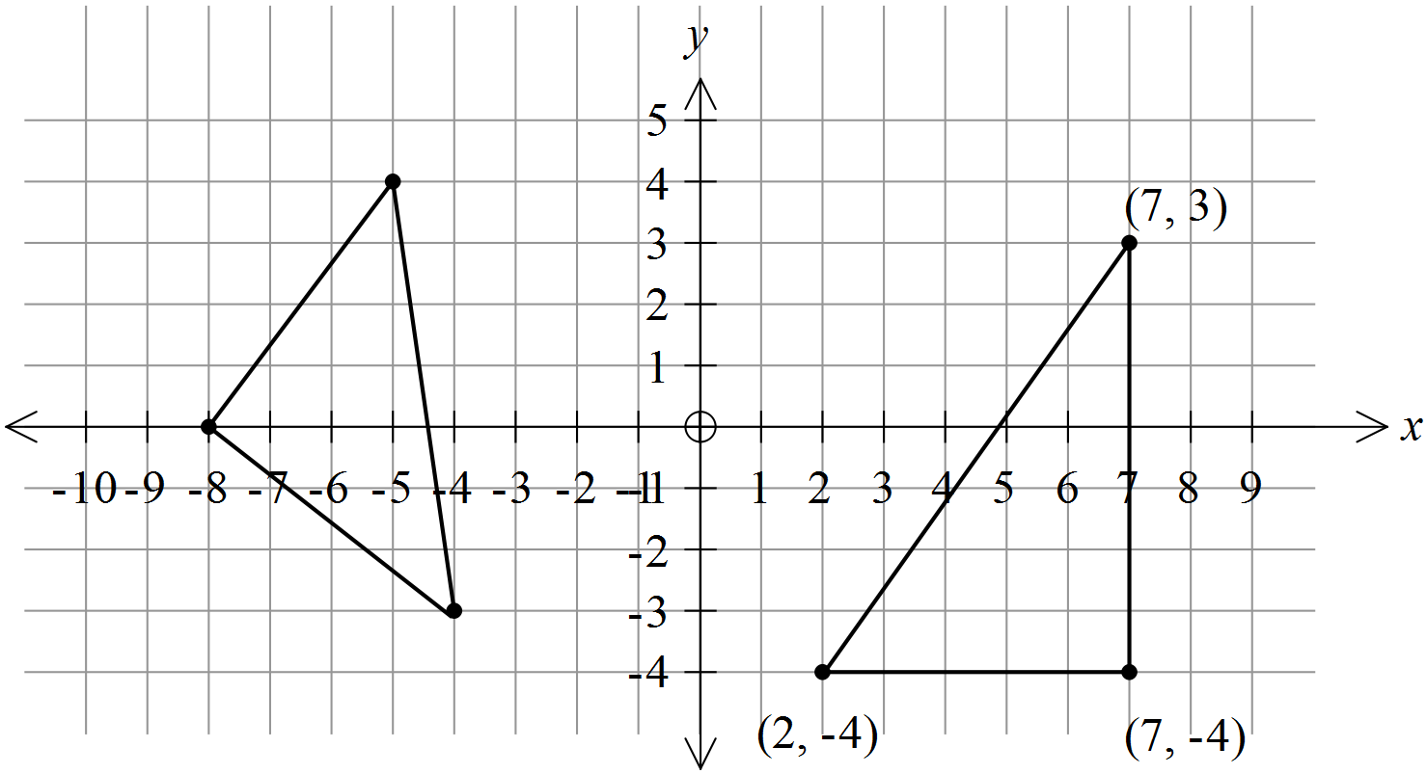
 | Mathematical behaviours | - Plots points  - Joins points | 1  1
Question 1 (cont’d)
 | Solution | Marking key/mathematical behaviours | Marks
(c) | (ii)  T =  |T| = -25  Area = -(-25) x 0.5 = 12.5 sq units | - Determines matrix of coordinates  - Determines determinant  - Halves determinant and makes positive | 1  1  1
(d) | |T| = 0  They form a straight line | - Determines matrix of coordinates  - Determines determinant  - Interprets area being 0 | 1  1  1
(e) | Divide area into 2 triangles  Create matrices of coordinates for each triangle  Calculate determinants for each matrix  Take positive values, add them and halve the total. | - Identifies the area as two triangles  - Describes the matrix method | 1  2

Question 2
Solution
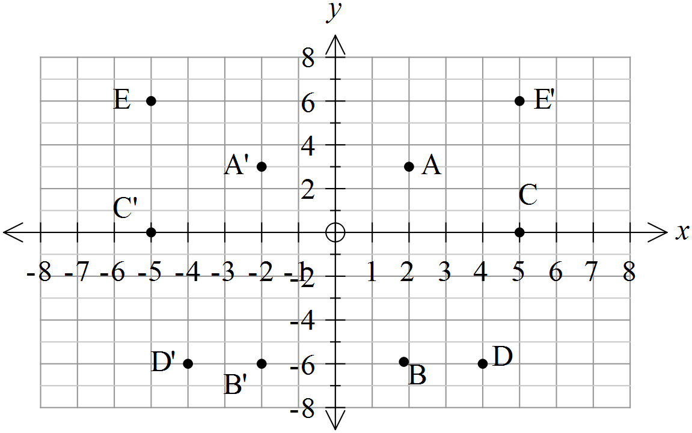

Marking key/mathematical behaviours | Marks
(a) Plots and labels the point (-2, 3)  (b) (ii) Plots and labels the point (-5, 0)  (c) (iii) Plots and labels the point (-4, -6)  (d) (iii) Plots and labels the point (5, 6) | 1  1  1  1
Question 2 (cont’d)
 | Solution | Marking key/mathematical behaviours | Marks
(b) | (ii) | - Determine product of matrices | 1
(c) | (i)  (ii) | - Determines column matrix  - Determines product of matrices | 1  1
(d) | (i)  (ii) | - Determines column matrix  - Determines product of matrices | 1  1
(e) | Reflected over the y axis | - Describes relative positions of points | 1
(f) |  | - Determines inverse of matrix | 1
(g) | Points are reflected back over the y axis.  Points are in original positions. A’ A etc.. | - Determines the matrix product  - Describes reflections  - Identifies final positions | 1  1  1

Question 3
 | Solution | Marking key/mathematical behaviours | Marks
(a) | The scores for the questions for one student | - Describes row data  - Refers to properties of all elements | 1  1
(b) | The students’ scores for a particular question | - Describes column data  - Refers to properties of all elements | 1  1
(c) | Row 2 | - Interprets matrix data | 1
(d) | In the columns further to the right of the matrix | - Interprets column data  - Describes variety of locations | 1  1
(e) |  | - Multiplies matrices | 1
Question 3 (cont’d)

 | Solution | Marking key/mathematical behaviours | Marks
(f) | The total score for a particular student | - Interprets elements in column matrix | 1
(g) | (i)  (ii) The scores for a particular question  (iii) A matrix showing the scores of 5 students for 10 different questions in which the students score 2 for a correct answer and 0 if the answer is incorrect. | - Transposes rows and columns  - Interpret rows of matrix  - Describes data in the matrix | 2  1  2
(h) | S^{T} x = | - Selects correct matrices  - Orders matrices  - Multiplies two matrices | 2  1  1
(i) | (SW)^{T} is a 1 x 5 matrix  S^{T}W^{T} does not exist because S^{T} has 5 columns and W^{T} has 1 row so the product does not exist | - Identifies multiplication not defined  - Justifies the fact that multiplication is not defined | 1  1

TASK 5: MATRICES FOR CONNECTIONS

In-class investigation

Unit 1

Topic 1.2: Algebra and matrices

Course-related information

The skills and concepts developed in this in-class investigation relate to the following dot points within the WA Mathematics Applications syllabus:
1.2.4 use matrices for storing and displaying information that can be presented in rows and columns; for example, databases, links in social or road networks
1.2.6 perform matrix addition, subtraction, multiplication by a scalar, and matrix multiplication, including determining the power of a matrix using technology with matrix arithmetic capabilities when appropriate
1.2.7 use matrices, including matrix products and powers of matrices, to model and solve problems; for example, costing or pricing problems, squaring a matrix to determine the number of ways pairs of people in a communication network can communicate with each other via a third person

The students are asked to apply reasoning skills to examine and use the information provided to apply uses of matrices more broadly.

Background information

Students should already be familiar with matrix operations including determining the power of a matrix using technology (dot point 1.2.6). It would be possible for students to use this investigation as an introduction to using matrices for communication.

Task conditions

For this task students would need access to calculators which can be used to perform matrix operations. No student notes are required. Suggested time is 45-50 minutes.

Matrices for connections

In-class investigation (50 marks)

Question 1 (6 marks)

Examine the following traffic flow where the arrows represent the types of streets (one-way or two-way) and the letters indicate places to visit.
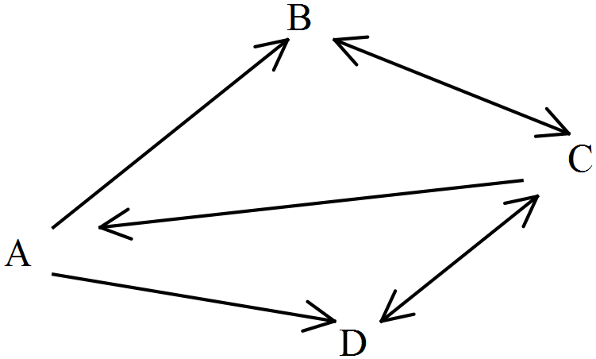

The street from A to B is one-way so traffic can go from A to B but not from B to A.
The street from C to A is also one-way so traffic cannot go from A to C.

(a) What is the other one-way street? (1)

(b) Two-way streets have arrows on each end. (2)

(i) How many two-way streets are there?

(ii) Which places are linked by two-way streets?

The traffic flow can be represented by the following matrix
TO
A vehicle can go from A to D which is represented by 1 in the traffic flow matrix.
A B C D
A vehicle CANNOT go from D to A so there is a 0 in the traffic flow matrix.
F
R
OM

(c) Vehicles do not travel in a circle (not directly from A to A). (3)

(i) Where is this shown in the traffic flow matrix?

(ii) What number represents this in the traffic flow matrix?

Question 2 (8 marks)

The same arrow system (as described in Question 1) is used to show that other streets are either one-way or two-way and is represented in the diagram below.

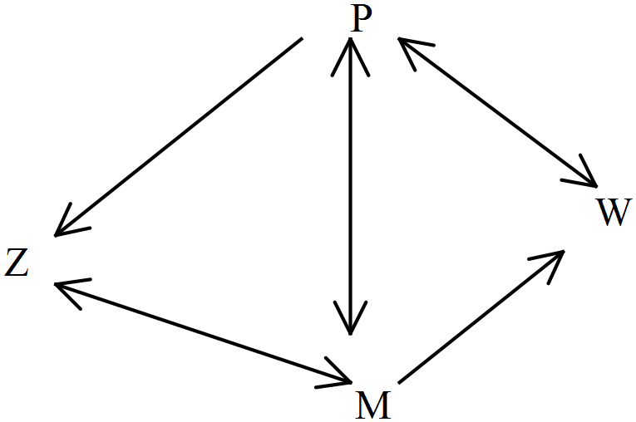

(a) How many one-way streets are there? (1)

(b) How many two-way streets lead to Z? (1)

(c) Show these connections in a labelled traffic flow matrix. (6)

Question 3 (13 marks)

(a) For the following traffic flow matrix, draw a diagram to represent the connections between locations J, K, L and M. Show arrows to indicate one-way and two-way streets as used in the previous questions. (4)
K
L
J
J
K
L
M

Question 3 (cont’d)
M

(b) For the following traffic flow matrix (7)

A B C D E

(i) What numbers occur on the leading diagonal? Why?

(ii) Draw a diagram to represent this traffic flow matrix.
Use arrows to indicate one-way streets and two-way streets as used in the previous questions.

(c) Using the following traffic flow matrix as an example (2)

P Q R S T

(i) What feature(s) of the matrix indicates that all locations (other than itself) connect to P?

(ii) What feature(s) of the matrix indicates that there is a two-way street between locations?

Question 4 (10 marks)

Consider again the traffic flow shown in Question 1.
Vehicles can go from A to B to C, so the number of steps on the route ABC is 2.
Vehicles can also go from B to C to B so number of steps on the route BCB is 2.
BCB is a different route to CBC
CBA is not a two-step route because the street between B and A is one-way.


(a) List all other routes which have 2 steps. (3)

(b) ADCB is a three-step route from A to B. (4)

(i) Is BCBA a three-step route from B to A? Explain

(ii) Name two other three-step routes for this traffic flow?

(c) Name a four-step route from A to D. (1)

(d) Name a four-step route from A to C. (1)

(e) Name a five-step route from C to D. (1)
Question 5 (7 marks)

The traffic flow between locations W, T, M and K is represented by the matrix Q below.
The matrix Q² is also given as is the traffic flow diagram. Q² shows the number of two-step routes between locations. There is 1 two-step route from W to W.
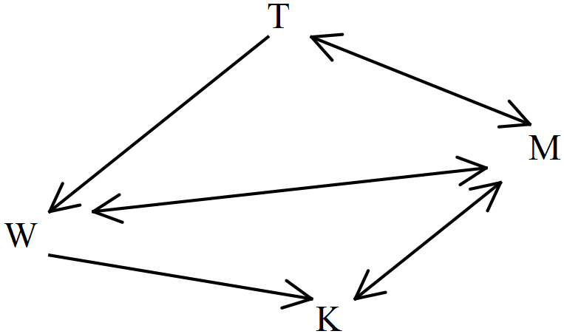

W T M K W T M K
Q = Q² =

(a) Name all the two-step routes (3)

(i) from K to T

(ii) from T to K

(iii) from M to M

(b) Determine the matrix which represents the number of two-step routes between these locations as described below. (4)
- There are 4 connected locations X, Y, Z and W
- There are no two-step routes from X to W, Y to W, Y to Z or Z to X
- There are 2 two-step routes from X to X, X to Y and X to Z as well as from Z to Z, W to Y and W to Z.
- On each of the other connections between locations there is only one two-step route..
Question 6 (6 marks)

The traffic flow between locations W, T, M and K is represented by the matrix Q and matrix Q² shows the number of two-step routes between locations.
Matrix Q³ represents all the three-step routes between W, T, M and K.
W T M K
Q =

W T M K
Q³ =

(a) How many three-step routes go from T to M? (1)

(b) If you added all the elements of matrix Q³, what would the total represent? (1)

(c) Write an expression to determine the total number of one, two and three-step routes between these four locations. (2)

(d) Determine the matrix to represent all the four-step routes between these four locations. (2)

End of questions
Matrices for connections

In-class investigation
Solutions and marking key

Question 1
 | Solution | Marking key/mathematical behaviours | Marks
(a) | A to D | - Identify uni-directional flow | 1
(b) | (i) 2  (ii) C and D, C and B | - Interpret diagram showing flow  - Describe flow in diagram | 1  1
(c) | (i) Along leading diagonal  (ii) 0 | - Describes all positions in matrix  - Identifies element of matrix | 2  1

Question 2
 | Solution | Marking key/mathematical behaviours | Marks
(a) | 2 | - Interpret diagram showing flow | 1
(b) | 1 | - Interpret diagram showing flow | 1
(c) | To | - Labels rows and columns  - Places 0 on leading diagonal  - Identifies one-way connections  - Identifies two-way connections  - Places 0 for lack of connections  - Identifies to and from | 1  1  1  1  1  1

Question 3
 | Solution | Marking key/mathematical behaviours | Marks
(a) | 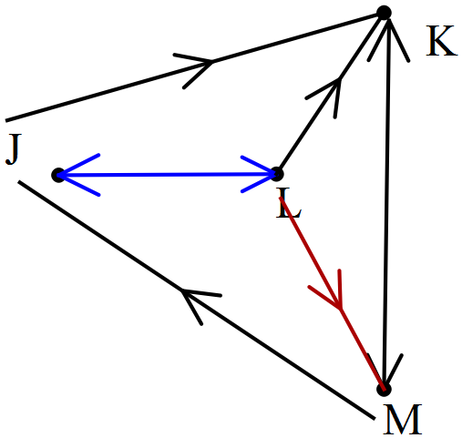 | - Interprets row 1 of matrix  - Interprets row 2 of matrix  - Interprets row 3 of matrix  - Interprets row 4 of matrix | 1  1  1  1
(b) | (i) 0  No streets to its own location | - Identifies elements of diagonal  - Interprets matrix elements | 1  1
(b) | 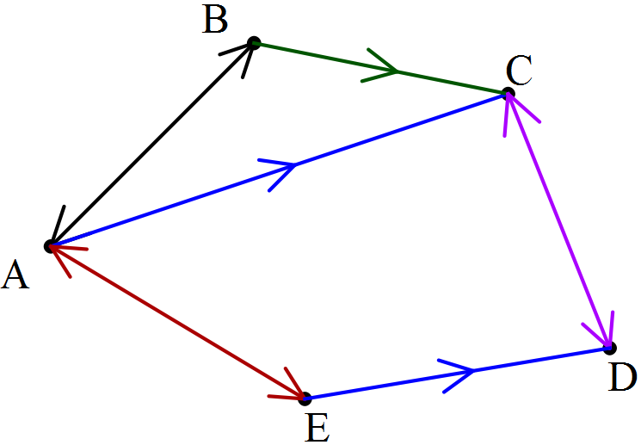(ii) | - Interprets row 1 of matrix  - Interprets row 2 of matrix  - Interprets row 3 of matrix  - Interprets row 4 of matrix  - Interprets row 5 of matrix | 1  1  1  1  1
Question 3 (cont’d)

(c) | (i) All 1s in column 1 except for first poistion  (ii) There is a 1 in two positions (original and transpose) ie a_{mn} and a_{nm} | - Interprets column 1 of matrix  - Describes location of related elements | 1  1

Question 4
 | Solution | Marking key/mathematical behaviours | Marks
(a) | DCD CDC ADC  BCD CAD DCB  DCA BCA CAB | - Interprets all two-step routes on flow diagram | 3
(b) | (i) No. Cannot go B to A  (ii) ABCB, ADCD | - Indentifies direction in flow diagram  - Identifies two-step routes | 2  2
(c) | ABCAD | - Identifies a four-step route | 1
(d) | ADCDC | - Identifies a four-step route | 1
(e) | CABCBC | - Identifies a five-step route | 1

Question 5
 | Solution | Marking key/mathematical behaviours | Marks
(a) | (i) KMT  (ii) TMK, TWK  (iii) MKM, MTM, MWM | - Uses matrix to identify number of paths and interprets flow diagram to locate paths | 3
(b) | X Y Z W | - Labels rows and columns  - Enters elements for zero two-step pathways  - Enters elements for one two-step pathways  - Enters elements for two two-step pathways | 1  1  1  1

Question 6

(a) | 4 | - Interpret matrix element | 1
(b) | The total number of 3-step routes in the traffic flow | - Interpret total of matrix elements | 1
(c) | Q + Q² + Q³ | - Determine expression of matrix addition | 2
(d) |  | - Identifies Q⁴ is needed  - Determines Q⁴ | 1  1

TASK 6

Investigative questions

Unit 1

Topic 1.2: Algebra and matrices

Course-related information

The concepts and skills included in these investigative questions relate to the following dot points from the WA Mathematics Applications syllabus:
1.2.4 use matrices for storing and displaying information that can be presented in rows and columns; for example, databases, links in social or road networks
1.2.5 recognise different types of matrices (row, column, square, zero, identity) and determine their size
1.2.6 perform matrix addition, subtraction, multiplication by a scalar, and matrix multiplication, including determining the power of a matrix using technology with matrix arithmetic capabilities when appropriate
1.2.7 use matrices, including matrix products and powers of matrices, to model and solve problems; for example, costing or pricing problems, squaring a matrix to determine the number of ways pairs of people in a communication network can communicate with each other via a third person

Background information

It is assumed that the students will have covered the dot points outlined above. Knowledge of simultaneous equations is not essential. The examples provided may be simply solved where necessary by a guess and check method.

Task conditions

These questions are independent of each other and are written so that they may be incorporated into a test or examination. Student access to a graphical/CAS calculator is assumed. The time required to complete each question is left to the discretion of the teacher but the intention is that each question may be completed within 15 minutes.

Investigative questions for Topic 1.2

Question 1 (10 marks)

Kate, Jane and Tom have different numbers of shares in the same three companies. The number of shares, as well as the share prices and dividends paid (per share) in 2004 and 2014, are summarised in the table below.

Company | Price in 2004  ($) | Price in 2014  ($) | Dividend in 2004  (cents) | Dividend in 2014  (cents) | Kate’s number of shares | Jane’s number of shares | Tom’s number of shares
AAA | 19.87 | 12.33 | 38 | 12 | 5000 | 2400 | 1600
BBB | 23.04 | 34.25 | 51 | 98 | 2500 | 3200 | 2700
CCC | 7.69 | 9.06 | 17.4 | 32 | 3800 | 4500 | 3980

Matrix operations are used to manipulate the share data. For the operations provided, determine the result and describe clearly what is represented by the data in each row of the resulting matrix.

(a) (2)

(b) (2)

(c) 0.5 x (2)

(d) (2)

(e) 0.01 x (2)

Question 2 (10 marks)

Given three matrices

(a) Determine (4)

(i) AB

(ii) AC

(iii) B – C

(iv) A ( B – C )

(b) Is the following statement true for the matrices defined above? (2)
AB – AC = A ( B – C )
Will the statement be true for all matrices? Explain your conclusion.

(c) Is the following statement true for the matrices defined above? (2)
3B x 3C = 3(BC)
Will the statement be true for all matrices? Explain your conclusion.

(d) Consider a fourth matrix P. What will be the dimensions of matrix P for the following statement to be true? (2)
P (ABC ) = (PA) x ( BC )

Question 3 (10 marks)

The sum of the ages of Max and Mila is 6. Twice Max’s age added to Mila’s age is equal to 11.
This can be represented by
where x represents Max’s age and y represents Mila’s age.
These equations can also be represented by a matrix operation.

(a) What are the ages of the two children? (2)

(b) The sum of the ages of Nic and Ben is 16. When three times Nic’s age is added to Ben’s age, the result is 24. This can be represented by (2)
where x represents Nic’s age and y represents Ben’s age.
Write these equations as a matrix operation.

(c) The sum ages of Ali and Dia is 20. Three times Dia’s age subtract Ali’s age is equal to 1. Write these equations as a matrix operation. (3)

(d) A matrix method can be used to solve the equation by determining the inverse (to the power of -1) of the matrix of the coefficients. (2)
So
Determine
(i) this inverse matrix.

(ii) the column matrix

(e) Compare and comment on your answers to parts (a) and (d) (ii) (1)

Investigative questions for Topic 1.2
Solutions and marking key

Question 1
 | Solution | Marking key/mathematical behaviours | Marks
(a) | Each row stores the total number of shares in one company for the three people | - Adds matrices  - Interprets data in column matrix | 1  1
(b) | Each row shows the change in the dividend from 2004 to 2014 | - Subtracts matrices  - Interprets data in column matrix | 1  1
(c) | Each row represents the average of the 2004 and the 2014 share prices | - Adds and applies scalar multiplication to matrices  - Interprets data in column matrix | 1  1
(d) | $3327 is the dividend paid out to Jane for these three companies in 2014 | - Multiplies matrices  - Interprets data in column matrix | 1  1
(e) | Each row represents the value of the shares ($) of each person for the three companies in 2014. | - Multiplies matrices  - Interprets data in matrix | 1  1

Question 2
 | Solution | Marking key/mathematical behaviours | Marks
(a) | (i) (ii)  (iii) (iv) | - Computes each resulting matrix correctly | 4
Question 2 (cont’d)

 | Solution | Marking key/mathematical behaviours | Marks
(b) | True for the matrices defined above  Only true when all three matrices have the same dimensions | - Identifies not true for all matrices  - Describes conditions for which where statement is not true | 1  1
(c) | Never true  If BC defined then 3B x 3C = 9BC | - Identifies never true  - Justifies conclusion | 1  1
(d) | P can have any number of rows but must have 2 columns | - Identifies 2 rows needed  - Identifies any number of columns will allow multiplication | 1  1

Question 3

 | Solution | Marking key/mathematical behaviours | Marks
(a) | Max is 5 and Mila is 1 | - Solves simultaneous equations | 2
(b) |  | - Models solution on matrix multiplication provided | 2
(c) | Let x represent Ali’s age and y represent Dia’s age. | - Defines variables used  - Models solution on matrix multiplication provided | 1  2
(d) | (i) (ii) | - Determines inverse of matrix  - Multiplies matrices | 1  1
(e) | The answers are the same: x = 5 and y = 1. These values satisfy the equations given. | - Compares the two solutions | 1

TASK 7: APPLICATIONS OF PYTHAGORAS’ THEOREM

Extended investigation

Unit 1

Topic 1.3: Space and measurement

Course-related information

The concepts and skills developed in this extended investigation relate to the following dot points within the WA Mathematics Applications syllabus:
1.3.1 use Pythagoras’ theorem to solve practical problems in two dimensions and for simple applications in three dimensions

Background information

In this investigation, students are provided with further opportunities to identify practical situations in which Pythagoras’ theorem can be applied. Students should also have the opportunity to discuss the justification of the use of the theorem in situations where a right-angled triangle is not immediately evident. To demonstrate their use of Pythagoras’ theorem, students should show the process by which their answer is determined by providing the substitution of the appropriate measurements into the rule for the theorem. The use of CAS technology would then be appropriate to solve for the variable. It is not anticipated that they would manipulate complex algebraic expressions; however, they should have previously covered dot points 1.2.1 and 1.2.2 of the syllabus.

Task conditions

Students should have access to a range of formulae for area and perimeter, and technology that facilitates the manipulation of such formulae to calculate unknown variables. The questions for Part 2 have been written with the assumption that students will have a copy of their solutions to Part 1 as “notes” during the in-class validation.

Applications of Pythagoras’ theorem

In this assessment students will have the opportunity to investigate various applications of Pythagoras’ theorem. In the examples provided, students should locate right-angled triangles and use Pythagoras’ theorem to determine lengths or distances which could be used in further calculations.

Extended investigation Part 1: Preparation activity

Question 1
From a tree Jenni walked 6 m North then 4 m East before turning North and walking a further 5 m. From there she walked due West for 10 m to arrive at the play area. Helen walked from the same tree directly to the play area.
(a) Using a scale of 1 cm = 2 m, draw an accurate diagram to represent these walks.

(b) Using the diagram drawn in (a), determine the distance (to 1 decimal place) that Helen walked.

(c) Use Pythagoras’ theorem to determine the distance (to 1 decimal place) that Helen walked.

(d) For the calculations from (b) and (c);
(i) which one represents the most accurate calculation of the distance that Helen walked? Justify your conclusion.

(ii) what is the difference between them?

(ii) determine the difference as a percentage of the calculation from (c).
Round this percentage to the nearest whole number.

Question 2
Children’s toy kites are sometimes made in the shape of a mathematical kite with pieces of dowel placed at right angles to form a frame, and string used to connect the ends of the dowel so that the string lies along the perimeter of the kite.
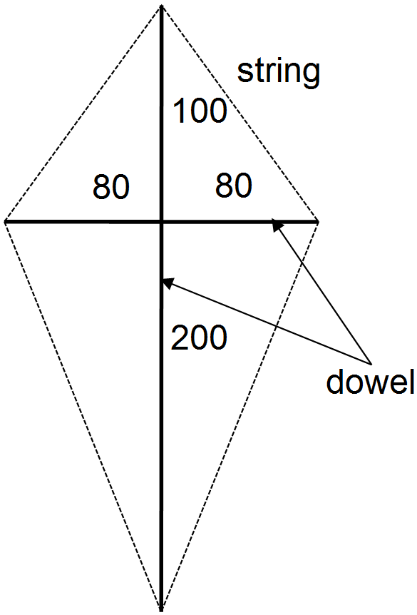The diagram provided shows the measurements (in cm) of the dowel for one of these kites.

(a) Calculate the length of string needed to
form this perimeter.

(b) If an extra 10 cm is needed at each corner,
what is the total length of string now required?

(c) How many metres of string will be needed
for 100 kites?

(d) Using the measurements provided on the diagram,
calculate the area of the kite.
Question 3

Luke sells juice containers in two different shapes and he wants to know how long the drinking straws should be. He wants them to protrude 10 cm from the edge of the juice container in each shape (see diagrams).
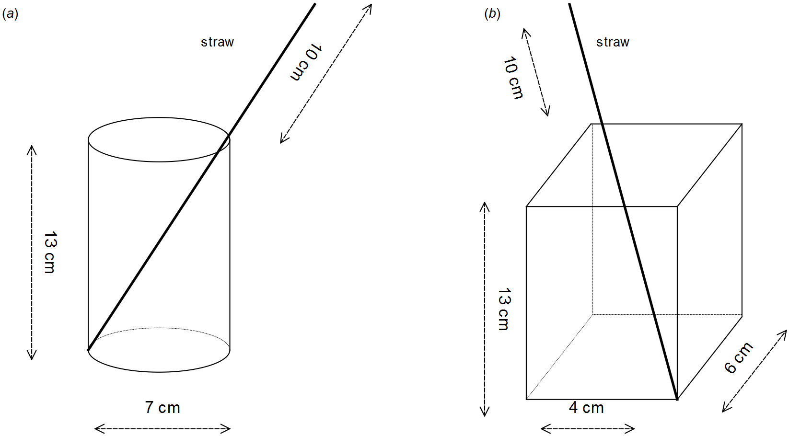Showing use of Pythagoras’ theorem, determine the length (to the nearest cm) of the straws required by Luke.

Question 4

As pictured in the diagram below, six wooden stakes are placed around a small tree to provide a frame for netting to protect the tree from birds. The stakes are all 3 m long and they meet 1.8 m above the ground, directly above the tree.
On the ground, the ends of the stakes are equidistant from each other and they are also equidistant from the tree.

(a) How far from the tree should the stakes be placed?

(b) Calculate the distance at ground level between two adjacent stakes.
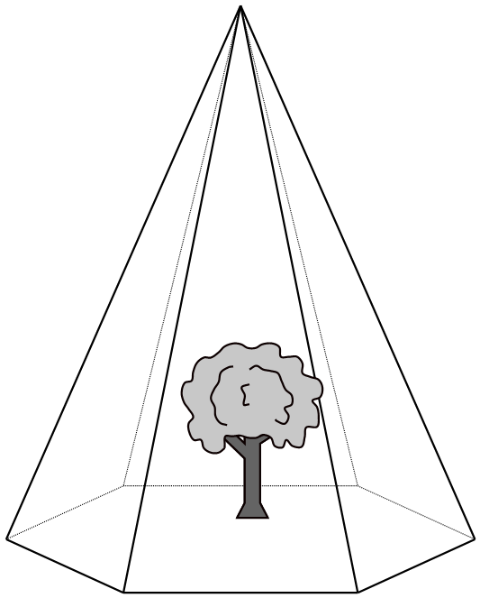 Show how you determined this distance.

(c) Calculate the area of netting required.
Justify any use of Pythagoras’ theorem.

Question 5
The diagram provided represents the part of a soccer field near the goals and it shows the rectangular goal and penalty areas. Position A is 5.5 m from the northern edge of the outer rectangle and opposite the middle of the goal mouth. Position B is 5.5 m from the southern edge and 11 m from the eastern edge of the outer rectangle.
Positions C and G are located at the vertices of rectangles
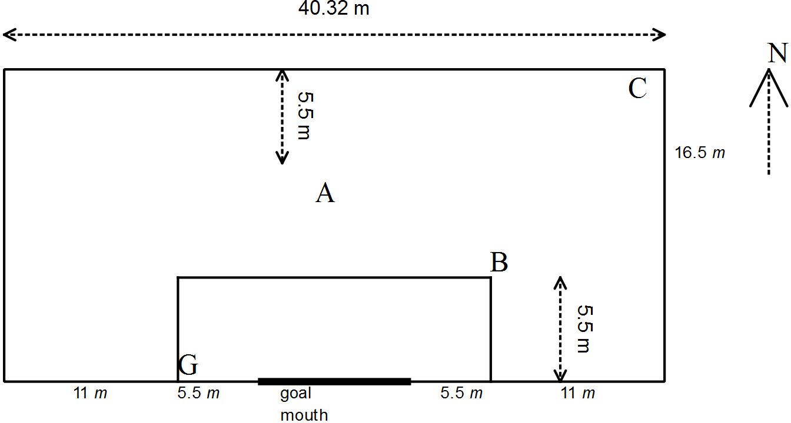

(a) Determine the length of the goal mouth.

(b) To reach the goal mouth from position A, how long is the shortest kick possible?

(c) Calculate the length of straight kicks to position G

(i) from position A

(ii) from position C

(iii) from position C after hitting a player at position B.

Question 6
A piece of furniture foam is in the shape of a triangular prism and all sides of the triangle are equal in length. Let s represent the length of each side of the triangle.

(a) Draw a labelled diagram to represent the triangle.

(b) A line drawn from a vertex of the triangle to the midpoint of the opposite sign makes a right angle at the midpoint. Draw this on the triangle from part (a).

(c) Write an expression to calculate the length of the line drawn in part (b).

(d) Show use of substitution in your expression in part (c) to calculate the height of a piece of foam in the shape of a triangular prism when all the lengths of the sides of the triangle are 20 cm.
Applications of Pythagoras’ theorem

Extended investigation Part 2: In-class validation (44 marks)

Question 1 (8 marks)

Jim cycles 3 km West from the start of the race (S), then turns North travelling 7 km before heading West again and cycling a distance of 5 km to his finishing point, W. where he stops. Meanwhile Tony starts from the same position (S) at the same time as Jim started and cycles 8 km East before heading North for 20 km to his finishing point, (E).
(a) Draw a labelled sketch to represent these travels. (3)

(b) If they both end their journeys at the same time, who has averaged the greater speed? Justify your answer. (2)

(c) Show how you apply Pythagoras’ theorem to determine how far Jim is from Tony when they finish their race. (3)

Question 2 (5 marks)

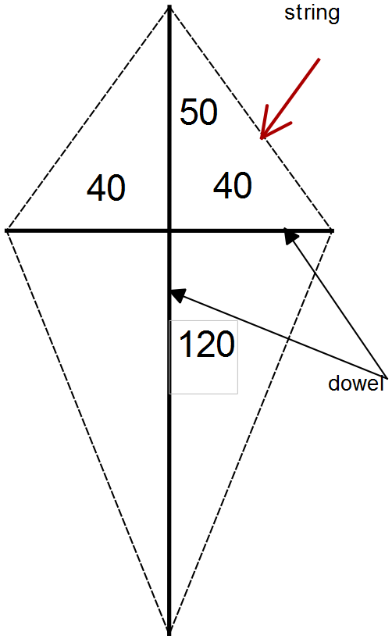Calculate the length of string needed to go all around the outside of this child’s toy kite in which the pieces of dowel, with measurements in cm, are perpendicular to each other.

Question 3 (8 marks)

Four wooden stakes, each 2 m long, are placed around a small tree so that they meet directly above the top of the tree. On the ground, the end of each stake is 1.5 m from the centre of the base of the tree.
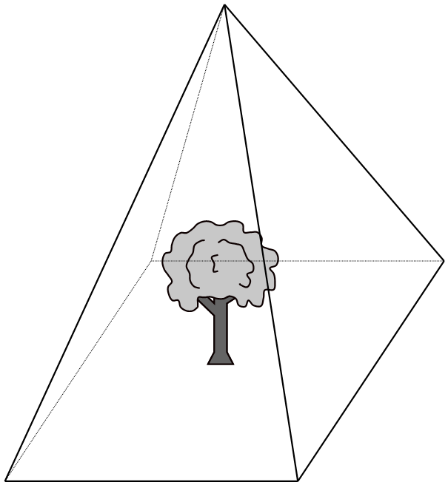
(a) Label the diagram provided (2)
with the given dimensions.

(b) What is the distance from the base of the tree to the point where the stakes meet? (2)

(c) What is the distance from the base of one stake to the base of the next stake? (2)

(d) Calculate the area of the base of the pyramid formed by the four stakes. (2)

Question 4 (4 marks)

A rectangular section of the side fence around the tennis court is represented by the diagram below. The fence is attached to a metal support which is made up of three sections. Use Pythagoras’ theorem to determine the length of the section labelled x.

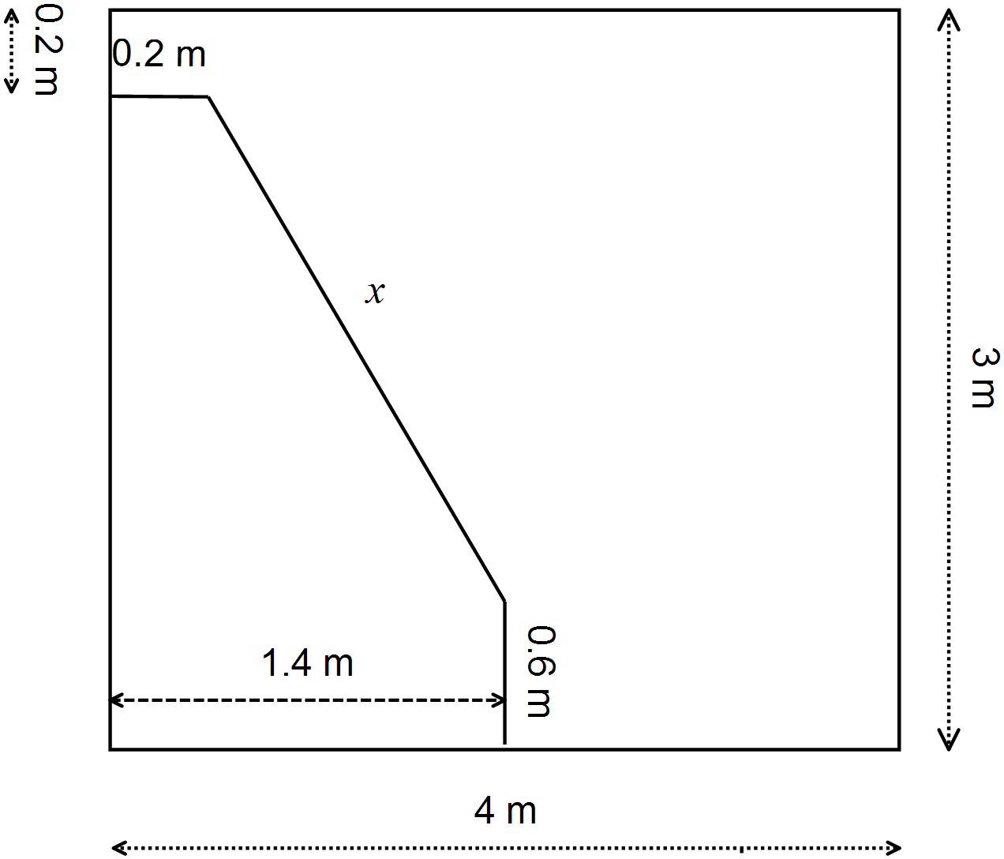

Question 5 (6 marks)

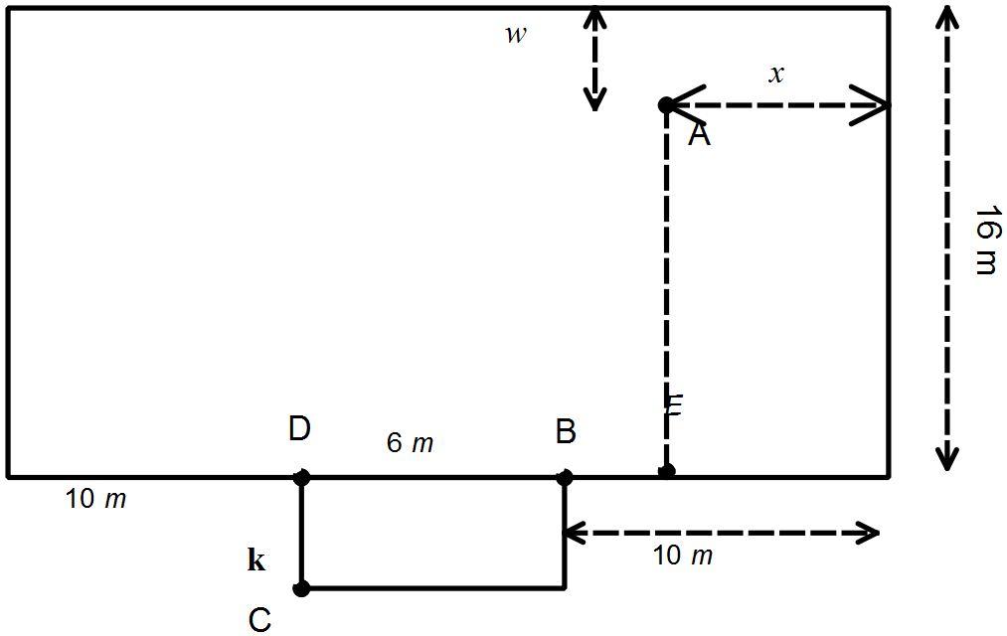The diagram shows part of a junior
soccer field: BD is 6 m and DC is
represented by k. Write algebraic
expressions for each of the
following lengths.
Do not simplify these expressions.

(a) AE (1)
(b) BE (1)

(c) AB (2)

(d) BC (1)

(e) The distance a ball will travel if it is kicked A to B to C. (1)

Question 6 (8 marks)

A straw, 23 cm in total length, protrudes 8 cm from the edge of a juice box which is in the shape of a rectangular prism. The box is 10 cm high and 9 cm in length.

(a) Draw a labelled diagram to represent this situation. (3)

(b) Use Pythagoras’ theorem to determine the width of the box. (5)

Question 7 (5 marks)

The diagram below shows the cross section of a carton containing 4 cylindrical tins, each 7 cm across. Use Pythagoras’ theorem to determine the width of the widest cylinder (the one shaded) that can fit in between these tins.
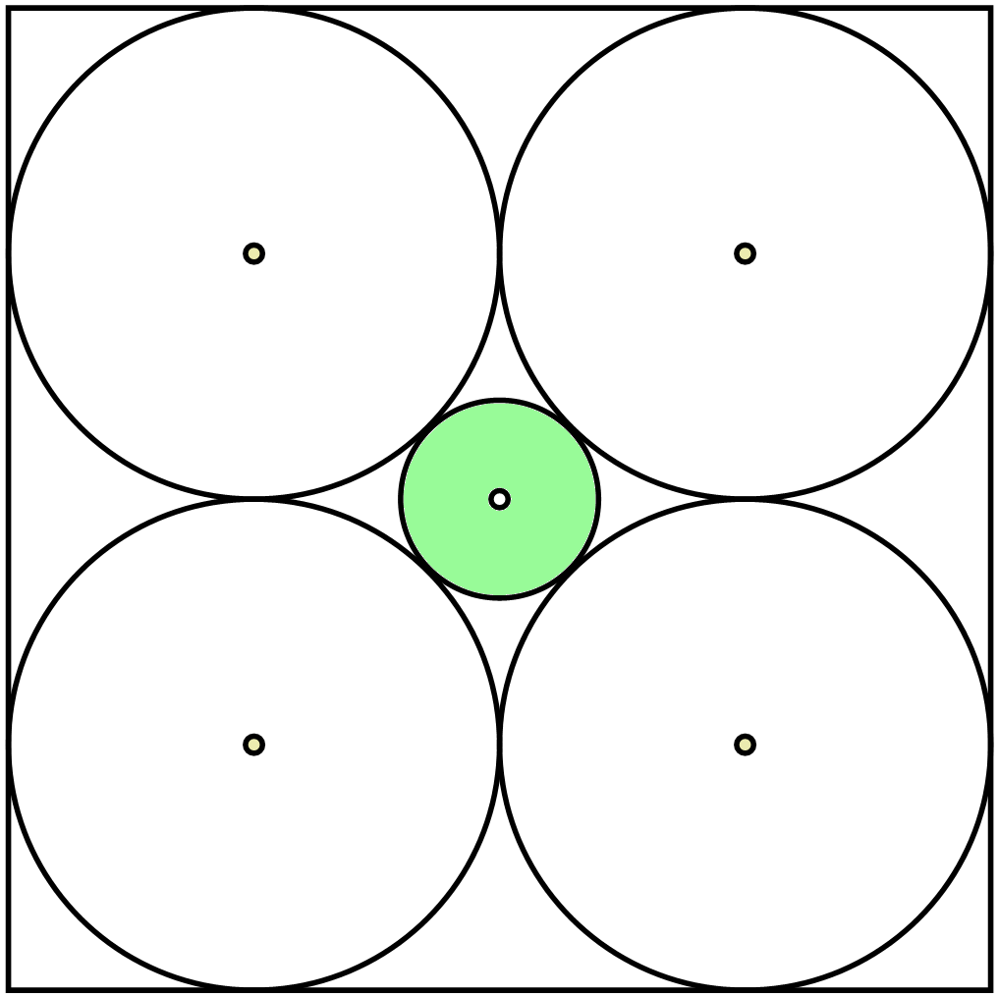

End of questions
Applications of Pythagoras’ theorem

Extended investigation Part 1: Preparation activity
Solutions

Question 1
(a) | 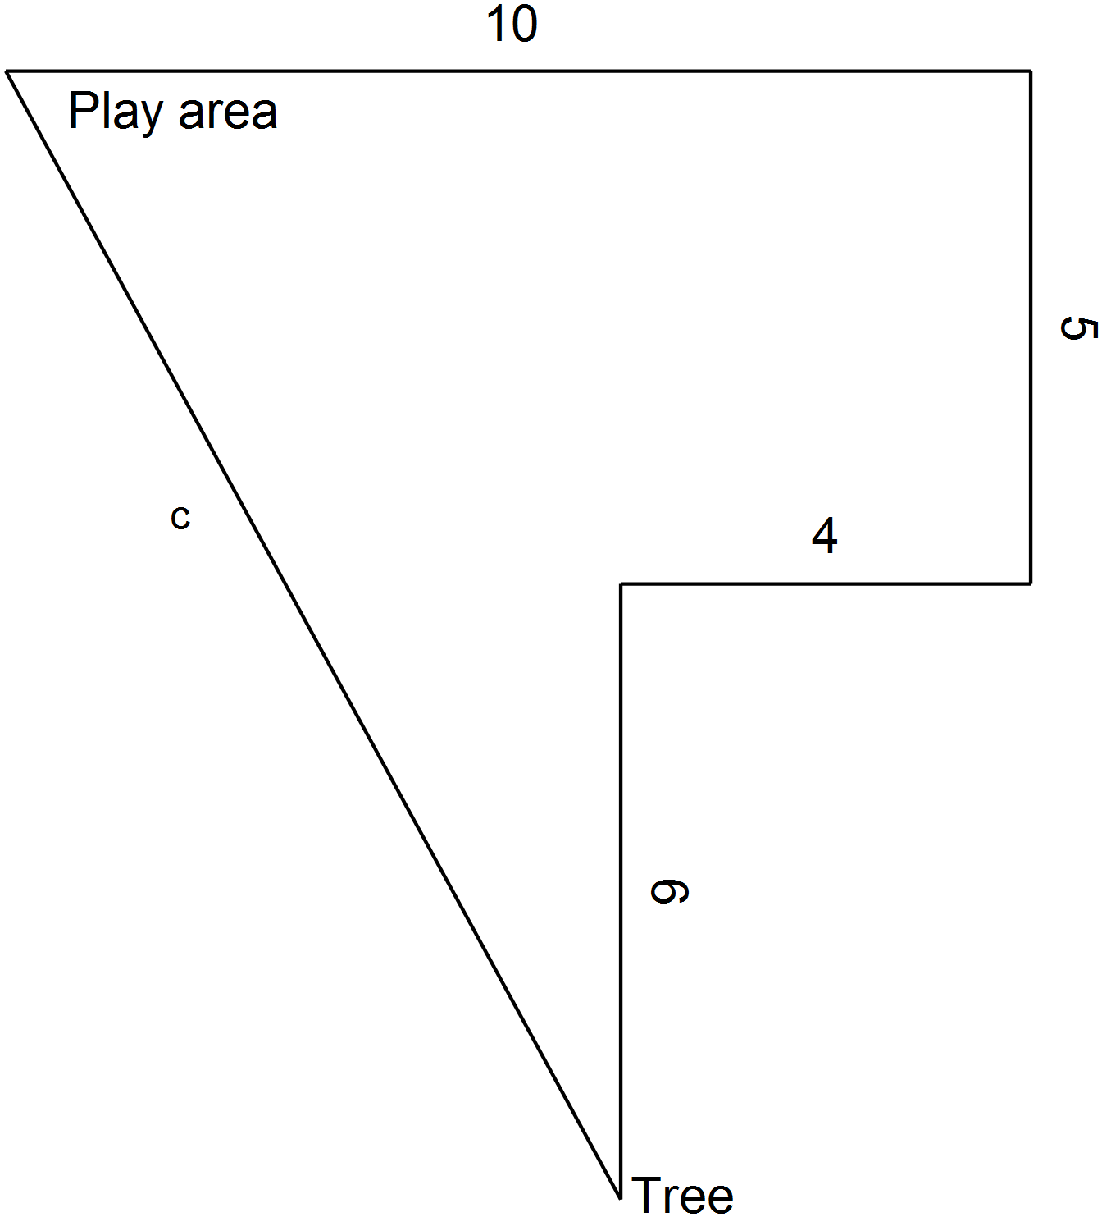 | (b) | 12.6 m
 |  | (c)
 |  | (d) | (i) Pythagoras. The measured distance is more likely to contain user error as it is measured rather than calculated.  (ii) 0.1 m  (iii) 0.56%

Question 2
(a) | For the top of the kite  For the bottom of the kite  Perimeter = | (b)  (c)  (d) | 687+ 4 × 10=727 cm  727 m  Area = 2 × 0.5 × 300 × 80  =24 000 cm²

Question 3
(a) | Straw inside cylinder  Then add 10 and round | (b) | First find the diagonal of the base  Now the diagonal of the box  Add 10 and round  Straw is 25 cm

Question 4
(a) | Distance of stake from tree
(b) | 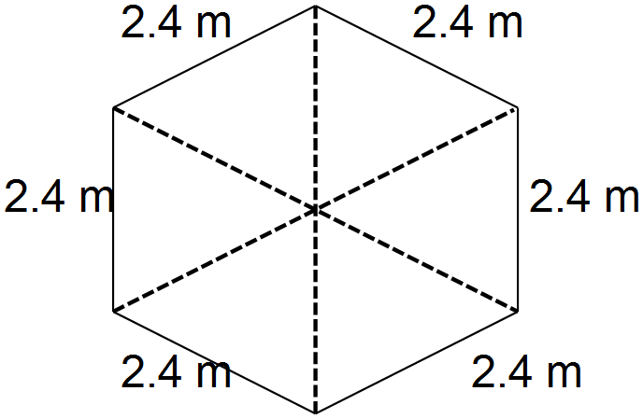 From above the tree is in the centre of a  regular hexagon with angles of 60º at the centre.  The stakes are equidistant from the centre  so the triangles have equal base angles  so the hexagonal base is made up of equilateral triangles with sides of 2.4 m.
(c) | For the netting, first find the height of the sides of the hexagonal pyramid..  Each side is an isosceles triangle; the line drawn from the vertex and perpendicular to the base represents the height. This line divides the triangle into 2 congruent triangles so meets the base at the mid-point. A right-angled triangle with base 1.2 m (half of 2.4) and hypotenuse 3 is formed.

Question 5
(a) | Goal mouth = 40.32-11-11-11=7.32 m | (c) | (iii)
(b) | 16.5 – 5.5 = 11 m
(c) | (i)  (ii)

Question 6
(a)  (b) | 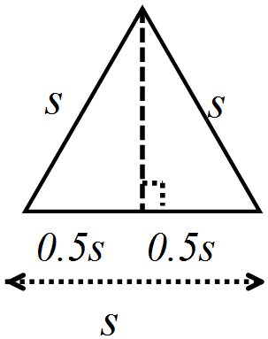 | (c)
 |  | (d)

Applications of Pythagoras’ theorem

Extended investigation Part 2: In-class validation
Solutions and marking key

Question 1
 | Solution | Marking key/mathematical behaviours | Marks
(a) | 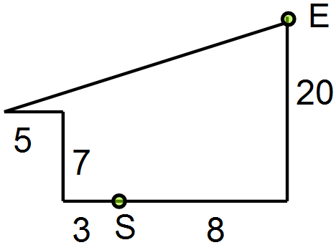 | - Indicates correct direction  - Indicates correct distances  - Diagram reflects correct order of travel, S and E marked. | 1  1  1
(b) | Tony: he has travelled 28 km compared to Jim’s 15. | - Calculates distance for each cyclist  - Relates faster speed to longer distance covered. | 1  1
(c) |  | - Determines missing lengths  - Substitutes into Pythagoras’ theorem  - Calculates using Pythagoras’ theorem | 1  1  1

Question 2
Solution | Marking key/mathematical behaviours | Marks
Top triangle  Bottom triangle  Total string = (64.03+126.49)×2  = 381.04 cm | - Substitutes into Pythagoras’ theorem  - Calculates using Pythagoras’ theorem  - Substitutes into Pythagoras’ theorem  - Calculates using Pythagoras’ theorem  - Calculates perimeter | 1  1  1  1  1

Question 3
 | Solution | Marking key/mathematical behaviours | Marks
(a) | 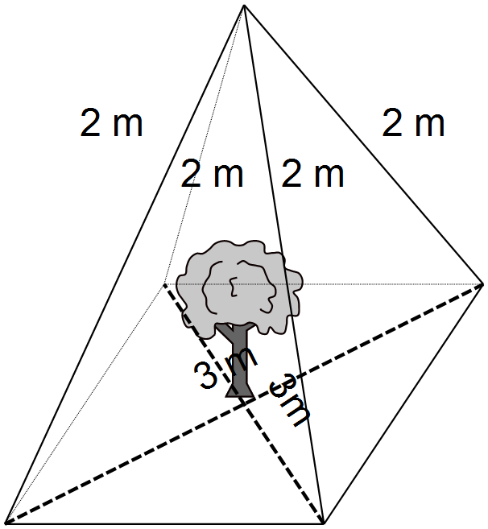 | - Correctly labels distance to stake  - Labels length of stakes | 1  1
(b) |  | - Substitutes into Pythagoras’ theorem  - Calculates using Pythagoras’ theorem | 1  1
Question 3 (cont’d)
(c) |  | - Substitutes into Pythagoras’ theorem  - Calculates using Pythagoras’ theorem | 1  1
(d) |  | - Identifies the area as a square  - Calculates area using value from (c) | 1  1

Question 4
Solution | Marking key/mathematical behaviours | Marks
 | - Calculates height of triangle with x  - Calculates width of triangle with x  - Substitutes into Pythagoras’ theorem  - Calculates using Pythagoras’ theorem | 1  1  1  1

Question 5
 | Solution | Marking key/mathematical behaviours | Marks
(a) |  | - Correctly determines length | 1
(b) |  | - Correctly determines length | 1
(c) |  | - Substitutes each value correctly into Pythagoras’ theorem | 1  1
(d) |  | - Substitutes values into Pythagoras’ theorem | 1
(e) |  | - Adds AB and BC | 1

Question 6
 | Solution | Marking key/mathematical behaviours | Marks
(a) | 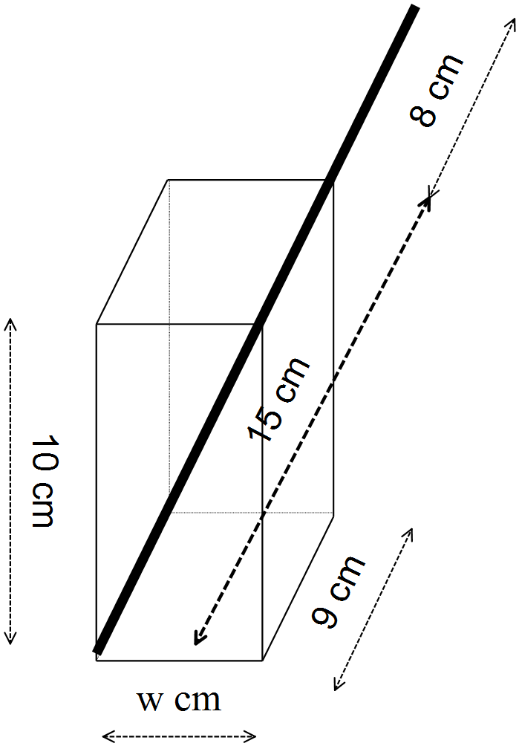 | - Draws a rectangular prism  - Labels height and length  - Labels straw sections | 1  1  1
(b) |  | - Identifies an expression for the diagonal of the base  - Identifies an expression equal to the internal hypotenuse  - Relates expressions  - Solves for w | 1  2  1  1

Question 7
Solution | Marking key/mathematical behaviours | Marks
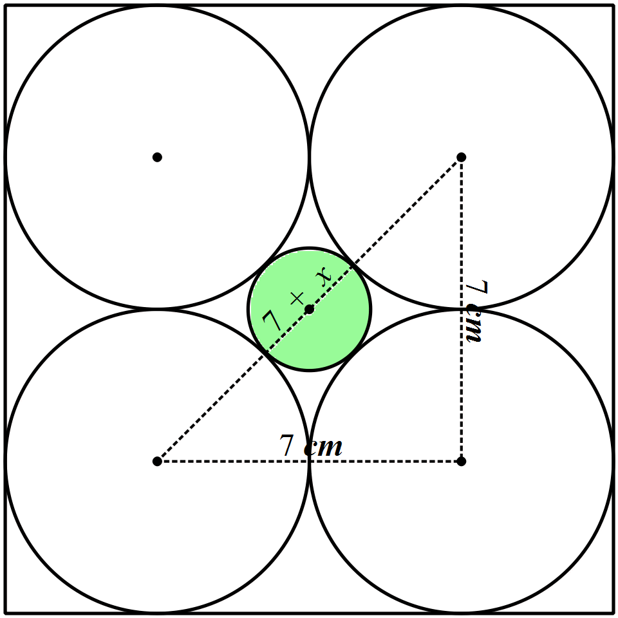  Let 7 + x = sum of both diameters  Triangle drawn has a right angle opposite 7 + x because line joining centres is parallel to the rectangular box. | - Determines an expression for the radius of the small cylinder  - Justifies existence of right-angles triangle  - Substitutes into Pythagoras’ theorem  - Calculates 7 + x  - Determines width of small cylinder | 1  1  1  1  1

TASK 8: EFFECTS OF SCALING ON VOLUME

In-class investigation

Unit 1

Topic 1.3: Shape and measurement

Course-related information

The concepts and skills developed in this investigation relate to the following dot points within the WA Mathematics Applications syllabus:
1.3.3 calculate the volumes of standard three-dimensional objects, such as spheres, rectangular prisms, cylinders, cones, pyramids and composites in practical situations, for example, the volume of water contained in a swimming pool
1.3.8 obtain a scale factor and use it to solve scaling problems involving the calculation of the areas of similar figures and surface areas and volumes of similar solids

This task provides opportunities for students to calculate volumes and to determine patterns in the scale factors among the values they have calculated and in those provided. The students are asked to apply reasoning skills to explain these patterns and to communicate their solutions and strategies

Background information

The mathematical skills and understandings that students would need for this task should have been covered in earlier years. Given appropriate formulae, students should be able to calculate the volumes of cubes, spheres and cylinders.

Task conditions

For this task students would need access to calculators. No student notes are required; formulae are provided.

EFFECTS OF SCALING ON VOLUME : IN-CLASS INVESTIGATION
In this task the effects of changing dimensions on the volumes of 3-dimensional shapes are examined.
Formulae which may be useful: cube , sphere , cylinder

Question 1 (12 marks)
(a) Complete the tables below. (7)

Volumes of cubes
Length of side (cm) | Volume (cm³) | Side doubled (cm) | New volume (cm³) | Scale factor
1 | 1 | 2 | 8
2 | 8 | 4
3 | 27 | 6 | 216 | 8
4 | 64 | 8
5 | 125 | 10

Volumes of spheres
Radius (cm) | Volume (cm³) | Radius doubled (cm) | New volume  (cm³)
1 | = 4.2 | 2
2 | = 33.5 | 4 | = 268.1
3 | = 113.1 | 6
4 | = 268.1 | 8 | = 2144.7
5 |  | 10 | = 4188.8

(b) How many times as large (the scale factor) is the volume of a cube after its sides are doubled? Justify your answer. (2)

(c) If a cube has a volume of 3375 cm³ and its sides are then doubled, what is the new volume? (1)

(d) What is the effect on the volume of a sphere when the radius is doubled? (1)

(e) If a spherical balloon has a volume of 14 137 cm³ and is deflated so that its diameter is halved, what will be the new volume? (1)

Question 2 (13 marks)

(a) Complete the table, rounding values to the nearest whole number. (5)

Volume of a cylinder
Radius  (cm) | Height  (cm) | Volume (cm³) | Radius doubled (cm) | New volume (cm³) | Scale  factor
1 | 10 | 31 | 2
2 | 10 | 126 | 4 | 503
3 | 10 | 283 | 6 | 1131
4 | 10 | 503 | 8 | 2011
5 | 10 |  | 10 | 3142

(b) How many times as large is the volume of the cylinder when the radius is doubled and the height is kept at 10 cm? Give your answer to the nearest whole number and show how you determined the value. (2)

(c) Consider the situation where both the height and radius are doubled as shown in the table below. Values have been rounded to the nearest whole number.
What happens to the volume of a cylinder when both the radius and the height are doubled? Give reasonable evidence to support your conclusion. (3)

Volume of a cylinder
Radius  (cm) | Height  (cm) | Volume (cm³) | Radius doubled (cm) | Height  doubled  (cm) | New volume (cm³)
3 | 10 | 283 | 6 | 20 | 2262
3 | 20 | 565 | 6 | 40 | 4523
3 | 30 | 848 | 6 | 60 | 6786
5 | 10 | 785 | 10 | 20 | 6283
5 | 20 | 1571 | 10 | 40 | 12 566
5 | 30 | 2356 | 10 | 60 | 18 850
7 | 10 | 1539 | 14 | 20 | 12 315
7 | 20 | 3079 | 14 | 40 | 24 630
7 | 30 | 4618 | 14 | 60 | 36 945

(d) A cylindrical water tank has a volume of 14 m³. (3)
What would be the volume of a tank that was
(i) The same height but double the width?

(ii) Double the width and double the height?

Question 3 (8 marks)

The tables provided show the volumes of cubes for different side lengths.

Side (cm) | Volume (cm³) | Side trebled (cm)  (multiplied by 3) | New volume (cm³)
1 | 1 | 3 | 27
2 | 8 | 6 | 216
3 | 27 | 9 | 729
5 | 125 | 15 | 3375

Side (cm) | Volume (cm³) | Side quadrupled (cm)  (multiplied by 4) | New volume (cm³)
1 | 1 | 4 | 64
2 | 8 | 8 | 512
3 | 27 | 12 | 1728
5 | 125 | 20 | 8000

Side (cm) | Volume (cm³) | Side x 5 (cm) | New volume (cm³)
1 | 1 | 5 | 125
2 | 8 | 10 | 1000
3 | 27 | 15 | 3375
5 | 125 | 25 | 15 625

(a) By what factor is the volume changed when the sides are multiplied by
(6)
(i) 3 (ii) 4 (iii) 5

(iv) 10 (v) 0.5 (vi) k

(b) A cubic crate has a volume of 4.096 m³. What is the volume of another cubic crate with sides a quarter of the length of the sides of the first crate?

(2)
Question 4 (8 marks)

The tables provided show the volumes of spheres for different radii. Values have been rounded to the nearest tenth.

Radius (cm) | Volume (cm³) | Radius trebled (cm) | New volume (cm³)
1 | 4.2 | 3 | 113.1
2 | 33.5 | 6 | 904.8
3 | 113.1 | 9 | 3430.6
5 | 523.6 | 15 | 14 137.2

Radius (cm) | Volume (cm³) | Radius quadrupled (cm) | New volume (cm³)
1 | 4.2 | 4 | 268.1
2 | 33.5 | 8 | 2144.7
3 | 113.1 | 12 | 7238.2
5 | 523.6 | 20 | 33 510.3

Radius (cm) | Volume (cm³) | Radius x 5 (cm) | New volume (cm³)
1 | 4.2 | 5 | 523.6
2 | 33.5 | 10 | 4188.8
3 | 113.1 | 15 | 14 137.2
5 | 523.6 | 25 | 65 449.8

(a) By what factor is the volume changed when the radius is multiplied by
(6)
(i) 3 (ii) 4 (iii) 5

(iv) 10 (v) 0.1 (vi) k

(b) A spherical gas balloon has a volume of 195.43 m³. What will be the volume of the balloon if it deflates so that the radius is a third of the original length? (2)

Question 5 (9 marks)

(a) Use algebra and the volume formulae (cube , sphere and cylinder ) to show (7)

(i) the change to the volume of a cube when the side is multiplied by k.

(ii) the change to the volume of a sphere when the radius is multiplied by k.

(iii) the change to the volume of a cylinder when the radius is multiplied by k and the height is multiplied by t.

(b) What do your answers to Part (a) of Question 5 suggest about your answers to the previous questions? (2)

End of questions
Effects of scaling on volume

Solutions and marking key

Question 1
 | Solution | Marking key/mathematical behaviours | Marks
(a) | Cubes  Column 4: 64,  Column 4: 512, 1000  Column 5: Each missing value is 8  Spheres  = 33.5 for radius of 2  = 904.8 for radius of 6  = 523.6 for radius of 5 | - Copies volume provided  - Calculates volume  - Divides volumes accurately (1 if 1 wrong)  - Recognises, copies pattern  - Determines correct cubes  - Calculates volumes correctly | 1  1  2  1  1  1
(b) | 8  8 ÷ 1 or 64 ÷ 8 etc.. | - Identifies 8 as the answer  - Shows correct calculation | 1  1
(c) | 27 000 cm³ | - Applies scale factor from (c) | 1
(d) | It is eight times as large | - Identifies 8 as the factor | 1
(e) | 1767.125 cm³ | - Divides by scale factor | 1

Question 2
 | Solution | Marking key/mathematical behaviours | Marks
(a) | Column 5: 126  Column 3: 785  Column 6: Each missing value is 4 | - Copies volume provided  - Calculates volume  - Divides volumes accurately (1 if one wrong)  - Rounds to nearest whole | 1  1  2  1
(b) | 4  503 ÷ 126 or 1131 ÷ 283 etc.. | - Identifies 4 as the answer  - Shows a correct calculation | 1  1
(c) | It is eight times as large  2262 ÷ 283 = 7.99...  4523 ÷ 565 = 8.00 ... | - Identifies 8 as the factor  - Selects values from correct cells  - Uses division to calculate answer | 1  1  1
(d) | (i) 56 m³  (ii) 112 m³ | - Multiplies by 4 for (i)  - Multiplies by 8 for (ii)  - Provides correct units | 1  1  1

Question 3
 | Solution | Marking key/mathematical behaviours | Marks
(a) | (i) 27 (ii) 64 (iii) 125  (iv) 1000 (v) 0.125 (vi) k³ | - Recognition of pattern of scale factors  - Uses pattern to cube the factor by which the sides are multiplied | 2  4
(b) | 4.096 x 0.015625 = 0.064 m³  or 4.096 ÷ 16 = 0.064 m³ | - Determines scale factor  - Multiplies by scale factor | 1  1

Question 4
 | Solution | Marking key/mathematical behaviours | Marks
(a) | (i) 27 (ii) 64 (iii) 125  (iv) 1000 (v) 0.001 (vi) k³ | - Recognition of pattern of scale factors  - Cubes the factor by which the sides are multiplied | 2  4
(b) | 195.43 ÷ 27 = 7.24 m³ | - Determines scale factor  - Adjusts volume using factor | 1  1

Question 5
 | Solution | Marking key/mathematical behaviours | Marks
(a)  (i)  (ii) |  | - Generates an algebraic expression for the new volume  - Demonstrates that the new volume is k³ the size of the original volume | 1  1
 |  | - Generates an algebraic expression for the new volume  - Demonstrates that the new volume is k³ the size of the original volume | 1  1
(iii) |  | - Generates an algebraic expression for the new volume  - Demonstrates that the new volume is k² t the size of the original volume | 1  1
(b) | Algebra can be used to provide evidence for, and the scale of, changes to volume when the dimensions are altered. | - Indicates algebra provides further evidence of the effect of scaling  - Indicates the factor of change alone determines the change to the volume | 1  1

TASK 9

Investigative questions

Unit 1

Topic 1.3: Shape and measurement

Course-related information

The concepts and skills developed in these investigative questions relate to the following dot points within the WA Mathematics Applications syllabus:
1.3.1 use Pythagoras’ theorem to solve practical problems in two dimensions and for simple applications in three dimensions
1.3.2 solve practical problems requiring the calculation of perimeters and areas of circles, sectors of circles, triangles, rectangles, parallelograms and composites
1.3.6 use the scale factor for two similar figures to solve linear scaling problems

Background information

Students should have studied the topic of Shape and measurement and are expected to apply their learning. They will need to decide how to solve these problems and should be provided with a general formula sheet rather than be given further formulae within these questions.

Task conditions

These questions are independent of each other and are written so that they may be incorporated into a test or examination. Student access to a graphical/CAS calculator is assumed. The time required to complete each question is left to the discretion of the teacher but the intention is that each question may be completed within 15 minutes. Students should be provided with formulae sheets containing the Pythagoras’ formula.

Investigative questions for Topic 1.3

Question 1 (8 marks)

When travelling by air, some destinations specify luggage limitations in linear measurements rather than weight. This is defined as
linear measurement = width + height + depth.
For one airline the maximum linear measurement is 158 cm for any one piece of luggage.
(a) Which of the following pieces of luggage satisfy this requirement?
Show working to justify your conclusion. (4)
(i) A case which is 60 cm wide, 40 cm deep and 40 cm long.

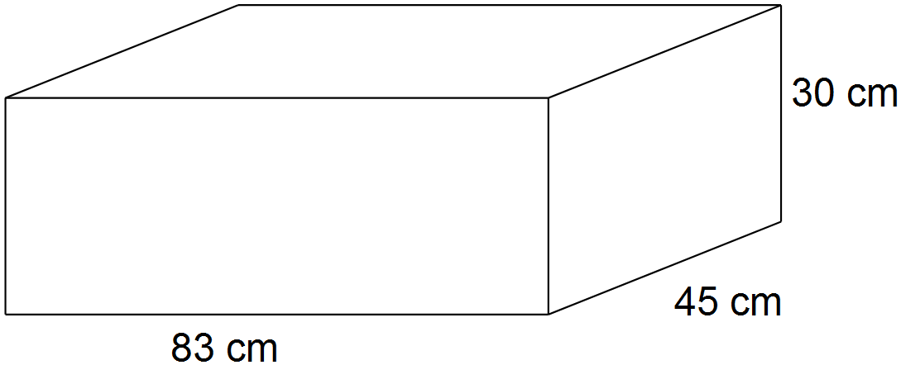 (ii) A case represented by the following drawing.

(iii) A bag which has the shape of a cylinder, is 1.09 m long and has a diameter of 0.25 m.

(b) Brett was looking at a selection of cylindrical bags in the shop. They were all 0.88 metres in length. What could be the maximum width of these bags that would satisfy this luggage limitation? (2)

(c) Will all items of luggage with a linear measurement of 158 cm have the same capacity? Provide mathematical evidence to support your answer. (2)

Question 2 (8 marks)

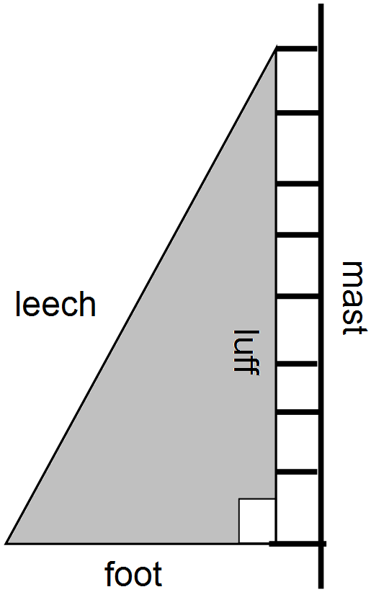The diagram on the right shows a triangular sail attached to the mast of a yacht. The luff of this sail is always perpendicular to the foot; the third side of the sail is called the leech.

When hoisting (raising) or lowering the sail, it can appear as shown in the series of diagrams provided below.

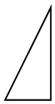 A B C D

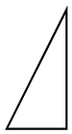

When the sail is fully raised (as in diagram D), the foot is 7 m in length and the luff is 24 m in length

(a) Calculate the length of the leech. (2)

(b) Calculate the area of the sail. (1)

(c) Lowering the sail from stages D to C results in the foot in C being 0.8 times the length of the foot in D.

(i) What will be the length of the foot in C?

(ii) Will the luff and the leech in C also be 0.8 times their previous lengths?
Justify your conclusion. (4)

(d) Each time the sail is lowered (D to C to B to A) the foot is 0.8 times the length of the foot at the previous stage. If the area of the sail needs to be decreased, which of these movements will reduce the area of the sail to 0.64 times the area of the previous stage? Circle the correct answer. (1)

D to C D to B D to A

Question 3 (10 marks)

A confectioner is investigating covering different sizes and shapes of nougat with a thin layer of chocolate. He has produced the following table showing the surface area of different shapes.

Surface area of shapes (cm²)
 | length of height and side (cm) | 2 | 4 | 6 | 8 | 10
 | length of radius of circular faces (cm) | 1 | 2 | 3 | 4 | 5
Shape | Surface area formulae
cube |  | 24.0 | 96.0 | 216.0 | 384.0 | A
sphere |  | 12.6 | 50.3 | 113.1 | 201.1 | 314.2
cylinder |  | 18.8 | 75.4 | 169.6 | 301.6 | B
cone |  | 10.2 | 40.7 | 91.5 | 162.7 | 254.2
square-based pyramid |  | 12.9 | 51.8 | 116.5 | 207.1 | C

Note:
- In the formulae, r is the radius length, s is the length of the side and h is the perpendicular height.
- For all shapes the perpendicular height is equal to the length of a side (s).

(a) Calculate the missing surface areas represented by A, B and C. (5)

(b) For shapes with the same height and width, (3)

(i) which shape has the greatest surface area?

(ii) place the shapes in ascending order of surface area.

(iii) which shape should be chosen to minimise the covering required?

(c) The sphere and the square-based pyramid have approximately the same surface area when they have the same height and width. If they both cost the same amount, would they represent approximately equal value for the money charged? Explain your conclusion. (2)

Investigative questions in Topic 1.3
Solutions and marking key

Question 1
 | Solution | Marking key/mathematical behaviours | Marks
(a) | (i) 60 + 40 + 40 = 140 yes  (ii) 83 + 45 + 30 = 158 yes  (iii) 1.09 + 0.25 + 0.25 = 1.59 m no | - Calculates using numbers in description  - Calculates using numbers from diagram  - Uses diameter for width and height  - Adds m and relates to cm to draw conclusion | 1  1  1  1
(b) | (1.58 – 0.88) ÷ 2 = 35 cm | - Calculates total width + height  - Calculates width | 1  1
(c) | No, volumes will differ | - States volumes will differ  - Provides volumes of two shapes with identical linear measurements | 1  1

Question 2
 | Solution | Marking key/mathematical behaviours | Marks
(a) |  | - Substitutes in Pythagoras’ theorem  - Calculates length of hypotenuse | 1  1
(b) |  | - Calculates area of triangle | 1
(c) | (i)  (ii) Yes  The triangles formed when the sail is lowered are similar.  The angle between the leech and the luff is not altered nor is the right angle between the foot and the luff. | - Calculates length of foot  - States agreement with statement  - Identifies similar triangles  - Explains why triangles are similar | 1  1  1  1
(d) | D to C | - Selects correct change to area | 1

Question 3
 | Solution | Marking key/mathematical behaviours | Marks
(a) | A  B  C | - Uses SA formula for cube  - Selects radius = 5  - Uses SA formula for cylinder  - Selects s = 10  - Uses SA formula for square-based pyramid | 1  1  1  1  1
(b) | (i) cube  (ii) cone, sphere, square-based pyramid, cylinder, cube  (iii) cone | - Identifies pattern of greatest surface area  - Identifies pattern of order of surface area  - Associates minimum surface area with lowest. | 1  1  1
(c) | No. The volumes will differ and the one with the greater volume will be better value for money because you are getting more nougat. | - Considers different volumes.  - States the one with the greater volume will provide better value for money. | 1  1

TASK 10: STATISTICAL INVESTIGATIONS

Extended investigation

Unit 2

Topic 2.1: Univariate data analysis and the statistical investigation process

Course-related information

This extended investigation provides an opportunity to address the skills and understandings that students should develop in their coverage of dot points 2.1.1-2.1.5 within the WA Mathematics Applications syllabus. Further work on these concepts during class time would be necessary to support the consolidation of such learning.

2.1.1 review the statistical investigation process; identifying a problem and posing a statistical question, collecting or obtaining data, analysing the data, interpreting and communicating the results
2.1.2 classify a categorical variable as ordinal, such as income level (high, medium, low) or nominal, such as place of birth (Australia, overseas) and use tables and bar charts to organise and display data
2.1.3 classify a numerical variable as discrete, such as the number of rooms in a house, or continuous, such as the temperature in degrees Celsius
2.1.4 with the aid of an appropriate graphical display (chosen from dot plot, stem plot, bar chart or histogram), describe the distribution of a numerical data set in terms of modality (uni or multimodal), shape (symmetric versus positively or negatively skewed), location and spread and outliers, and interpret this information in the context of the data
2.1.5 determine the mean and standard deviation of a data set using technology and use these statistics as measures of location and spread of a data distribution, being aware of their limitations

Task conditions

Class time should be allocated for this investigation: students will need to collaboratively decide on the processes of data collection, prepare data displays and share results with other class members. Findings could be shared by oral presentations or by using visual (movie or poster) media. A period of 2-3 weeks could be set aside for a combination of this preparation and other related activities during class time.

Students could bring a page of notes summarising the findings of the class investigations to the in-class validation.

Solutions are not provided for the preparation activities.
Statistical investigations

Extended investigation Part 1: Preparation activities

For all of these activities students are expected to work collaboratively to;
- Identify all data displays appropriate for the data collected
- Present their findings in at least one appropriate data display
- Identify which statistics are not appropriate in the situation
- Share their findings with the other students in the class

For Activity 1 and Activity 2, students will also need to:
- Sample the population indicated
- Choose and calculate relevant statistics

Activity 1
Plan and carry out an investigation to answer one of the following questions.
1. What are the most popular drinks sold at the canteen during lunchtime?
2. What is the least popular subject chosen by Year 11 students at our school?
3. By what means of transport do our Year 11 students arrive at school?
4. What is the most popular holiday destination for staff in our school?
5. What is the most popular Saturday morning activity for students in Year 11?

Investigating categorical data is the focus for this activity. You will need to decide which data to collect and determine the categories in which the data belong. The numbers in each category are to be compared during this investigation.

Activity 2
Select one of the following questions and once you have clarified the question, collect data from a random sample of 50 Year 11 students. Prepare a summary of your data by calculating relevant statistics and preparing two different data displays.
1. On how many days did you watch television last week?
2. How many texts did you receive yesterday?
3. On how many days did you buy food from the canteen in the last fortnight?
4. How many hours of paid work have you done in the past week? [to the nearest hour]
5. How many different sporting grounds have you been to in Perth?

What type of data will be collected in each of these situations?
The data collected could be used to suggest answers to simple problems
e.g., How many different sporting grounds have been visited by students in Year 11?

Identify three such problems for which your data could indicate the solution.

Activity 3
Some students were given a selection of problems to solve. Five groups each chose a different problem and then in each group the students devised one question to clarify their problem. The questions from each of the five groups are given below.

1. What was the total rainfall in Sydney for each month of the last four years?
2. What was the relative humidity in Brisbane at 9 am each day of the last two months?
3. What were the wind-gust speeds every half hour in Adelaide yesterday?
4. What were the minimum temperatures in Melbourne each month for last four years?
5. What were the maximum temperatures each day in January and February in Hobart last year?

Select one of the questions and use the internet to collect the data indicated.
The Australian Bureau of Meteorology website would have the data for each question.

What type of data have you collected?
Calculate the mean, range and standard deviation.
Draw a histogram to represent the data.
What conclusions can you draw from the data display?

Summary

After investigating students should:

1. Know and be able to use the following terms

categorical ordinal nominal discrete continuous
modality bimodal unimodal multimodal outlier
skew (positive and negative)
symmetric distribution
statistical investigation process

2. Construct and interpret the following data displays

bar charts tables dot plots stem plots histograms

3. Calculate and interpret the following statistics

mean mode median range standard deviation

Statistical investigations

Extended investigation Part 2: In-class validation (42 marks)

Question 1 (6 marks)
Complete the table by identifying the data described in the first column as being either numeric or categorical.
If the data is numerical, then classify it as discrete or continuous in the third column.
If the data is categorical then classify it as ordinal or nominal in the third column.

Data | Numeric  Or  Categorical | If numeric then discrete or continuous  If categorical then ordinal or nominal
On the meteorology website there is a bar indicating the amount of rain on the radar. The bar is white or blue if the rain is light, green or yellow if the rain is moderate and red if the rain is heavy.
For the athletics carnival, a three-letter code is written on each student’s hand for identification purposes. The codes are allocated at random and no two students have the same code.
Annie is investigating water storage and has decided to collect data to determine the number of dams in each state.
Plants are affected by the amount of sunshine (hours) each day so Max has collected sunrise and sunset times and calculated the differences.
The air pressure (hectoPascals) is also available on the meteorology website and two readings that Jon wrote down were 1017.0 and 1016.4
Lee was travelling in remote areas of Australia and collecting data from each weather station to see how often each day the local resident was recording the observations.
Before Tim goes sailing on Sunday, he checks the direction of the wind speed which can be E, NE, W, SW, etc..

Question 2 (7 marks)

(a) Nat is trying to decide which player to drop from the team for the finals. She goes through the investigation process which consists of the following steps. The steps are out of order. Using the letters in front of these steps, write down the appropriate order. (2)
A Nat prepares a column graph and plots the percentage of games won for each player.
E Nat goes to the web and locates the number of games won and lost each week for each player.
G Jacki is dropped from the team.
K Nat discovers the presence of an outlier; a player with a much lower percentage than all the other players.
N Nat calculates the ratio of games won to games lost for each player
S For each player Nat determines the games won as a percentage of games played.
T Nat decides to look at the number of games that the players have won and lost each week.

------- ------ ------ ------ ------ ------ ------

(b) For each set of data described, circle the best type of display to represent the data. (5)

Data set | Display 1 | Display 2
Jody had been investigating favourite ice cream flavours for the students in her class and had collected numbers of students favouring five different types of ice cream. | bar chart | stem plot
Shoe sizes for the 32 Year 8 students were one of the following sizes: 6, 6.5, 7, 7.5, 8 and 8.5. Data was collected for all the students in the class | stem plot | dot plot
The incomes of the basketball players in the local league, about 100 players in all, were recorded so that an interstate comparison could be made. | histogram | bar chart
Ruby collected data on rainfall. She has the total rainfall data for each month for the last 100 years. | histogram | dot plot
Toby had to prepare a display to show the heights of the 15 students in his Year 11 Maths class | histogram | stem plot
Question 3 (9 marks)

Some people travelling to a concert were arguing about the number of roundabouts they had to pass so Ben started counting the types of intersections they went through.
He classified the intersection as a roundabout (regardless of any other signs), a give way (only give-way signs and no other) or a stop.

His results for the next 20 intersections are shown in the diagram below.

Give way  60% | Roundabout  30% | Stop  10%

(a) This is categorical data. (4)
(i) Is the data ordinal or nominal? Explain your choice of answer.

(ii) State the number of categories.

(ii) Name each of the categories

(b) Show another display to represent these data. (3)

(c) What feature of the diagram given would make it an accurate representation of the data that Ben collected? (1)

(d) Ben then calculated the mean of the types of intersections as follows: (1)
What does this value represent?

Question 4 (9 marks)

The dot plot provided shows the mental maths scores for the 32 students in Year 7.

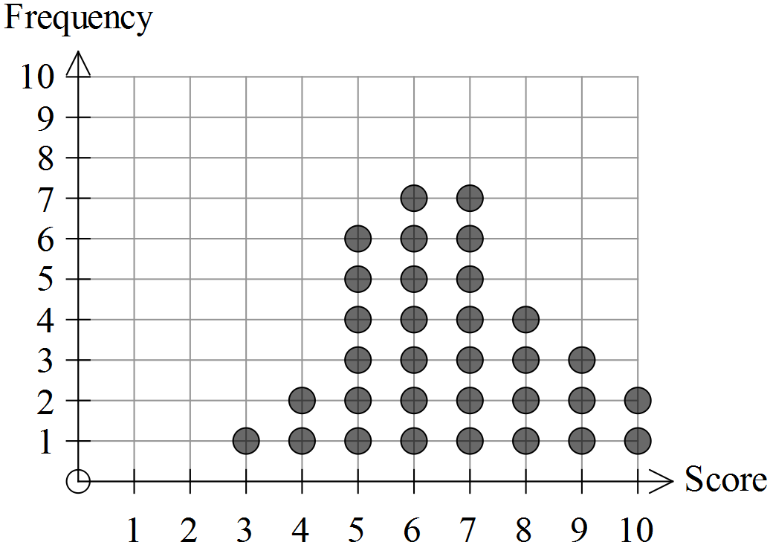

(a) For this data set, state the (2)

(i) maximum score.

(ii) median score.

(b) Describe the mode of this distribution. (2)

(c) How many students scored less than 5? (1)

(d) What statistic can be calculated using the following process? (1)

(e) Describe the shape of the distribution and comment on the success of the students with their mental maths skills. (3)

Question 5 (11 marks)

The histograms provided show the daily solar exposure (MJ per m²) at weather stations in Darwin and Canberra for 2013. The total solar energy was determined for each day of the year for both capital cities. [Data obtained from the website of the Australian Bureau of Meteorology]

Canberra
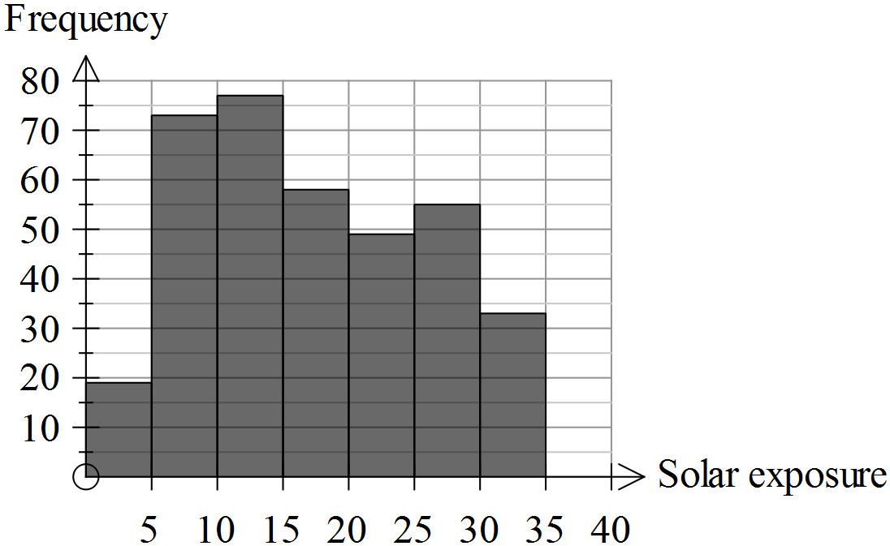

Darwin
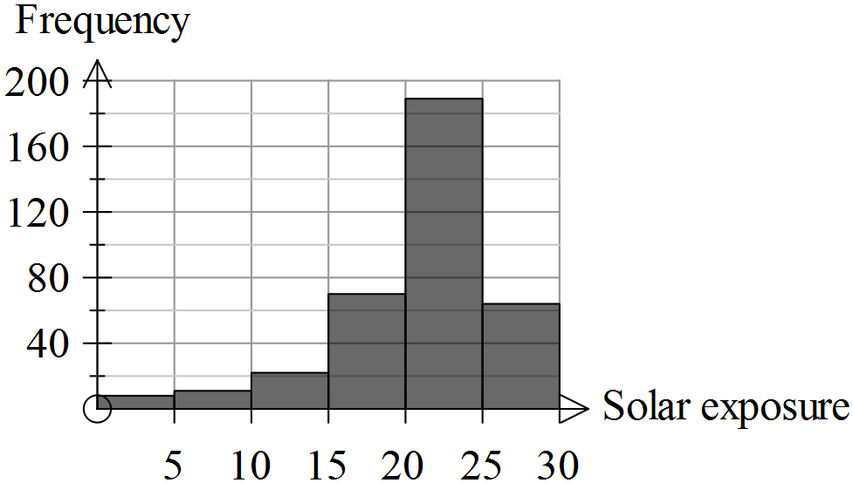

For both cities the readings were expressed to 1 decimal place and were grouped in 5 MJ intervals.

(a) Approximate the number of readings in each of these groups for the city of Darwin and enter these in the table provided. (2)

Solar exposure (MJ per m²) | Frequency (days)
0 – 4.9
5 – 9.9
10 – 14.9
15 – 19.9
20 – 24.9
25 – 29.9
(b) Which city had the highest reading for solar exposure? (2)
Justify your selection.

(c) For which city would the standard deviation be lower? (2)
Justify your selection.

(d) For which city would the mean be higher? (2)
Justify your selection

(e) Describe the shape of the data distribution for Darwin. (3)

End of questions

Statistical investigations

Extended investigation Part 2: In-class validation
Solutions and marking key

Question 1
 | Solution | Marking key/mathematical behaviours | Marks
(a) | Categorical – ordinal  Categorical – nominal  Numeric – discrete  Numeric – continuous  Numeric – continuous  Numeric – discrete  Categorical - nominal | Selects numeric or categorical correctly for:  - all seven  - five or six  - three or four  Selects discrete, continuous, ordinal or nominal correctly for  - all seven  - five or six  - three or four | 3  2  1  3  2  1

Question 2
 | Solution | Marking key/mathematical behaviours | Marks
(a) | T E N S A K G or  T E S N A K G | Lists events in correct order  [1 mark if one out of order] | 2
(b) | Bar chart Dot plot Histogram Histogram Stem plot | Identifies most appropriate graph in the each situation | 5

Question 3
 | Solution | Marking key/mathematical behaviours | Marks
(a) | (i) nominal  They are not in order of size or importance etc... They are named  (ii) 3  (iii) Give way, roundabout, stop | - Indicates (1) and justifies type of categorical data  - States number of categories  - Names categories | 2  1  1
(b) |  | - Provides categories  - States frequencies  - Represents categories and frequencies accurately in a table or graph | 1  1  1
(c) | The sections are in proportion to their frequencies | Understands the importance of scale | 1
(d) | It does not represent anything useful | Identifies mean for categorical data is not appropriate | 1

Question 4
 | Solution | Marking key/mathematical behaviours | Marks
(a) | (i) 10  (ii) 6.5 | - Identify maximum score  - Determines the median | 1  1
(b) | Bi-modal. 6 and 7 have equal (and maximum) frequencies | - Identifies bi-modal  - States the mode(s) | 1  1
(c) | 3 | - Determines frequency | 1
(d) | Mean | - Identifies process for calculating mean | 1
(e) | Skewed negatively – most students score 5 or more, very few below 5  Hard to determine success unless you know what the test is out of.  (No outliers)  (Not symmetric) | - Identifies data is skewed  - Identifies direction of skew  - Recognises success depends on maximum score possible (cf achieved) | 1  1  1

Question 5
 | Solution | Marking key/mathematical behaviours | Marks
(a) | Solar exposure (MJ per m²) Frequency (days)  0 – 4.9 8  5 – 9.9 12  10 – 14.9 21  15 – 19.9 70  20 – 24.9 190  25 – 29.9 62 | - Approximates 6 values  - Approximates no more than 4 values (1) | 2
(b) | There are data in the 30-35 class for Canberra but not for Darwin. | - Locates maximum reading  - Compares cities | 1  1
(c) | Canberra  The data are more similar to each other but for Darwin the variation is higher | - Identifies graph with lower standard deviation  - Explains why the deviation is lower | 1  1
(d) | Darwin  About two thirds of the readings are over 20 but for Canberra only about one third are over 20. | - Identifies graph with lower mean  - Justifies choice of city | 1  1
(e) | Skewed negatively  Unimodal / One class has very high proportion of readings | - Identifies data is skewed  - Identifies direction of skew  - Describes modality | 1  1  1

TASK 11: MAKING IT FAIR

In-class investigation

Unit 2

Topic 2.1: Univariate data analysis and the statistical investigation process

Course-related information

The concepts and skills developed in this in-class investigation relate to the following dot points within the WA Mathematics Applications syllabus:
2.1.11 compare groups on a single numerical variable using medians, means, IQRs, ranges or standard deviations, and as appropriate; interpret the differences observed in the context of the data and report the findings in a systematic and concise manner
2.1.12 implement the statistical investigation process to answer questions that involve comparing the data for a numerical variable across two or more groups; for example, are Year 11 students the fittest in the school?
This investigation will provide evidence of the students’ ability to compare data and to communicate precisely and clearly their interpretation of the data presented.

Background information

Students should have completed dot point 2.1.10 and already be familiar with the following terms: mean, median, range, first and third quartiles and interquartile range. This investigation could be undertaken as part of Topic 2.1; it is not necessary for students to have completed the topic before attempting this investigation.

Task conditions

Students should be able to complete this investigation in 40 – 50 minutes. Scientific calculators only are required and formulae sheet are not necessary.

Making it fair

In-class investigation (Total marks 50)
In this investigation the effects of various measures on students’ marks are examined.

Introduction
Two classes of 25 Year 8 students have sat the same test in Science. Class 8.1 did the test in period 1 and had 50 minutes, the recommended time. Class 8.2 started the test in period 2 and after 40 minutes the school had to be evacuated and they missed out on the last 10 minutes. The maximum number of marks any student could have achieved in the test was 50. The teachers wanted to adjust the marks so that it was fair to both classes. They marked the test, placed some statistics in the table below and then discussed various options for adjusting the marks.

Science marks for Classes 8.1 and 8.2 (out of 50)

Statistic | Class 8.1 | Class 8.2
Minimum | 20 | 15
Maximum | 48 | 41
Median | 34 | 25
Mean | 33.76 | 25.16
First quartile | 29 | 20
Third quartile | 38 | 27
Range
Inter-quartile range

Question 1 (6 marks)

(a) Complete the table. (2)

(b) On the basis of these statistics only, which class has produced a higher standard? Justify your answer. (2)

(c) Suggest a reason why the marks might need to be adjusted so that it is fairer for Class 8.2. (1)

(d) Suggest a reason why the marks should not be adjusted. (1)

Question 2 (4 marks)

(a) The first option considered was to take 10 marks off each person in Class 8.1.
Give one reason why this process would be unfair. (1)

The teachers decided they would only adjust the marks for Class 8.2. A sample of five students was chosen and the effects of the changes on their marks were examined for each adjustment suggested. The five students chosen and their marks in the test were;

Tom 41 Don 15 Sam 25 Ria 20 Fay 27

(b) Suggest two reasons why this is a good sample. (2)

(c) The second option chosen was to say that the test for Class 8.2 was only out of 40 (instead of 50) so the marks were altered and Ria’s 20 out of 50 became 20 out of 40. Would Ria be pleased with this outcome? Explain. (1)

Question 3 (7 marks)

The third option for adjusting the marks of students in Class 8.2 was to add 10 marks to each student’s mark.

(a) Why was the addition of 10 marks thought to be a fair adjustment? (1)

(b) What marks do the sample students now get? (1)

Tom
Don
Sam
Ria
Fay
(c) For the adjusted marks in Class 8.2, state the (3)

(i) range

(ii) interquartile range

(iii) mean

(d) Give two reasons why it is not appropriate to add 10 marks to each student’s score. (2)

Question 4 (7 marks)

It is suggested that as the students missed a fifth of the time for the test, then add a fifth of their marks onto the total of their original score.

(a) Show the effect of this adjustment on the sample students by completing the table below. (3)

Student | Tom | Don | Sam | Ria | Fay
Original mark | 41 | 15 | 25 | 20 | 27
One fifth of original mark
Adjusted mark
Round to the nearest whole number

(b) For the adjusted marks of the students in Class 8.2, what is the new (2)

(i) range

(ii) interquartile range

(c) Give two reasons why this method of adding a fifth of the students’ marks to their original marks is better than adding 10 marks. (2)
Question 5 (11 marks)

The fifth adjustment investigated was to multiply the marks for students in Class 8.2 by 1.25.

(a) Show the effect of this process on the sample students by completing the table below. (3)

Student | Tom | Don | Sam | Ria | Fay
Original mark | 41 | 15 | 25 | 20 | 27
Multiply by 1.25 to get new score
Gain in marks
Round new score to nearest whole number

(b) What is the range for the new scores of the students in Class 8.2? (1)

(c) Does multiplying by 1.25 give the same results as adding on one-fifth of the original marks? Justify your answer. (1)

(d) List the students in ascending order of their original marks (1)

(e) List the students in ascending order of their gain in marks (1)

(f) Compare the lists produced in parts (d) and (e). Explain the comparison. (2)

(g) Which is a fairer adjustment of the marks?

Determining a fifth and adding it on OR Multiplying by 1.25
Justify your decision (2)

Question 6 (11 marks)

The last process considered to adjust the marks was to make both class averages the same (i.e., 33.76) as the means for both classes were equal in the previous test.

(a) Determine the total of the marks for students in Class 8.2 if the mean of their marks is to be 33.76. (1)

(b) Determine the total of the marks for students in Class 8.2 before any adjustments. (1)

(c) To increase the mean for Class 8.2 to 33.76, 8.6 marks can to be added to each student’s mark. Describe two ways by which this value (8.6) could have been determined from the data available in this investigation? (3)

(d) Complete the following table using this method of adding 8.6 to adjust the score.
(3)
Student | Tom | Don
Original mark
Marks added
Percentage increase

(e) For the adjusted class data calculate the

(i) median

(ii) inter-quartile range (2)

(f) Is this process fair to the students in Class 8.2? (1)
Explain.

Question 7 (4 marks)
(a) For all options chosen complete the table provided expressing numbers to the nearest tenth where numbers are not whole numbers. (2)

Process  Student | Original marks | Add 10 to original marks | Add a fifth of the original marks | Multiply original marks by 1.25 | Add 8.6 to original marks
Tom | 41
Don | 15
Sam | 25
Ria | 20
Fay | 27

(b) Determine the best and worst options as far as these students are concerned. (2)

End of questions
Making it fair

In-class investigation
Solutions and marking key

Question 1
(a) Solution
Science marks for Classes 8.1 and 8.2 (out of 50)

Statistic | Class 8.1 | Class 8.2
Range | 28 | 26
Inter-quartile range | 9 | 7

Marking key/mathematical behaviours |  |  | Marks
- Calculates the range  - Calculates interquartile range |  |  | 1  1
 | Solution | Marking key/mathematical behaviours | Marks
(b) | Class 8.1  Mean is higher i.e.,33.76 cf 25.16 | - Determines better performance  - Justifies selection by comparing a summary statistic | 1  1
(c) | They could have earned more marks in the extra time | - Provides fair reason for adjustment | 1
(d) | If all the students had already finished | - Provides valid reason not to adjust | 1

Question 2
 | Solution | Marking key/mathematical behaviours | Marks
(a) | The decrease needs to be proportional to the achievement  The loss affects some more than others with respect to % scores | - Identifies differentiated effect on students. | 1
(b) | Contains sufficient number of students  Good variation within sample | - Identifies one or two features of representative samples | 1  1
(c) | Yes. She goes from 40% to 50%. | - Provides valid reason to explain impact on Ria | 1

Question 3
 | Solution | Marking key/mathematical behaviours | Marks
(a) | The test allowed a mark a minute and 10 minutes could give 10 marks. | - Relates 10 to test time | 1
(b) | Tom 51, Don 25, Sam 35, Ria 30, Fay 37 | - Adds 10 to original scores | 1
Question 3 (cont’d)

(c) | Range = 26  Interquartile range = 7  Mean = 35.16 | - Calculates each statistic accurately | 3
(d) | Tom is over 100%  It is unlikely that all students would have got 10 marks in the remaining time – the harder questions may have been at the end. | - States two reasons to explain why adding 10 is inappropriate | 2

Question 4

(a) Solution

Student | Tom | Don | Sam | Ria | Fay
Original mark | 41 | 15 | 25 | 20 | 27
One fifth of original mark | 8.2 | 3 | 5 | 4 | 5.4
Adjusted mark | 49.2 | 18 | 30 | 24 | 32.4
Round to the nearest whole number | 49 | 18 | 30 | 24 | 32

Marking key/mathematical behaviours | Marks
- Calculates one fifth of originals  - Adds on one fifth  - Rounds to whole number | 1  1

 | Solution | Marking key/mathematical behaviours
(b) | Range = 31.2 (or 31)  Interquartile range = 8.4 | - Calculates range  - Calculates interquartile range | 1  1
(c) | The increase varies according to student performance  Proportion of time lacking to do test is considered | - States two reasons to explain why adding a fifth is better than adding 10 | 2

Question 5

(a) Solution

Student | Tom | Don | Sam | Ria | Fay
Original mark | 41 | 15 | 25 | 20 | 27
Multiply by 1.25 to get new score | 51.25 | 18.75 | 31.25 | 25 | 33.75
Gain in marks | 10.25 | 3.75 | 6.25 | 5 | 6.75
Round new score to nearest whole number | 51 | 19 | 31 | 25 | 34

Marking key/mathematical behaviours | Marks
- Multiplies by 1.25 accurately  - Determine increase in marks  - Rounds correctly to nearest whole number | 1  1  1

Question 5 (cont’d)
 | Solution | Marking key/mathematical behaviours
(b) | 32.5 | - Calculates range of new scores | 1
(c) | No. Tom gets 49.2 when a fifth is added and 51.25 when original score is multiplied by 1.25 | - Explains why the effect is different or provides example to justify | 1
(d) | Don, Ria, Sam, Fay, Tom | - Provides student in ascending order of original marks | 1
(e) | Don, Ria, Sam, Fay, Tom | - Provides student in ascending order of gain from original marks | 1
(f) | The lists are the same because the increase is proportional to the original marks. | - Compares lists and justifies | 1
(g) | Multiplying by 1.25  Assuming 50 marks in 50 minutes then in 40 minutes to get 50 marks you need to multiply by 1.25. Adding on one fifth ony gives 48 | - Identifies correct method  - Gives mathematical argument for the method | 1  1

Question 6

 | Solution | Marking key/mathematical behaviours
(a) | 844 |  | - Determines class total | 1
(b) | 629 |  | - Determines class total | 1
(c) | (i) 33.76 – 25.16  (ii) (844-629)÷ 25 |  | - Recognises both methods to determine change in mean | 1  1
(d) | Tom Don  Original 41 15  Marks added 8.6 8.6  % increase 21% 57% |  | - Complete table with known values  - Calculates % increase for Tom  - Calculates % increase for Don | 1  1  1
(e) | Median = 25 + 8.6 = 33.6  IQR = 35.6 – 28.6 = 7 |  | - Calculates median  - Calculates IQR | 1  1
(f) | No. The % gain is much higher for Don than Tom |  | - Concludes that the process is unfair and justifies conclusion | 1

Question 7

Solution
Process  Student | Original marks | Add 10 to original marks | Add a fifth of the original marks | Multiply original marks by 1.25 | Add 8.6 to original marks
Tom | 41 | 51 | 49 | 51 | 50
Don | 15 | 25 | 18 | 19 | 24
Sam | 25 | 35 | 30 | 31 | 34
Ria | 20 | 30 | 24 | 25 | 29
Fay | 27 | 37 | 32 | 34 | 36
Marking key/mathematical behaviours |  |  |  |  |  | Marks
- Copies all data from earlier questions accurately  - Identifies best option is add 10 for all students  - Identifies worst option is adding a fifth for all students |  |  |  |  |  | 2  1  1

TASK 12

Investigative questions

Unit 2

Topic 2.1: Univariate data analysis and the statistical investigation process

Course-related information

The concepts and skills covered in these investigative questions relate to the following dot points within the WA Mathematics Applications syllabus:
2.1.5 determine the mean and standard deviation of a data set using technology and use these statistics as measures of location and spread of a data distribution, being aware of their limitations
2.1.9 calculate probabilities for normal distributions with known mean μ and standard deviation σ in practical situations
2.1.10 construct and use parallel box plots (including the use of the ‘Q1 – 1.5 x IQR’ and ‘Q3 + 1.5 x IQR’ criteria for identifying possible outliers) to compare groups in terms of location (median), spread (IQR and range) and outliers, and interpret and communicate the differences observed in the context of the data

Background information

These questions have been written in anticipation of the concepts having been previously covered in class.

Task conditions

These questions are independent of each other and are written so that they may be incorporated into a test or examination. Student access to a graphical/CAS calculator is assumed. The time required to complete each question is left to the discretion of the teacher but the intention is that each question may be completed within 15 minutes.

Question 1 (9 marks)

Four students have missed Test 5 and the teacher needs to estimate marks for these students. She decides to base the mark on the students’ earlier results and wants each test to have the same weighting. The teacher calculates as follows for each student in the class:
- Each of the Tests 1 to 4 is given a mark out of 25.
- These marks are then added to create a combined mark out of 100 for Tests 1 to 4. The student mean and the standard deviation of these combined marks are also calculated.

For the combined marks for Tests 1 to 4, the mean is 65.4% and the standard deviation is 8.2%
For Test 5, the mean is 73.2% and the standard deviation is 3.5%

As an estimate for Test 5, the missing students will receive the class mean for Test 5, plus 3.5% times their number of standard deviations above the mean of the previous four tests. This number is subtracted if they were below the mean.

Example: Sol’s combined mark was 2 standard deviations above the mean of the combined marks. Sol’s estimate mark is 73.2% + 2 x 3.5% = 80.2%

(a) Why is each of the tests (1 to 4) given a mark out of 25? (1)

(b) Chas’ combined mark was 1 standard deviation above the mean of the combined marks. His estimate mark for Test 5 was 76.7%.
Show how this is a correct estimate for Chas. (1)

(c) Lou’s combined mark was 2.5 standard deviations below the mean of the combined marks. Calculate his estimate mark for Test 5. (2)

(d) For Tests 1 to 4 Sam had the same mean as the class. (2)
Should he be given 73.2% as an estimate for Test 5? Justify your decision.

(e) Fred had a mean of 72% for Tests 1 to 4. Show how the estimate mark for Fred should be calculated. (3)

Question 2 (10 marks)

Share dividends (cents per share)
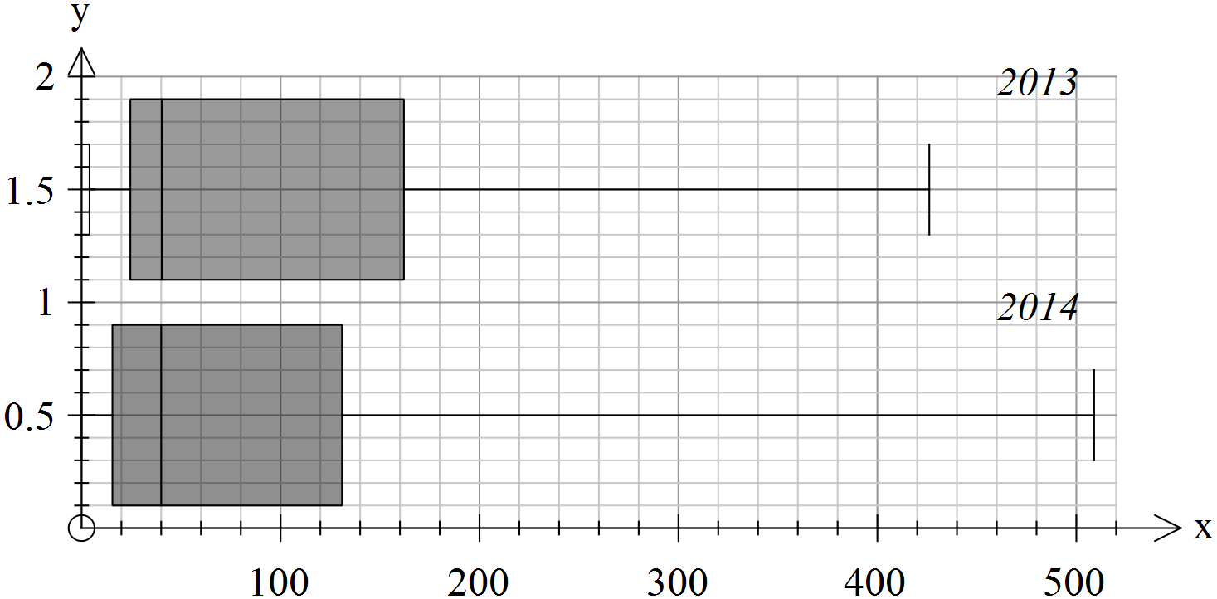

Sam’s mean for the first four tests

The box plots show the annual dividends (cents per share) for 25 companies in 2013 and 2014. The same companies are represented in each year.

For each of the statements below, state whether it is true, false or cannot be determined. Justify your conclusion by referring to evidence (including data where possible) from the box plots.

(a) The median dividend is the same for both years. (2)

(b) At least 75% of the dividends in 2013 were greater than $1 per share. (2)

(c) At least half of the dividends in 2014 were greater than $1 per share. (2)

(d) The maximum dividend in 2014 is greater than the maximum dividend in 2013. (2)

(e) There were more companies with dividends over 20c in 2014 than there were in 2013. (2)

Question 3 (10 marks)

The scores achieved on a particular test of intelligence conform to a normal distribution with a mean of 100 and a standard deviation of 15.
The table below shows the probability of a person achieving a score of intelligence within a specific range of values or outside this range.

Range of scores | Probability of being in that range | Probability of being outside that range
From 85 to 115 (100-15 to 100+15) | 0.68268949 | 0.31731051
From 77.5 to 122.5 | 0.86638560
From 70 to 130 | 0.95449974 | 0.04550026
From 62.5 to 137.5 | 0.98758067 | 0.01241933
From 55 to 145
From 47.5 to 152.5 | 0.99953474 | 0.00046526
From 40 to 160 |  | 0.00006334

(a) Complete the table by entering the probabilities correct to 8 decimal places. (4)

(b) From a population of 100 people selected at random, how many would you expect to score in the range of 85 to 115? (1)

(c) From a population of 10 000 people selected at random, how many would you expect to have a score higher than 152.5? (2)

(d) To expect to locate three people each with a score over 160, what is the minimum number of people (to the nearest thousand) that you would need to sample? (2)

(e) For every n people you can expect to find 1 with a score outside the range of 70 to 130. Determine n. (1)

Question 1
 | Solution | Marking key/mathematical behaviours | Marks
(a) | To give the tests equal weighting | - Identifies equal weightings | 1
(b) | 73.2% + 3.5% = 76.7% | - Determines addition to obtain 76.7% | 1
(c) | 73.2% - 8.75% = 64.45% | - Determines 2.5 standard deviations from the mean  - Subtracts result from mean for Test 5 | 1  1
(d) | Yes. He did not deviate from the mean (0 deviations) and the mean was 73.2% | - States agreement  - Identifies zero deviations | 1  1
(e) | 72% - 65.4% = 6.6%  6.6% ÷ 8.2=0.8048  0.8048 x 3.5%=2.817%  73.2%+2.817%~76% | - Calculates difference in means  - Determines number of deviations  - Determines marks to be added | 1  1  1

Question 2
 | Solution | Marking key/mathematical behaviours | Marks
(a) | True. In both years the median is 40c per share | - Identifies truth of statement  - Justifies conclusion | 1  1
(b) | False. Q1 is less than 30c  Medina is less than $1 | - Identifies truth of statement  - Justifies conclusion | 1
(c) | False. The cut-off for 50% was 40c. Only half were 40c or above | - Identifies truth of statement  - Justifies conclusion | 1  1
(d) | True. The right whisker is further to the right. | - Identifies truth of statement  - Justifies conclusion | 1  1
(e) | False. At least 75% were over in 2013 but Q1 was under 20c in 2013. | - Identifies truth of statement  - Justifies conclusion | 1  1

Question 3
(a) Solution
. Range of values | Probability of being in that range | Probability of being outside that range
From 85 to 115 | 0.68268949 | 0.31731051
From 77.5 to 122.5 | 0.86638560 | 0.1336144
From 70 to 130 | 0.95449974 | 0.04550026
From 62.5 to 137.5 | 0.98758067 | 0.01241933
From 55 to 145 | 0.99730020 | 0.00269980
From 47.5 to 152.5 | 0.99953474 | 0.00046526
From 40 to 160 | 0.99993666 | 0.00006334

Marking key/mathematical behaviours | Marks
- Subtracts given probability from 1  - Uses Normal distribution to calculate probability  - Calculates complement  - Subtracts given probability from 1 | 1  1  1  1

Question 3 (cont’d)
 | Solution | Marking key/mathematical behaviours | Marks
(b) | 68 | - Links population and probability to calculate | 1
(c) | 0.00046526 ÷ 2 = 0.00023263  0.00023263 x 10 000 ~ 2 | - Identifies half the probability  - Calculates number in sample | 1  1
(d) | 0.00006334 ÷ 2 = 0.00003167  To get 3 multiply by 100 000  (95 000) | - Identifies half the probability  - Determines sample size | 1  1
(e) | 1 ÷ 0.04550026 ~22 | - Identifies division by probability | 1

TASK 13: SIMILARITY AND TRIGONOMETRY

Extended investigation

Unit 2

Topic 2.2: Applications of trigonometry

Course-related information

The skills and concepts developed in this extended investigation relate to the following dot points within the WA Mathematics Applications syllabus:
2.2.2 determine the area of a triangle, given two sides and an included angle by using the rule ,or given three sides by using Heron’s rule, and solve related practical problems
2.2.3 solve problems involving non-right-angled triangles using the sine rule (acute triangles only when determining the size of an angle) and the cosine rule
2.2.4 solve practical problems involving right-angled and non-right-angled triangles, including problems involving angles of elevation and depression and the use of bearings in navigation
Students will have the opportunity to further develop their capacity to choose and use technology efficiently.

Background information

This investigation is best considered after the students have had experience using the area, sine and cosine rules and have considered similarity and scale factors. Students need to have had the opportunity to practise complex problems and have been taught to break such problems down into smaller more manageable components.

Task conditions

Students should check their answers to the preparation activities and bring their work to the in-class validation. It is assumed that students will be using technology to solve equations but they will need to show substitution into the formulae that they have chosen. Formulae sheets should be provided. Suggested time is one week for the preparation and 50 minutes for the validation.

Similarity and trigonometry

Extended investigation Part 1: Preparation activities

Activity 1
For all figures determine and record
- the lengths of all missing sides
- the size of all unmarked angles
- the area
- the three trigonometric ratios (sin, cos and tan) for each of the angles
Note: The figures provided are not drawn to scale.

Activity 2
Consider each pair of shapes: the figures A and B are similar. They have been drawn so the “corresponding” sides and angles are in corresponding positions.
What is the relationship between the corresponding sides of the two figures?
What is the relationship between the areas of the two figures?
What is the relationship between the corresponding angles of the two figures?
What are the relationships between the trigonometric ratios of the corresponding angles of the two figures?

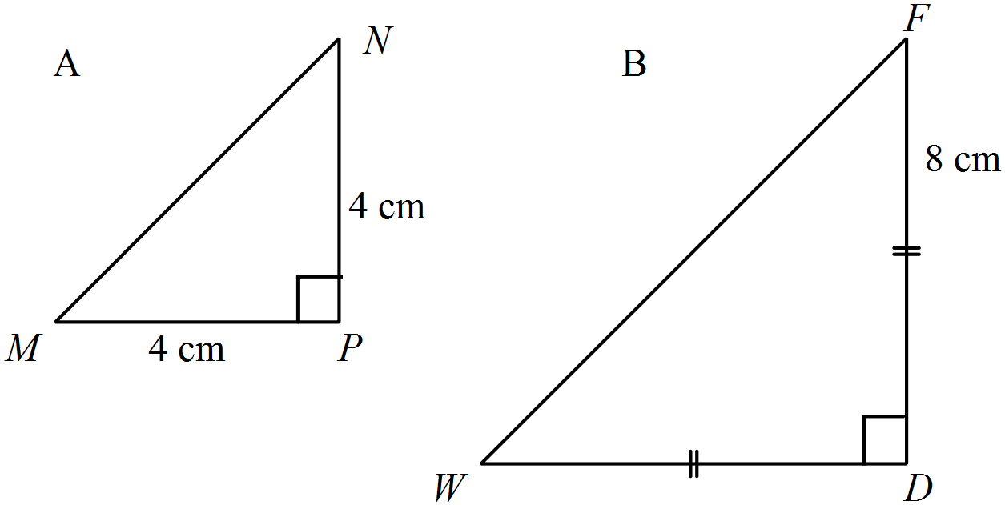1.

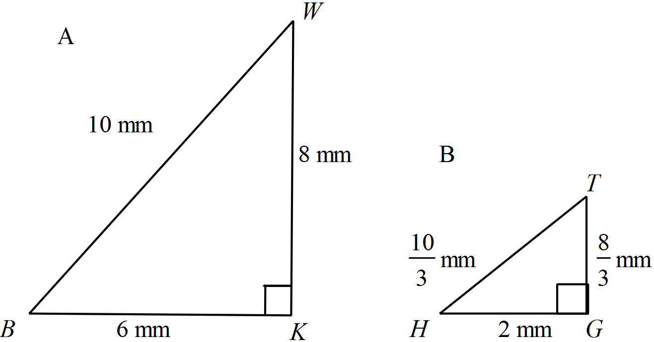2.

3.
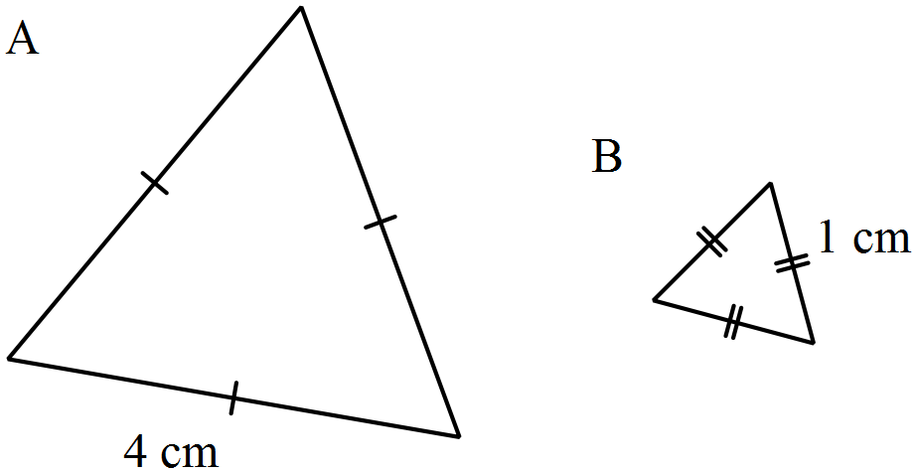

4.
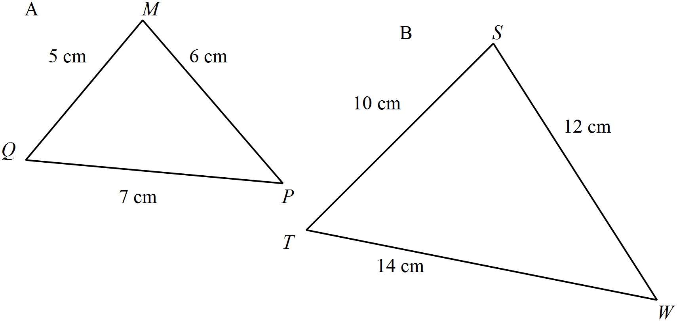

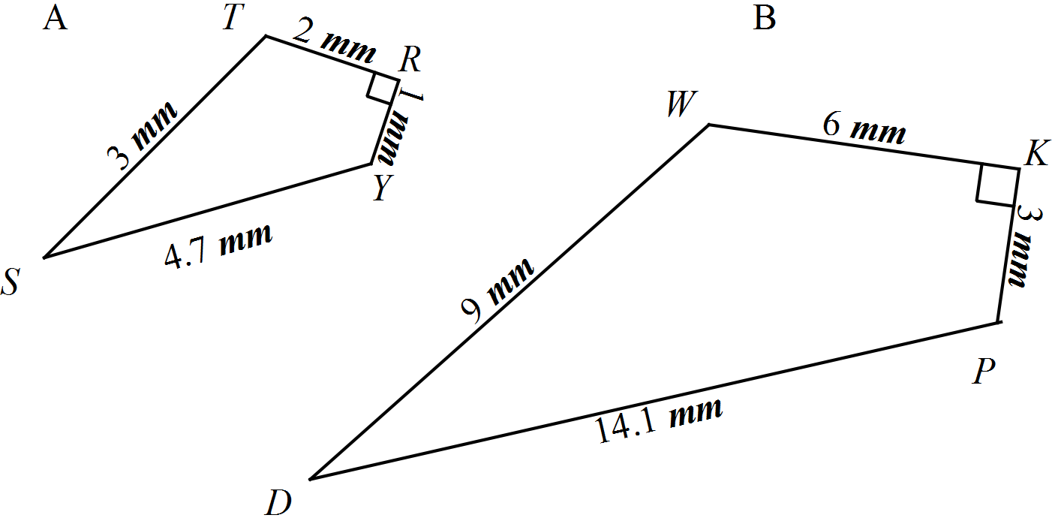5.

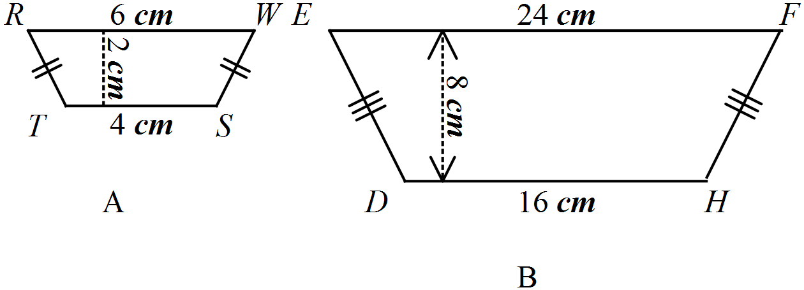6.

Similarity and trigonometry

Extended investigation Part 2: In-class validation (50 marks)

Question 1 (14 marks)
(a) Use the results from the preparation activities to complete the first six rows of the table. (7)

To determine the scale factor for sides divide the larger sides by the smaller sides.

To determine the scale factor for area, divide the larger area by the smaller area.

Express both scale factors as whole numbers

No. | Larger shape?  A or B | Scale factor for sides | Larger area | Smaller area | Scale factor for area
1 | B
2 | A
3 | A
4 | B
5 | B
6 | B
7 | B | 2 | 168.72 m² | 42.18 m²
8 | B | 3 | 170.41 m² | 18.93 m²
9 | B | 4 | 437.3 m² | 27.33 m²

(b) Complete the last three rows of the table. (3)

(c) What appears to be the scale factor for area when (2)
(i) the sides are doubled

(ii) the sides are tripled

(iii) the sides are increased four times their original lengths

(d) What would be the scale factor for area when the scale factor for the sides is 7?
(1)
(e) What would be the scale factor for area when the scale factor for the sides is k?
(1)
Deb and Al design garden beds and playgrounds for backyards and for local parks. They use a variety of shapes and sizes and are interested in knowing about the areas of the garden beds so that they can calculate the required amounts of fertiliser and soil. Some of their designs are pictured below and none of them is drawn to scale.

Question 2 (7 marks)
There are three rules that Deb and Al could use for calculating the area of a triangular-shaped garden bed. For the following triangle, show the use of substitution into all three rules for calculating area.

1. Rule using trigonometry
2. Rule to use when height is known
3. Heron’s rule
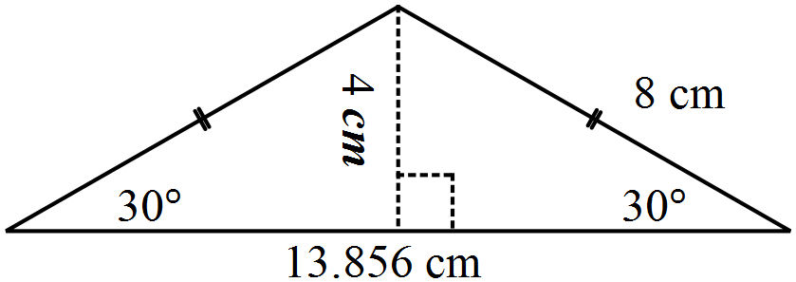

Question 3 (14 marks)
(a) Show how to use Heron’s rule to confirm that the area of the children’s playground shown in this diagram is 18.9 m². (10)
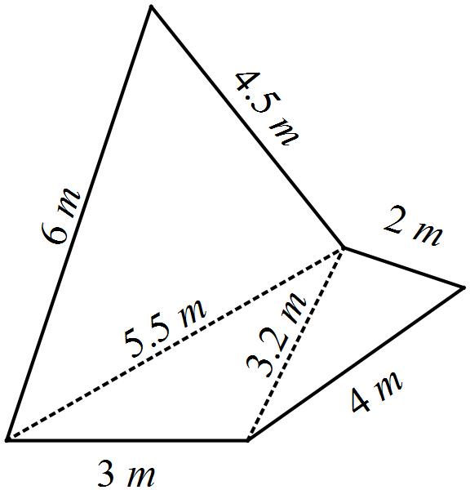

(b) Draw a sketch of a playground which is SIMILAR to the one above, with sides three times as long. Write the length of each side on your diagram. (2)

(c) What will be the area of the playground drawn in part (b)? (2)

Question 4 (15 marks)
(a) Use trigonometry to confirm that the area of this playground is 27.33 m². (10)

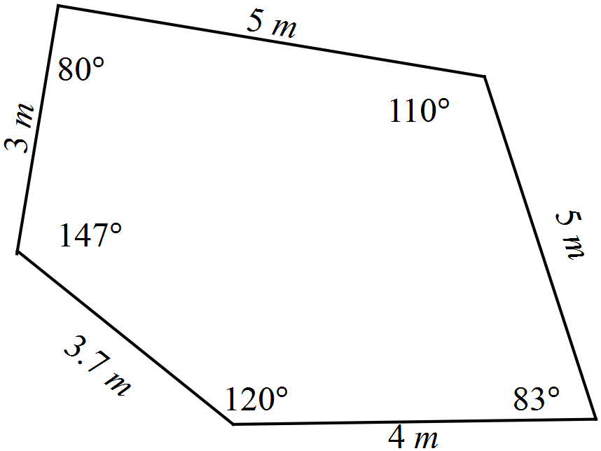

(b) Draw a sketch of a playground which is SIMILAR to the one above, with all the sides four times as long. Write the length of each side and the size of each angle on your diagram. (3)

(c) What will be the area of the playground that you have drawn? (2)

End of questions
Similarity and trigonometry

Extended investigation Part 1: Preparation activities
Solutions

Activity 1
Solutions
1.

2.

3.
A B
All sides in figure A are 4 cm in length. All sides in figure B are 1 cm in length.
All angles in figure A are 60º All angles in figure B are 60º

For both figures
4.
A B

5.
A B
6.

Activity 2
1 | The sides of B are twice the length of the sides of A  The area of B is four times the area of A  Corresponding angles are equal  The trigonometric ratios of the corresponding angles are equal
2 | The sides of B are a third the length of the sides of A  The area of B is one ninth the area of A  Corresponding angles are equal  The trigonometric ratios of the corresponding angles are equal
3 | The sides of B are a quarter the length of the sides of A  The area of B is one sixteenth the area of A  Corresponding angles are equal  The trigonometric ratios of the corresponding angles are equal
4 | The sides of B are twice the length of the sides of A  The area of B is four times the area of A  Corresponding angles are equal  The trigonometric ratios of the corresponding angles are equal
5 | The sides of B are three times the length of the sides of A  The area of B is nine times the area of A  Corresponding angles are equal  The trigonometric ratios of the corresponding angles are equal
6 | The sides of B are four the length of the sides of A  The area of B is sixteen times the area of A  Corresponding angles are equal  The trigonometric ratios of the corresponding angles are equal

Similarity and trigonometry

Extended investigation Part 2: In-class validation
Solutions and marking key

Question 1 (a) (b)
Solution

No. | Larger shape?  A or B | Scale factor for sides | Larger area | Smaller area | Scale factor for area
1 | B | 2 | 32 cm² | 8 cm² | 4
2 | A | 3 | 24 mm² | mm² | 9
3 | A | 4 | 6.92 cm² | 0.433 cm² | 16
4 | B | 2 | 58.8 cm² | 14.7 cm² | 4
5 | B | 3 | 24.076 mm² | 2.675 mm² | 9
6 | B | 4 | 160 cm² | 10 cm² | 16
7 | B | 2 | 168.72 m² | 42.18 m² | 4
8 | B | 3 | 170.41 m² | 18.93 m² | 9
9 | B | 4 | 437.3 m² | 27.33 m² | 16

Marking key/mathematical behaviours | Marks
- Identifies scale factors for sides  - Enters data for areas  - Determines scale factors for area in 1-6  - All Scale factors rounded to whole numbers  - Determines scale factors for area in 7-9 | 2  2  2  1  3

Question 1 (cont’d)
 | Solution | Marking key/mathematical behaviours | Marks
(c) | (i) 4 (ii) 9 (iii) 16 | - Reads table and determines pattern | 2
(d) | 49 | - Uses pattern to determine scale factor | 1
(e) | k² | - Generalises pattern | 1

Question 2

 | Solution
1

2

3
Marking key/mathematical behaviours |  | Marks
- Substitutes correctly into rule 1  - Determines area using substituted values  - Substitutes correctly into rule 2  - Determines area using substituted values  - Substitutes correctly into rule 3  - Determines value for half perimeter  - Determines area using substituted values |  | 1  1  1  1  1  1  1

Question 3

 | Solution
(a) | For the top triangle
Question 3 (cont’d)

 | Solution
(a) | For the middle triangle  For the lower triangle
Marking key/mathematical behaviours |  | Marks
- Substitutes correctly into rule for half perimeter  - Substitutes correctly into Heron’s rule  - Determines area of triangle from substitution  - Adds area for each triangle |  | 3  3  3  1

 | Solution | Marking key/mathematical behaviours | Marks
(b) | 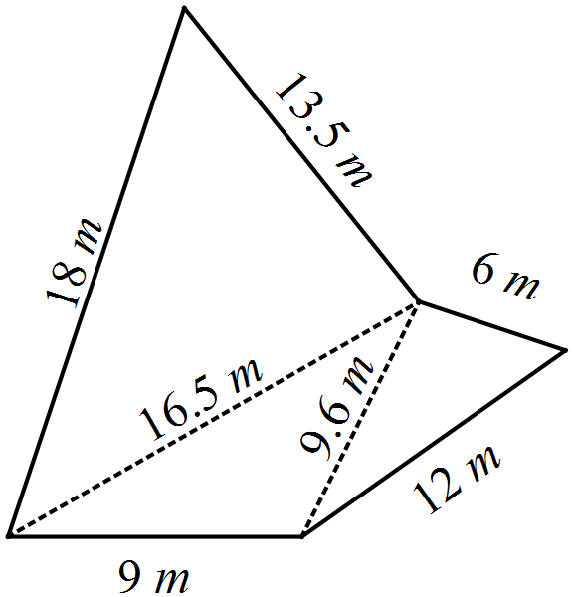 | - Draws similar shape  - Marks all sides as 3 times the original | 1  1
(c) | 170.37 m² | - Multiplies by 9  - Determines area | 1  1
Question 4

 | Solution | Marking key/mathematical behaviours | Marks
(a) | 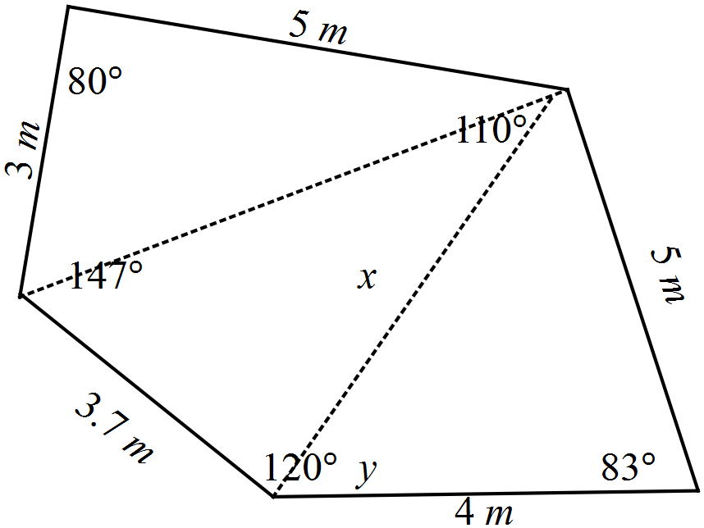  Area of top triangle  Area of bottom triangle  Area of middle triangle  Angle adjacent to y = 64.3º  Total area = 7.386+9.925+10.019=27.33 m² | - Use trig formula to determine area of top and bottom triangles – shows substitution and uses values to calculate area  - Uses cos rule to determine one missing side  - Uses sin rule to determine missing angle  - Determines angle in middle triangle  - Use trig formula to determine area of middle triangle – shows substitution and uses values to calculate area  - Calculates total area | 4  2  2  1  1

Question 4 (cont’d)

(b) | 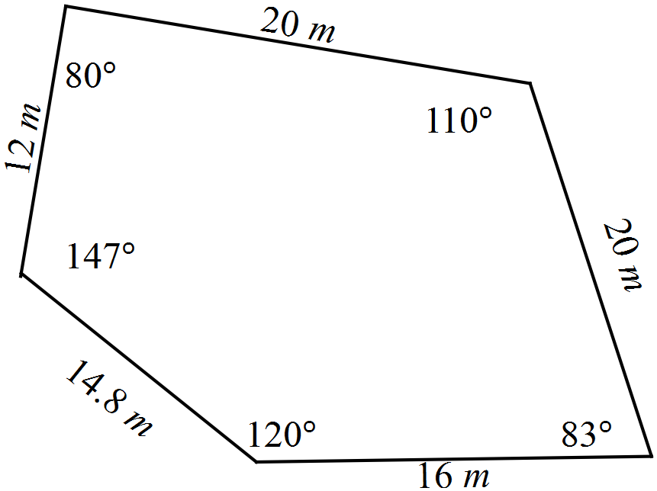 | - Angle sizes marked  - All sides quadrupled | 1  2
(c) | 437.3 m² | - Multiplies by 16  - Determines area | 1  1

TASK 14: EXPLORING TRIGONOMETRIC RATIOS

In-class investigation

Unit 2

Topic 2.2: Applications of trigonometry

Course-related information

The concepts and skills developed in this extended investigation relate to the following dot points within the WA Mathematics Applications syllabus:
2.2.1 use trigonometric ratios to determine the length of an unknown side, or the size of an unknown angle in a right-angled triangle
2.2.3 solve problems involving non-right-angled triangles using the sine rule (acute triangles only when determining the size of an angle) and the cosine rule

Background information

Students could undertake this investigation before commencing topic 2.2 if they have developed a basic understanding of using trigonometric ratios in lower secondary. This investigation provides a further opportunity for students to consolidate some basic understanding of a topic that can be quite challenging.

Task conditions

Students will need a calculator with the capacity to calculate angles and sides using trigonometric ratios. Formulae have not been provided in this investigation though examples of the use of the trig formulae are given. It is reasonable to expect students at this level to be able to recognise these formula as well as know the rule to use Pythagoras’ theorem.

Exploring trigonometric ratios

In-class investigation (Total: 46 marks)
Question 1 (16 marks)

For the triangle drawn below (not necessarily to scale), the following trigonometric ratios apply for the angle at A.

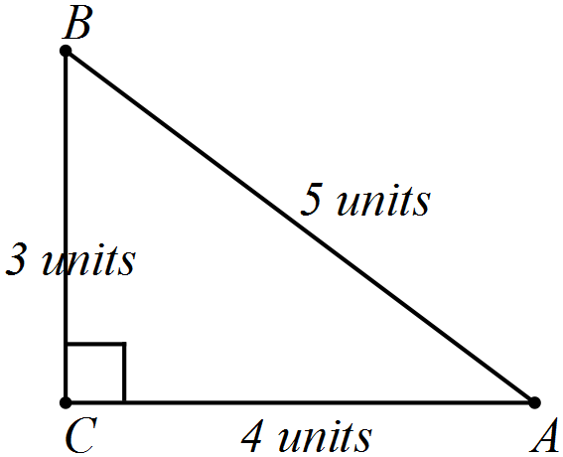

(a) Consider the sides of the triangle above are all doubled so that the triangle (not necessarily drawn to scale) can be represented by the diagram below.
Write statements, similar to those above, showing the unsimplified fractional and decimal values for the trigonometric ratios. (3)

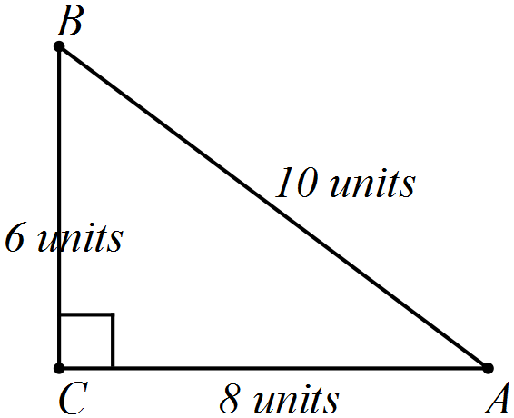

(b) Consider the sides of the first triangle given above are all tripled. (4)

(i) Complete the number of units on the sides of the triangle below.

(ii) Write statements, similar to those above, showing the unsimplified fractional and decimal values for the trigonometric ratios.

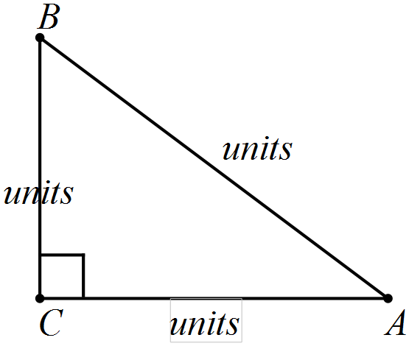

(c) Consider that the sides of the first triangle given previously are all multiplied by k.
(5)
(i) Complete the number of units on the sides of the triangle below.

(ii) Write statements, similar to those above, showing the unsimplified fractional and decimal values for the trigonometric ratios.


(d) Add your results from parts (a) to (c) to the table below. (2)

Part | Trigonometric ratio | Unsimplified fraction | Decimal
 |  |  | 0.6
 |  |  | 0.8
 |  |  | 0.75
(a)
(b)
(c)

(e) When all the sides of the triangle are multiplied by the same factor, what changes occur to (2)

(i) the size of the angle at A?

(ii) the trigonometric ratios for the angle at A?
Question 2 (10 marks)

(a) Write down the trigonometric ratios as fractions for the angles at M and Q. (3)
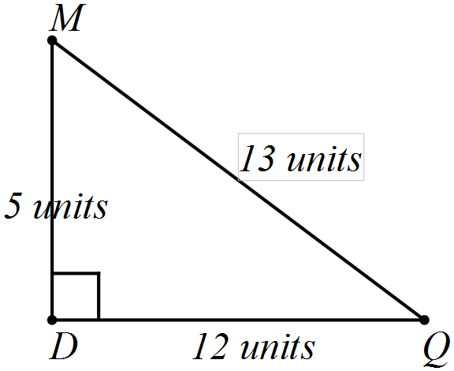

(b) What happens to these trigonometric ratios for the angles at M and Q when you multiply all the sides of the triangle above by a factor of 5? Explain how you arrived at your conclusion. (3)

(c) Calculate the sides marked x in each of these triangles. (4)

(i) (ii)

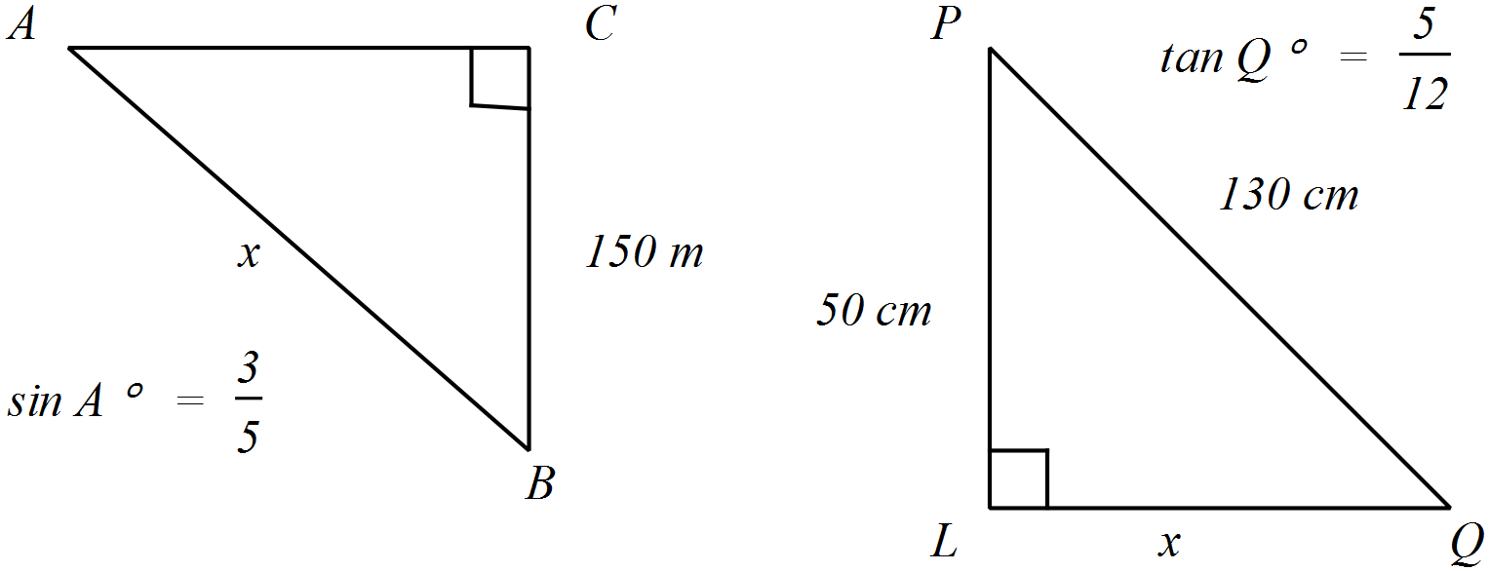
Question 3 (9 marks)

Consider the question:
If the length of one side of a triangle is doubled, is the size of the angle opposite it also doubled?

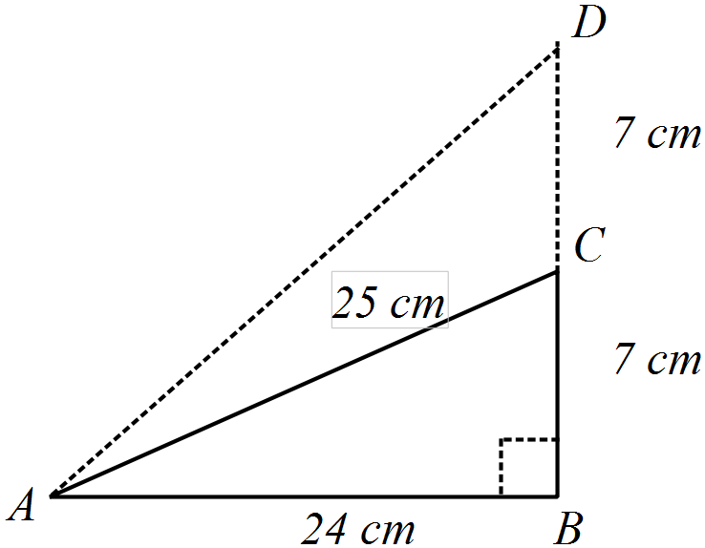(a) Determine the size of the angle opposite CB (1)

(b) Determine (2)

(c) (i) Determine (2)

(ii) Determine the size of

(d) When the triangle was enlarged so that the side opposite A was doubled.

(i) was the tangent ratio of the angle at A () doubled?

(ii) was the size of the angle at A doubled? (2)

(e) Is the following statement TRUE or FALSE? (2)

. Justify your conclusion.
Question 4 (11 marks)

The steps of a process to determine the length of the third side of a triangle are provided below.

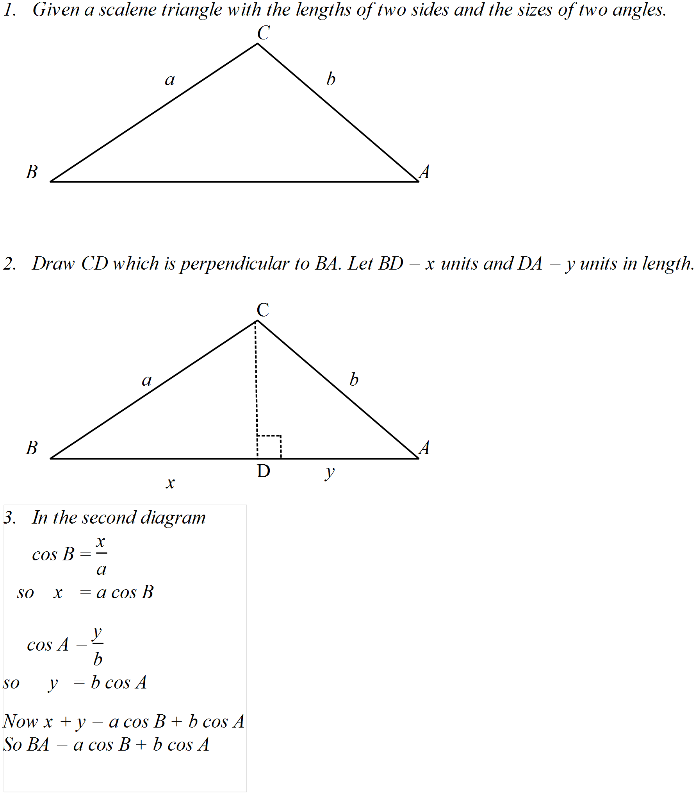

(a) Use the steps described above to determine the length of the base of the triangle below.
(6)
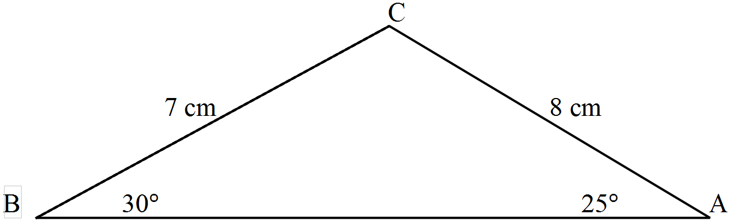

(b) Use the rule developed above [ BA = a cos B + b cos A ] to determine the length of the third side of each of these triangles.
(5)
(i)
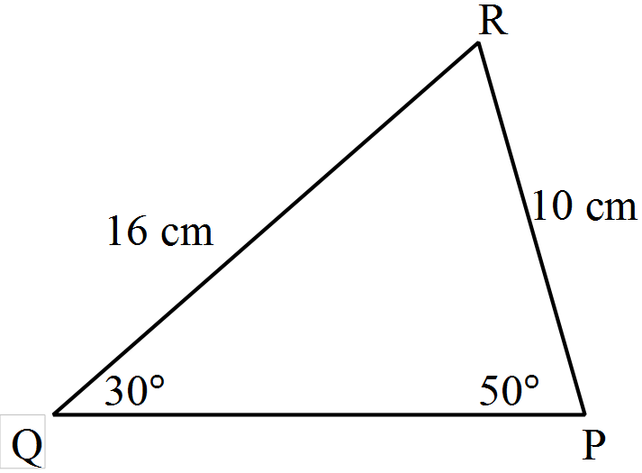

(ii)
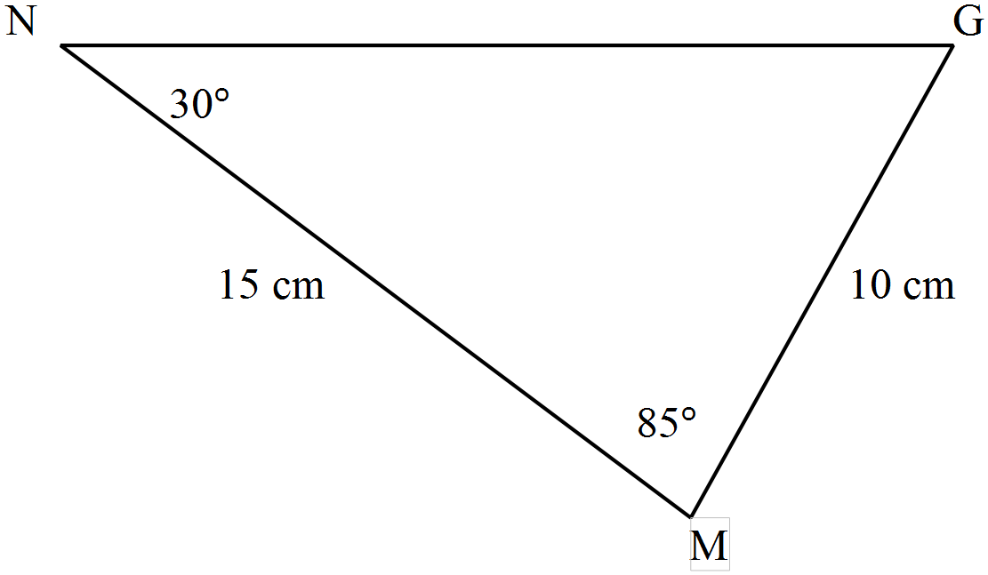

End of questions
Exploring trigonometric ratios

In-class investigation

Question 1
 | Solution | Marking key/mathematical behaviours | Marks
(a) |  | - Provides correct trigonometric ratios as fractions  - Expresses fractions in un-simplified form  - Expresses fractions as decimals | 1  1  1
(b) | 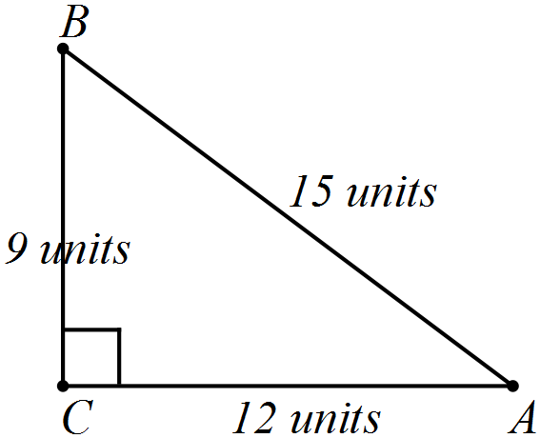 | - Identifies all sides of the triangle  - Provides correct trigonometric ratios as fractions  - Expresses fractions in un-simplified form  - Expresses fractions as decimals | 1  1  1  1
(c) | 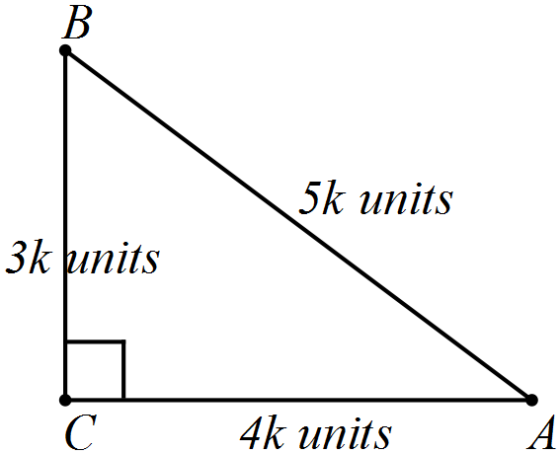 | - Identifies all sides of the triangle  - Provides correct trigonometric ratios as fractions  - Expresses fractions in un-simplified form  - Expresses fractions as decimals | 2  1  1  1
(e) | (i) The size of the angle does not change  (ii) The trigonometric ratios are not changed | - Draws correct conclusion for both angle and ratios according to own results | 2

Question 1 (cont’d)
Solution

Part | Trigonometric ratio | Unsimplified fraction | Decimal
 |  |  | 0.6
 |  |  | 0.8
 |  |  | 0.75
(a) |  |  | 0.6
 |  |  | 0.8
 |  |  | 0.75
(b) |  |  | 0.6
 |  |  | 0.8
 |  |  | 0.75
(c) |  |  | 0.6
 |  |  | 0.8
 |  |  | 0.75

Marking key/mathematical behaviours | Marks
- Accurate transfer of all previous results into correct positions  - One mark only if minor errors in translation | 2

Question 2
 | Solution | Marking key/mathematical behaviours | Marks
(a) |  | - States correct sin ratios  - State correct cos ratios  - States correct tan ratios | 1  1  1
(b) | The trigonometric ratios remain as above  The ratios are multiplied on the top and bottom by 5 and this cancels out. | - Correct conclusion  - Identifies multiple of 5 for both numerator and denominator  - Explains simplification | 1  1  1
(c) | (i)  (ii) | - Writes equation connecting sin to sides of triangle  - Solves equation  - Writes equation connecting tan to sides of triangle  - Solves equation | 1  1  1  1

Question 3
 | Solution | Marking key/mathematical behaviours | Marks
(a) | 16.3º | - Determines angle | 1
(b) |  | - Use formula for tangent ratio  - Substitutes into formula | 1  1
(c) |  | - Determines tangent ratio  - Calculates size of angle | 1  1
(d) | Yes  no | - Identifies fraction is doubled  - Identifies angle is not doubled | 1  1
(e) | False  sin 30º =0.5 but sin 60º≠ 1 | - Concludes correctly  - Provides reasonable justification | 1  1

Question 4 (a)
Solution
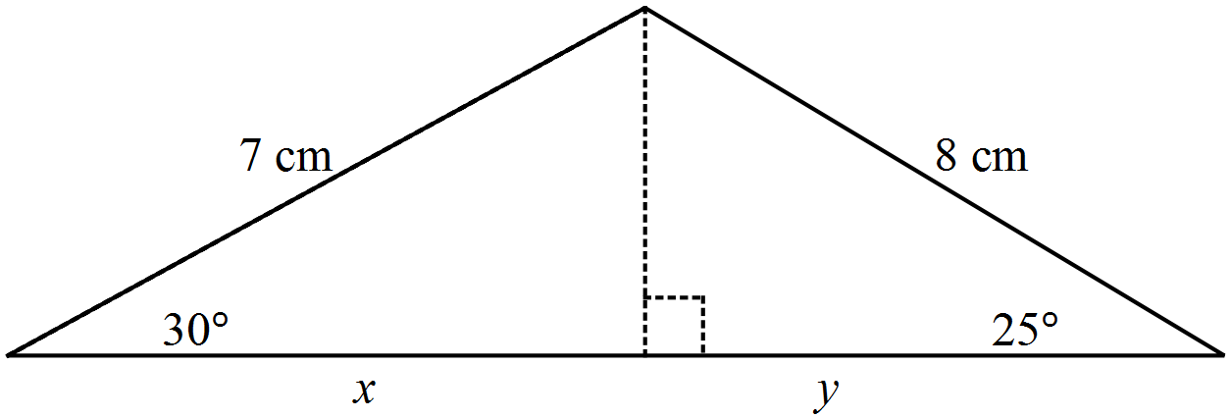

Marking key/mathematical behaviours | Marks
- Draws a line perpendicular to the base  - Write expression for cos 30º  - Writes expression for x  - Write expression for cos 25º  - Writes expression for y  - Calculates length of base | 1  1  1  1  1  1

Question 4 (b)
 | Solution | Marking key/mathematical behaviours | Marks
(b) | (i) Side = 16 cos 30º + 10 cos 50º  = 20.3 cm  (ii)  Missing angle = 65º  Side = 10 cos 65º + 15 cos 30º = 17.2 cm | - Substitutes into rule  - Calculates triangle side  - Calculates missing angle  - Substitutes into rule  - Calculates triangle side | 1  1  1  1  1

TASK 15

Investigative questions

Unit 2

Topic 2.2: Applications of trigonometry

Course-related information

The concepts and skills covered in these investigative questions relate to the following dot points within the WA Mathematics Applications syllabus:
2.2.1 use trigonometric ratios to determine the length of an unknown side, or the size of an unknown angle in a right-angled triangle
2.2.2 determine the area of a triangle, given two sides and an included angle by using the rule
$area=\frac{1}{2} absinC$, or given three sides by using Heron’s rule, and solve related practical problems
2.2.3 solve problems involving non-right-angled triangles using the sine rule (acute triangles only when determining the size of an angle) and the cosine rule
2.2.4 solve practical problems involving right-angled and non-right-angled triangles, including problems involving angles of elevation and depression and the use of bearings in navigation
The ability to choose and use appropriate technology to enhance and extend concept development is also required for some of the items

Background information

To attempt these tasks, students should have practised solving a variety of problems using trigonometry. The ability to use CAS calculator technology to evaluate and simplify expressions is assumed. Students should be able to show substitutions into the trigonometric formulae they choose for solving problems.

Task conditions

These questions are independent of each other and are written so that they may be incorporated into a test or examination. Student access to a graphical/CAS calculator is assumed. The time required to complete each question is left to the discretion of the teacher but the intention is that each question may be completed within 15 minutes.

Investigative questions for Topic 2.2

Question 1 (9 marks)

The positions of three rubbish bins at the local park are described in relation to the water fountain. The first bin is 55 m from the fountain on a bearing of 060º, the second bin is 66 m from the fountain on a bearing of 210º and the third bin is 40 m from the fountain on a bearing of 330º.

(a) Draw a labelled diagram showing the positions of the bins relative to the fountain and all distances and angles. (4)

(b) Determine the distance that you would walk if you went from the second bin to the third bin and then to the first bin.. (5)

Question 2 (9 marks)

On his travels outside Australia, Mitch noticed these four different road signs being used to indicate the steepness of roads. They are drawn here but not to scale.
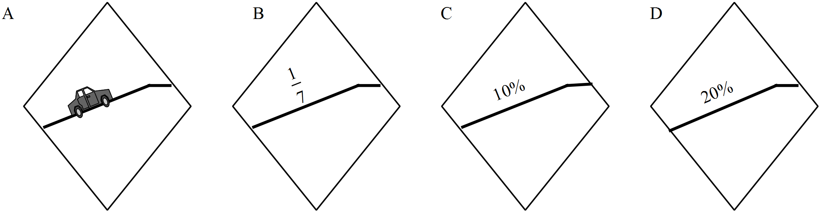

(a) What can you learn from sign A? (1)
(b) How does the fraction describe steepness? Refer to the relationship between 1 and 7 to describe the steepness. (2)
(c) If describes the tangent of the angle that the road makes with the horizontal, what is the size of the angle between the road and the horizontal? (1)

(d) If the road sign D showed a fraction rather than a percentage, what would that fraction be? (1)

(e) Determine the angle that the road at sign C makes with the horizontal? (2)

(f) Is the road at sign B or at sign C steeper? Justify your selection. (2)

Question 3 (11 marks)

Circles are drawn with a radius r and centre O. In each figure the lines drawn from the centre to the circumference are equal and the figure consists of congruent triangles within a circle. Use the formula to write expressions for the areas of the triangles as described below.

(a) (i) Determine the size of the angle marked x. (3)

(ii) Write an expression to calculate the area of the equilateral triangle drawn inside the circle. Do not simplify your expression.

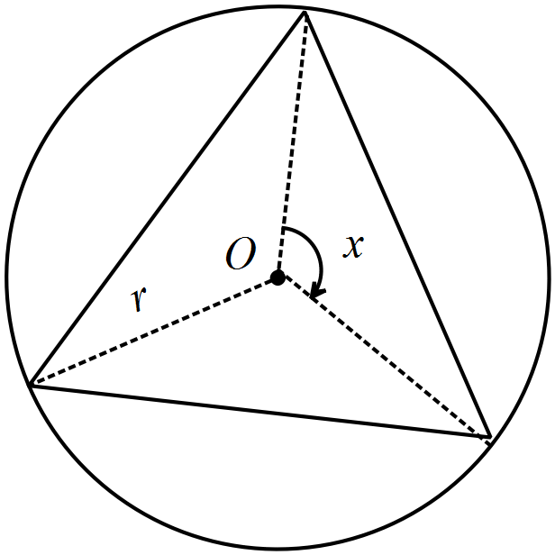

(b) Write an expression to calculate the area of the square drawn inside the circle. Do not simplify your expression. [Hint: First determine the angle where the diagonals intersect] (3)
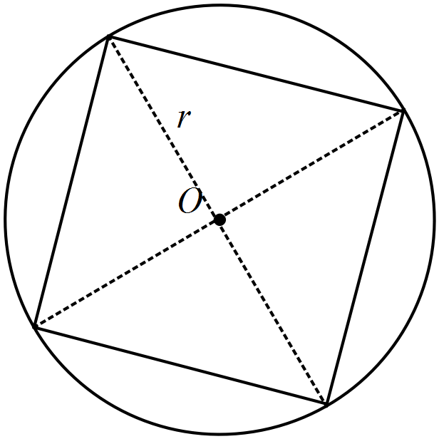

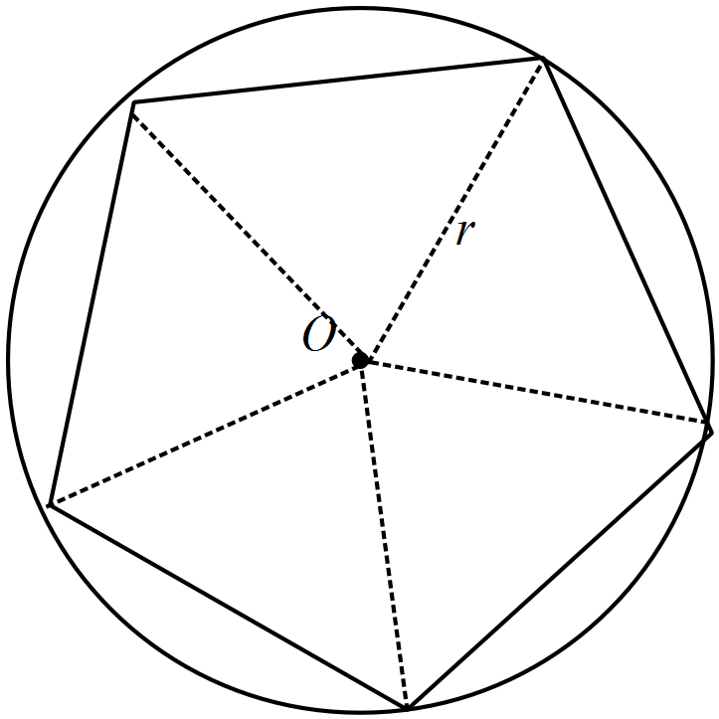(c) Write an expression to calculate the area of the regular pentagon drawn inside the circle. Do not simplify your expression. (3)

(d) Write an expression to calculate the area of a regular n-sided polygon drawn inside a circle so that all vertices lie on the circumference of the circle. (2)

Question 4 (9 marks)

The location of the first resting place (F) on a walking track is on a bearing of 062º and at a distance of 10 km from the start (S). The second resting place (R) is on a bearing of 150º and at a distance of 9 km from the first resting place. From the second resting place the start (S) is on a bearing of 280º.

(a) Complete the diagram provided by labelling all known angles and distances. (3)
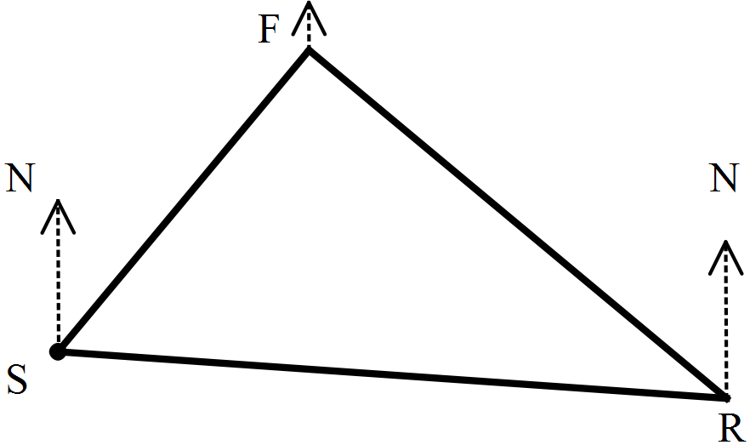

(b) Determine and label any missing angles including the internal angles of the triangle formed by this walk. (3)

(c) The walking track is changed so that
- F is now twice the distance from S as it was originally
- R is twice the previous distance from F
- The bearings are not altered
How will these changes alter the angles of the triangle? Justify your answer.
(3)
Investigative questions in Topic 2.2
Solutions and marking key

Question 1
 | Solution | Marking key/mathematical behaviours | Marks
(a) | 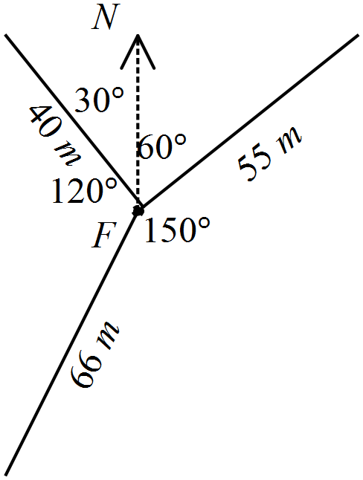 | - Marks distance and bearing for bin 1  - Marks distance and bearing for bin 2  - Marks distance and bearing for bin 3  - Calculates angle 30º | 1  1  1  1
(b) | Second bin to third bin  Third bin to first bin  Total distance = 160.7 m | - Substitutes into cos rule  - Calculates distance  - Uses Pythagoras  - Determines distance  - Adds distances | 1  1  1  1  1

Question 2
 | Solution | Marking key/mathematical behaviours | Marks
(a) | Unless it is drawn to scale, not much fact except that the road will become steeper. | - Concludes logically | 1
(b) | The road rises 1 unit vertically for every 7 units horizontally | - Relates rise and run  - Rise of 1 to run of 7 | 1  1
(c) | 8.1º | - Determines angle | 1
(d) |  | - Converts 20% to a fraction | 1
(e) | 5.7º | - Applies tan⁻¹ to 0.1  - Determines angle | 1  1
(f) | (c) the angle is larger | - Selects steeper road  - Justifies selection | 1  1

Question 3

 | Solution | Marking key/mathematical behaviours | Marks
(a) | (i) 120º  (ii) Area = 3 x 0.5 x r² x sin 120º | - Determines angle at centre  - Area is for 3 triangles  - Correct substitution into rule for area | 1  1  1
(b) | Area = 4 x 0.5 x r² x sin 90º | - Determines angle at centre  - Area is for 4 triangles  - Correct substitution into rule for area | 1  1  1
(c) | Area = 5 x 0.5 x r² x sin 72º | - Determines angle at centre  - Area is for 5 triangles  - Correct substitution into rule for area | 1  1  1
(d) | Area = n x 0.5 x r² x sin (360 ÷ n) | - Generalises rule using variable correctly | 2

Question 4
Solution (a), (b)  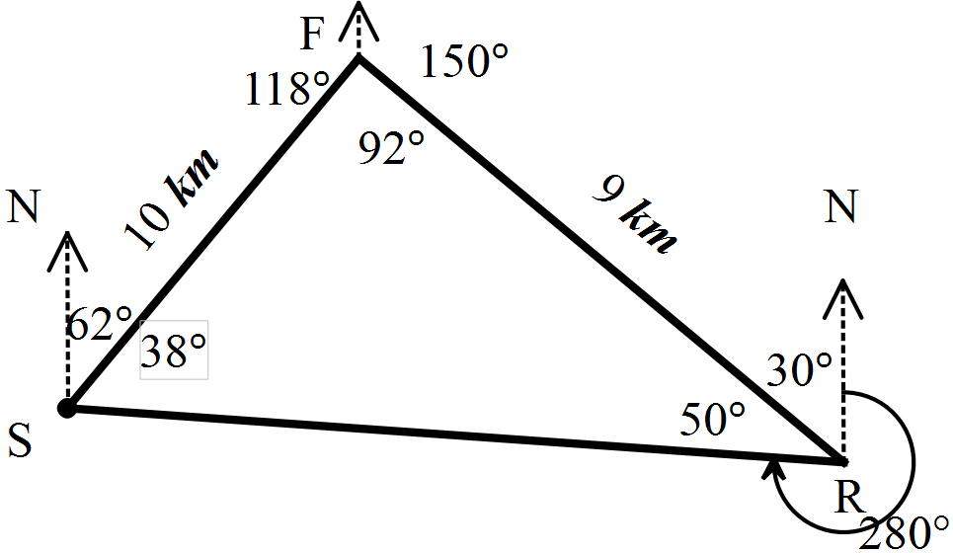 | (c)  Internal angles of the triangle are the same  None of the angle calculations were based on the distances so the angle calculations are not altered.  The diagram formed is similar and similar figures have equal corresponding angles
Marking key/mathematical behaviours |  | Marks
(a)  - Labels information provided about F in relation to S  - Labels information provided about R in relation to F  - Labels information provided about S in relation to R  (b)  - Labels co-interior angles of 118 and 30  - Determines internal angle at R  - Calculates third angle of triangle  (c)  - Identifies angles are not altered  - Explains why angles will not be changed |  | 1  1  1  1  1  1  1  2

TASK 16: LINEAR WITH A DIFFERENCE

Extended investigation

Unit 2

Topic 2.3: Linear equations and their graphs

Course-related information

The skills and concepts developed in this extended investigation relate to the following dot points within the WA Mathematics Applications syllabus:

2.3.9 sketch piece-wise linear graphs and step graphs, using technology when appropriate
2.3.10 interpret piece-wise linear and step graphs used to model practical situations; for example, the tax paid as income increases, the change in the level of water in a tank over time when water is drawn off at different intervals and for different periods of time, the charging scheme for sending parcels of different weights through the post
Students will have the opportunity to further develop their capacity to choose and use technology efficiently.

Background information

Students should be able to construct and interpret step graphs and piece-wise linear graphs. They should be able to construct these types of graphs without technology. Students should know how to calculate speed.

Task conditions

For the preparation activities, students will need graph paper. A week could be allocated to the preparation activities and the in-class validation could be done in a 40-50 minute period. It is left to the teacher’s discretion to determine the need for students to bring their preparation activities to the validation. The extent of exposure to this topic could also be influential in making this decision.

Linear with a difference

Extended investigation Part 1: Preparation activity

Question 1

The table below shows the schedule for parking fees at a local hospital.
The car park is open from 6:00 am to 6:00 pm
Draw a step graph to represent the data.

Parking fees
Time (hours) |  | Cost
Equal to or more than | Less than
0 | 0.5 | $9
0.5 | 1 | $11
1 | 1.5 | $15
1.5 | 2 | $18
2 | 2.5 | $20
2.5 | 3 | $23
3 | 3.5 | $26
3.5 | 4 | $29
4 | 8 | $31
8 | 12 | $33

Question 2

In the 2014 Commonwealth games, the triathlon consisted of three stages: a 1500 m swim followed by a 40 km bike ride and then a 10 km run for both the men’s and the women’s events. The winners completed the three stages in the times below.

Swim Cycle Run
Men’s event 18 mins 58 mins 43 secs 31 mins 9 secs
Women’s event 19 mins 37 secs 1 h 4 mins 1 sec 34 mins 21 secs

(a) Convert all times to minutes correct to one decimal place.

(b) Calculate the average speed (km/h) of the winners on each stage of the triathlon.

(c) On the same set of axes, draw two piece-wise graphs – one for the men’s event and the other for the women’s event - showing the distance covered for the time taken.
Plot “time taken” (in minutes) on the horizontal axis and “distance covered” on the vertical axis.

(d) Compare the performance of the two triathletes.

(e) What conclusions can you draw about each winner’s performance on the different stages of the triathlon?
Question 3

The graphs below show the cost of posting parcels to locations overseas in 2014. The first graph is for transport by air and the second is for sea transport.

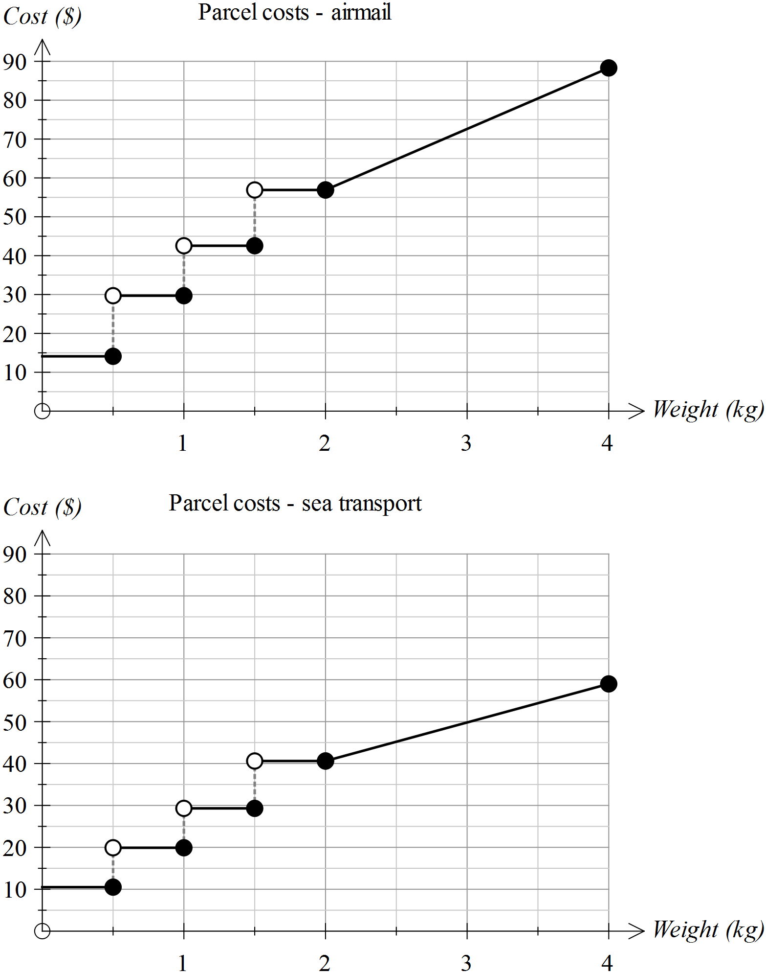

(a) Use the graphs to determine the approximate costs for sending these parcels.

(i) A parcel weighing 500 g by air and by sea

(ii) A parcel weighing 1.8 kg by air

(iii) A parcel weighing 1.99 kg by air

(iv) A parcel weighing 3 kg by sea

(v) A parcel weighing 4 kg by air
(b) Using a different colour, place the data from the second graph onto the first graph. Describe the location of the new graph in relation to the original one.

(c) Consider the following statement.

For the same weight, it is always cheaper to send the parcel by sea than by air

Is this statement always true? How would you know this from the graphs?

(d) There is a change to pricing when the parcel is over 2 kg.

A. The price is set for a fixed range of weights
B. The price increases by a fixed amount per kg

Which of the two statements above applies when the parcel is
(i) under 2 kg in weight
(ii) over 2 kg in weight

(e) What is the approximate cost per kg of sending a parcel overseas by air if the parcel weighs more than 2 kg?

(f) Determine the rate at which the cost changes per kg, when a parcel to be sent overseas by sea, weighs more than 2 kg.

(g) Determine the gradients of the following lines - the lines linking the costs of postage for parcels
(i) sent overseas by air and weighing less than 500 g
(ii) sent overseas by air and weighing over 2 kg
(iii) sent overseas by sea and weighing over 2 kg
(iv) sent overseas by sea and weighing between 1.5 kg and 2 kg

(h) Consider the following change to the cost of sending a parcel overseas by sea transport.

The price will rise by $5 within each range of weights between 0 and 2 kg.
The cost per kg for parcels weighing more than 2 kg will remain unchanged.

Add a new graph to the second graph to reflect this change.

Question 4

The cost of postage for parcels less than 2 kg in weight is displayed as a step graph. Locate at least five other examples of data for which a step graph would be most appropriate.

Question 5

Jon pays his water bill every two months. It consists of a fixed charge for the connection and sewage plus a fee that varies according to the amount of water used. The graph of the pricing schedule is shown below.

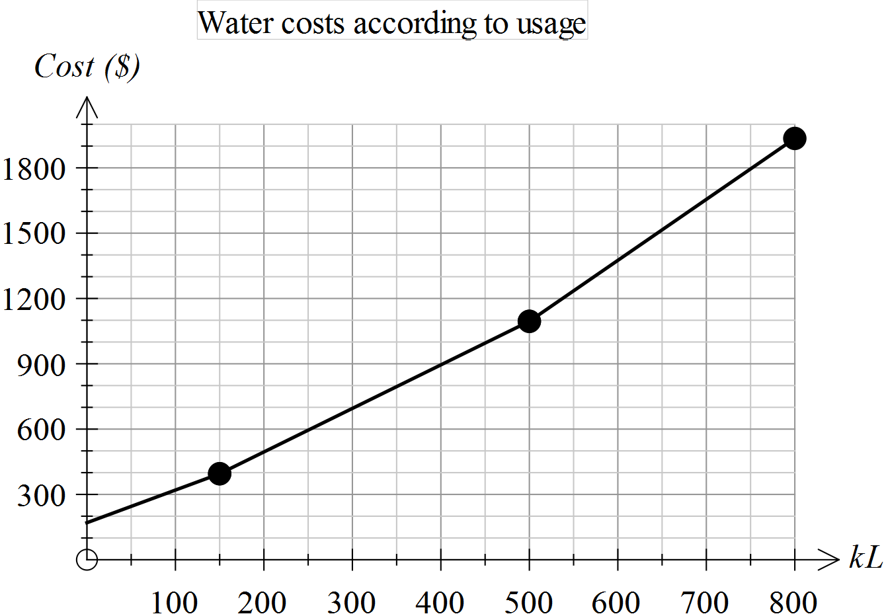

(a) Estimate the total fixed charge.

(b) At what levels of water usage do the rates at which water is charged vary?

(c) Is it true to say that “when the rates vary, they are increasing”? How can you verify your conclusion from the graph provided?

(d) Determine the approximate charges for the following water usages.

(i) 100 kL (ii) 0.25 ML

(iii) 650 kL (iv) 50 000 L

(e) Use the graph to determine the rate at which water is charged when the consumption is over 500 kL.

(f) Explain how you can determine the equation of the first section of this piece-wise graph.

(g) The second section of this piece-wise graph has the equation

Cost = 2 x Number of kL + 95

What is the significance of “2” in the equation above?

Linear with a difference

Extended investigation Part 2: In-class validation (50 marks)

Question 1 (6 marks)

Ida parks her car at 8.00 am at the university where parking costs $1.50 per hour. She leaves there at 10 am and arrives at the airport at 10:45 am where she parks the car for an hour at $4 per hour. She then drives to the city, arriving at 12.15 pm and parks on the Esplanade at a cost of $4.50 per hour for 2 hours. She then leaves the city and drives home, arriving there at 3.00 pm.
Use the axes below to graph the amount Ida pays for parking from 8.00 am to 3.00 pm.
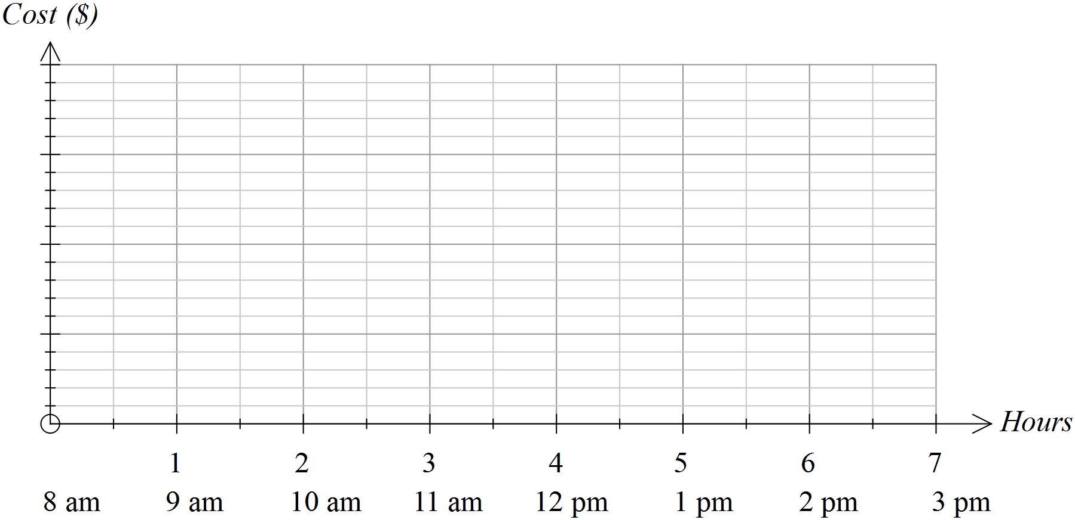

Question 2 (7 marks)

The cost of parking at the airport for up to 5 hours is summarised in the table. Show these costs on the axes provided.

First 15 mins | Over 15 mins  Up to 30 mins | Over 30 mins  Up to 1 hour | Over 1 hour  Up to 2 hours | After 2 hours it is an extra $2 per hour or part thereof
Free | $5 | $8 | $12
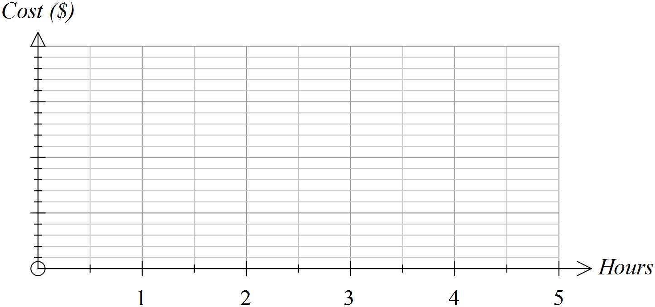

Question 3 (10 marks)

The costs of sending parcels of varying weights by post are represented in the graph below.
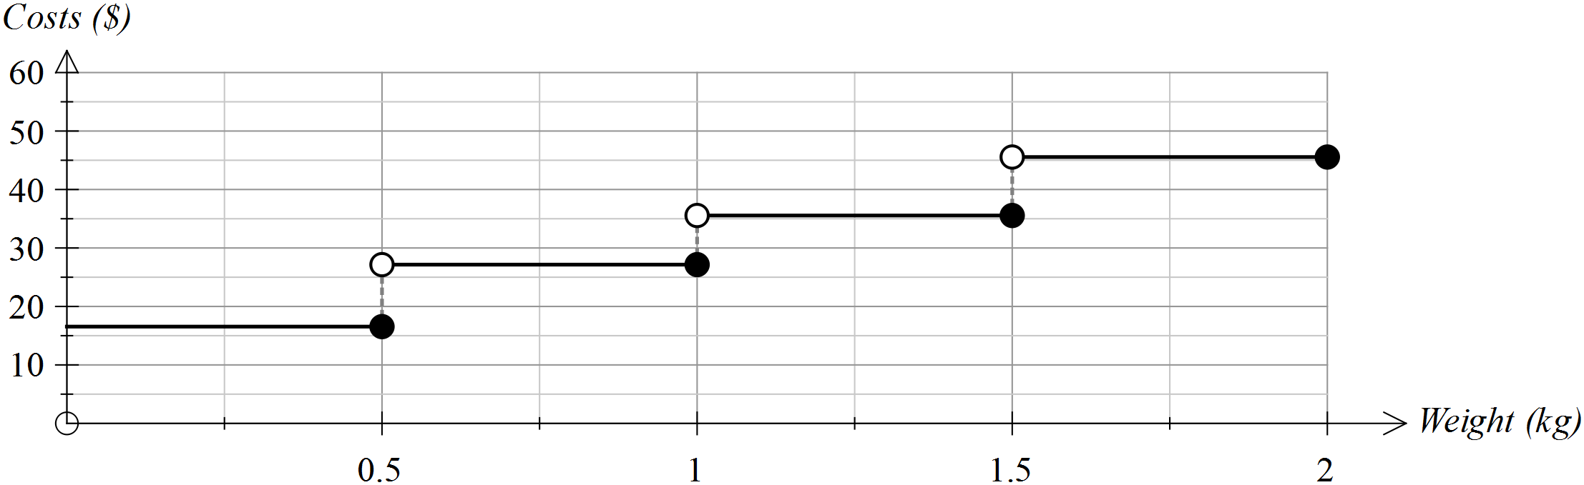

Use the graph to answer the following questions.

(a) What is the approximate cost of sending a parcel weighing 500 g? (1)

(b) What is the approximate cost of sending a parcel weighing 120 g? (1)

(c) If you had $40 to spend on the postage of one parcel, what is the maximum weight that the parcel could be? (1)

(d) If you were told that your parcel would probably cost less than $30, what might its weight be? (2)

(e) A decision was made to lower the costs by $10 in each weight range.
Draw the graph showing these lowered costs on the graph drawn above. (2)

(f) A decision was made to lower the costs by 50% in each weight range.
Draw the graph showing these lowered costs on the graph drawn below. (3)



Question 4 (10 marks)

Tom and Mary were driving in a car rally last week. The time taken to return to their starting point is shown in the graph below.
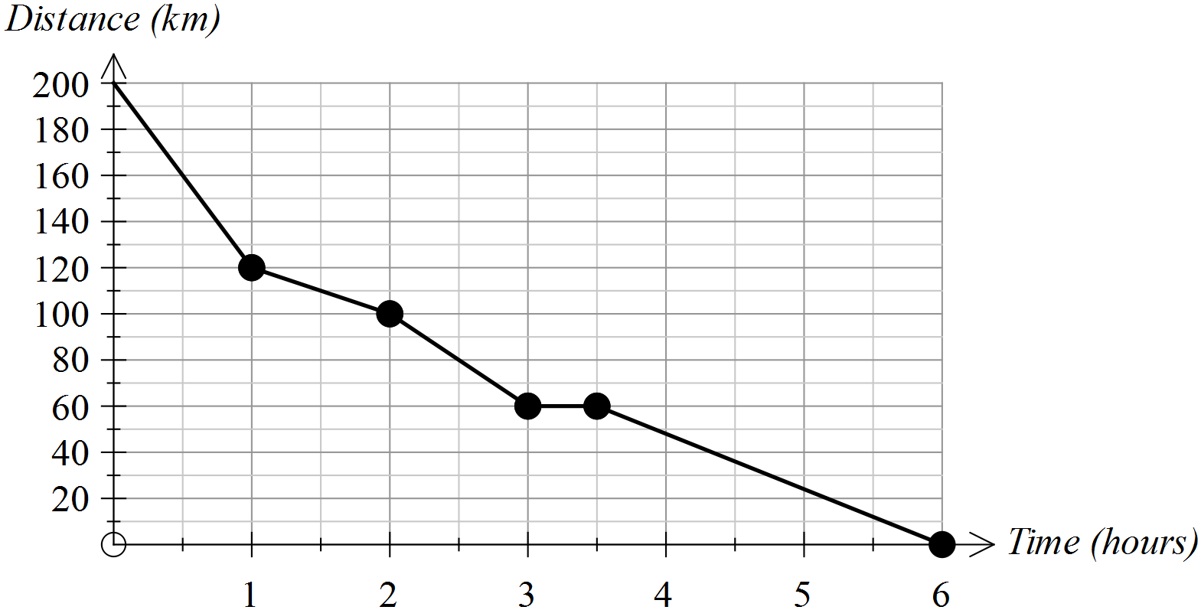

(a) How far was the return journey? (1)

(b) How long did the return journey take? (1)

(c) During which hour did Tom and Mary average the highest speed? (2)

How did you determine this answer from the graph?

(d) For how long did Tom and Mary stop? (2)

(e) At what average speed were Tom and Mary travelling during the last hour of their journey? Show how you determined your answer. (2)

(f) Tom and Mary started their return journey at 6.00 am. (2)

(i) How far had they travelled by 8.30 am?

(ii) Add a segment to this graph to indicate that Tom and Mary could have travelled at a constant speed between 9.00 am and 11.00 am.

Question 5 (17 marks)

The cost of travelling on a city train varies according to the number of zones travelled.
The table provided shows the;
- stations numbered 1 to 9
- distance to each station from the city
- cost of travelling to that station from the city
- time taken to reach each station from the city.

Station | Distance from city (km) | Cost  from the city | Time taken from city  (mins) | Time taken since last station  (mins) | Distance since last station  (km) | Cost since the last station
1 | 7.3 | $2.90 | 6 | 6 | 7.3
2 | 11.7 | $4.40 | 9 | 3 | 4.4
3 | 13.8 | $4.40 | 11 |  | 2.1
4 | 20.5 | $5.30 | 16 |  | 6.7
5 | 32.9 | $6.30 | 23 |  | 12.4
6 | 37.39 | $6.30 | 29 |  | 4.49
7 | 43.2 | $7.80 | 33 |  | 5.81
8 | 47.6 | $7.80 | 36 |  | 4.4
9 | 70.19 | $10.30 | 48 |  | 22.59 | $2.50

(a) Complete the table. (4)

(b) The graph below shows the cost of travel according to the distance travelled. (8)
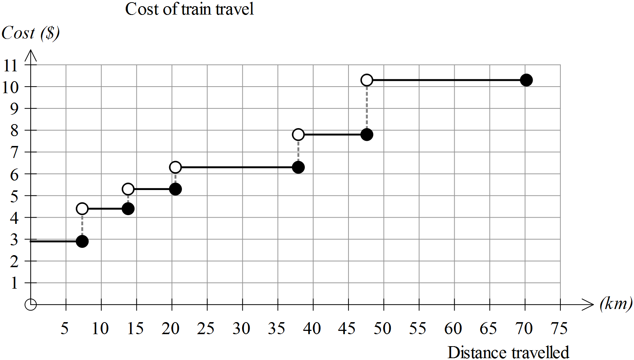

(i) How many different prices are used for this schedule of costs?

(ii) At which distance from the city does the sharpest rise in costs occur?

(iii) What would you need to do to this graph to show an increase of $1 on all the fares given in the table?

(iv) For people who receive a 15% discount on their fares, how would their graph of costs be different to the one above?

(v) It was suggested that, rather than increase the fares the same fares would apply, but the stations would be moved so that they were closer to the city. How would the new graph of costs differ from the one given?

(c) If you plotted time on the horizontal axis and distance travelled on the vertical axis, would you create a step graph or a piece-wise linear graph?
Justify your conclusion. (2)

(d) Is the following statement True or False? Justify your conclusion. (3)

The further you travel from the city, the less it costs per kilometre.

End of questions
Linear with a difference

Extended investigation Part 1: Preparation activity
Solutions

Question 1

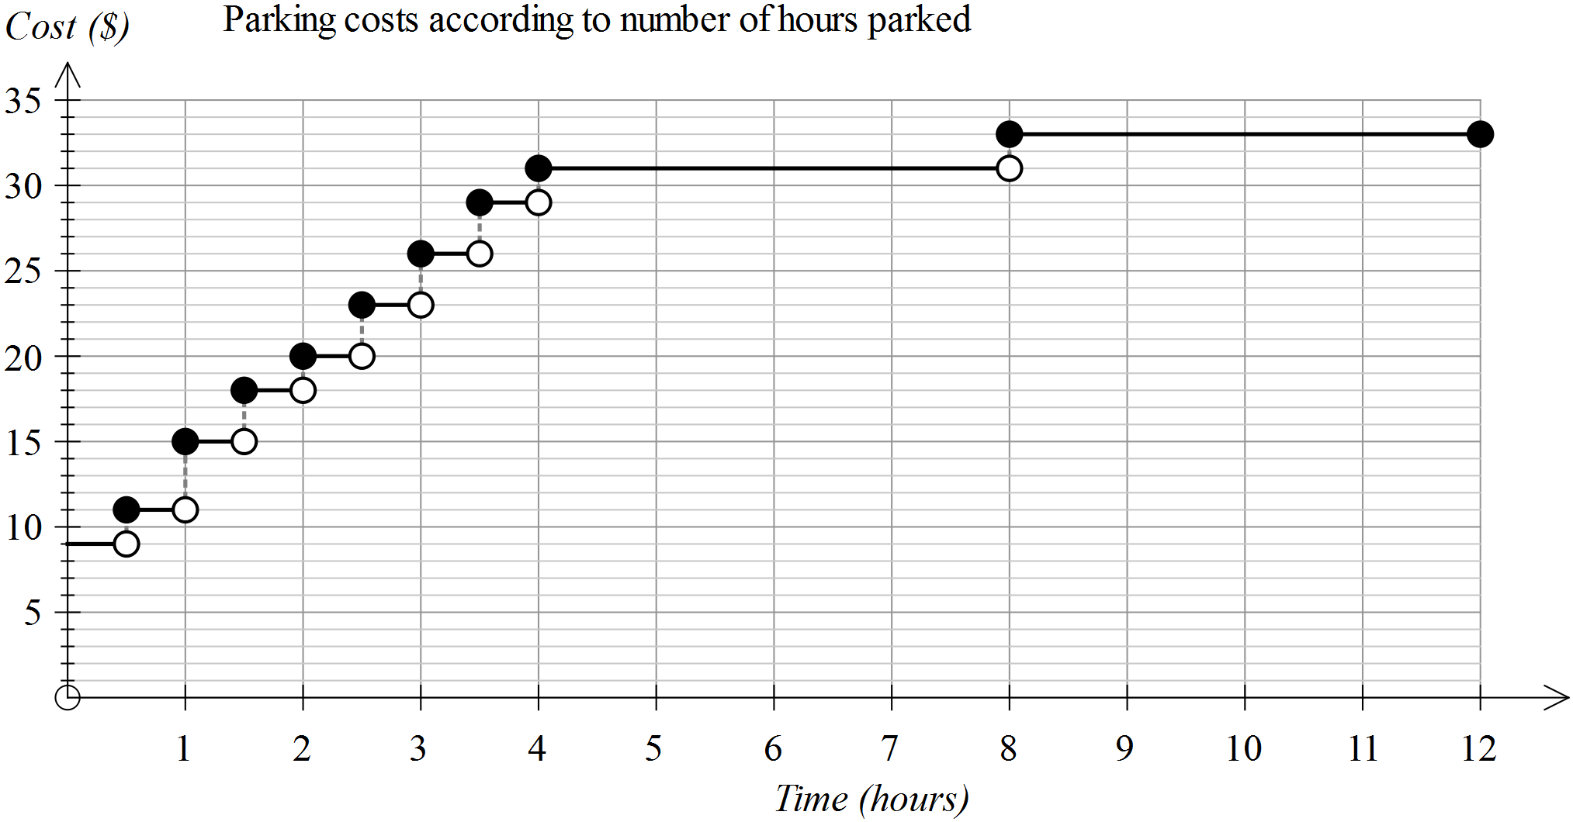

Question 2
(a) Swim Cycle Run
Men’s event 18 mins 58.7 mins 31.2 mins
Women’s event 19.6 mins 64.0 mins 34.4 mins

(b) Swim Cycle Run
Men’s event 5 km/h 40.9 km/h 19.2 km/h
Women’s event 4.6 km/h 37.5 km/h 17.4 km/h

(c) Table of data for graph. Graph drawn on the next page.
Triathlon | Time elapsed (to nearest minute) |  | Distance
 | Men's | Women's | km
Start | 0 | 0 | 0
After swim | 18 | 20 | 1.5
After cycle | 77 | 84 | 41.5
End | 108 | 118 | 51.5

(d) For each stage of the triathlon, the female winner was slower than the male.

(e) For both triathletes, the fastest stage was the cycle leg and the slowest was the swimming leg. Both athletes ran about four times as fast as they swam and cycled about twice as fast as they ran.

Question 2 (c)

Question 3

(a) (i) About $15 by air and $10 by sea (ii) $57 (iii) $57
(iv) $50 (v) $90

(b) See graphs below
The graph for transport by sea is located directly underneath the first graph until the price reaches 2 kg. After 2 kg, the graph is lower but the line is not as steep for transport by sea.

(c) True
For the same values (weight range) along the horizontal axis, the values for the cost of transport by sea are lower than (below) those for transport by air on the vertical axis.

(d) (i) A (ii) B

(e) 73-57 = $16 per kg

(f) 60-50 = $10 per kg

(g) (i) 0 (ii) 16 (iii) 10 (iv) 0

(h) See addition to second graph below
Question 3 (cont’d)
(c), (h)
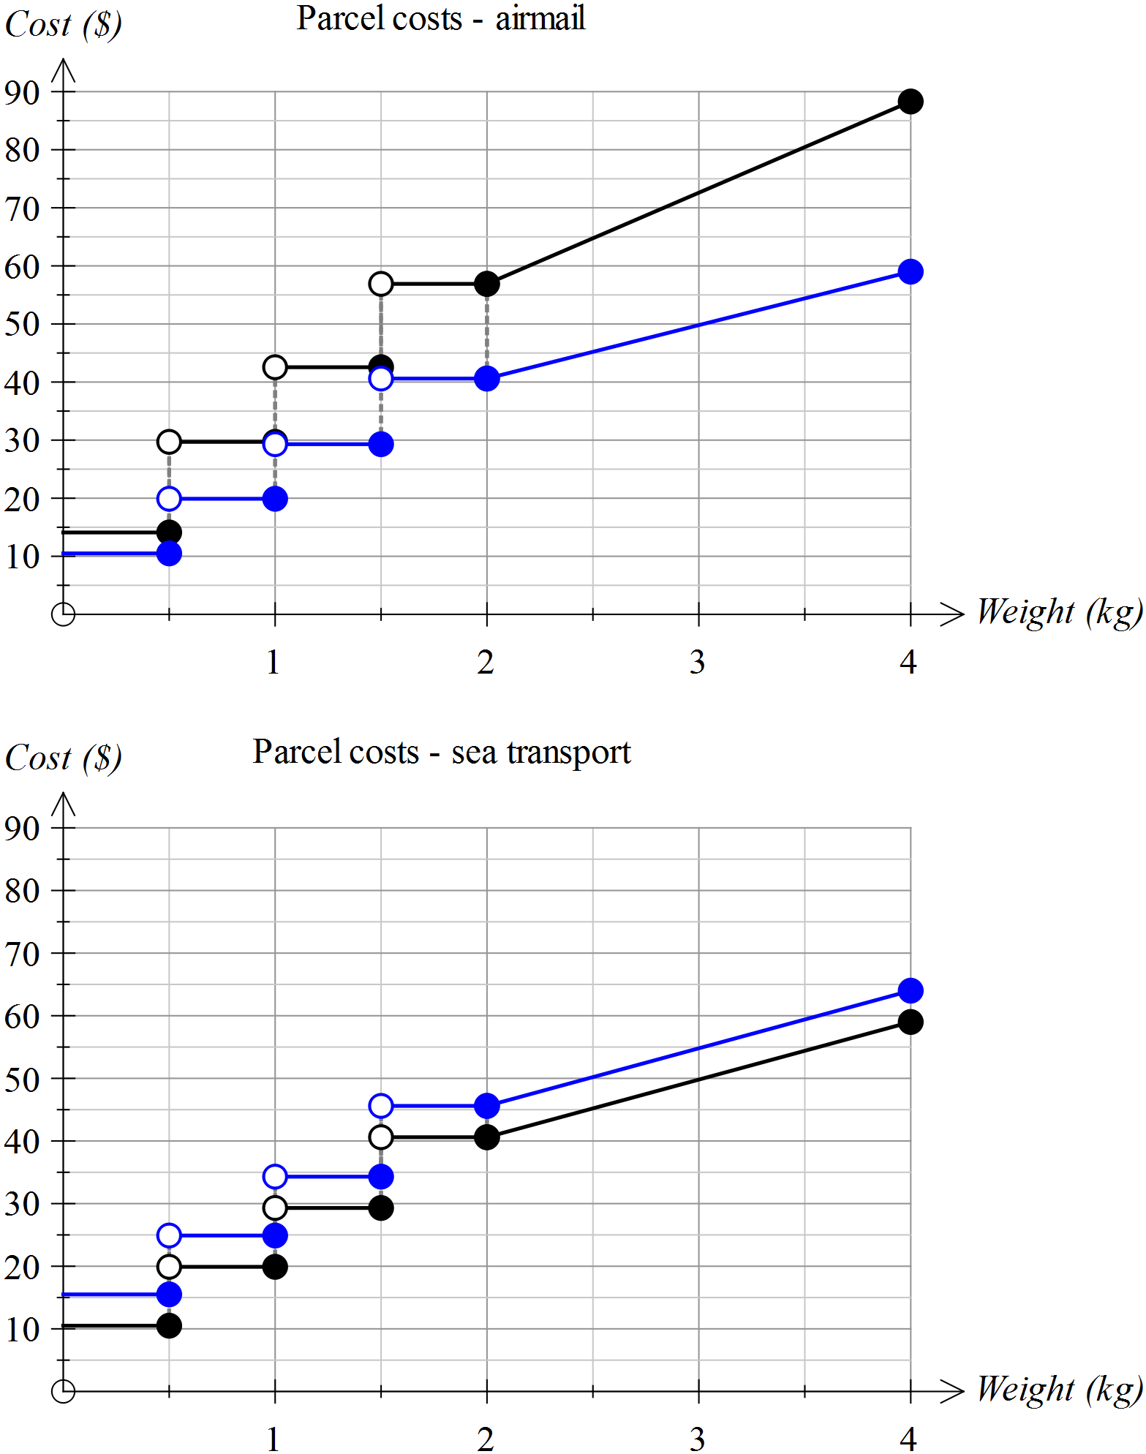

Question 4

Other data for which step graphs are suitable include
- Cost of posting parcels interstate
- Parking fees in city car parks
- Costs of travelling on public transport
- Costs of medical consultations
- Interest rates on long term deposits

Question 5
(a) $180

(b) at 150 kL and 500 kL

(c) Yes. As the number of kL increases, the gradient of the line segment increases because the line segments are increasingly steeper.

(d) (i) $310 (ii) $600 (iii) $1500 (iv) $250

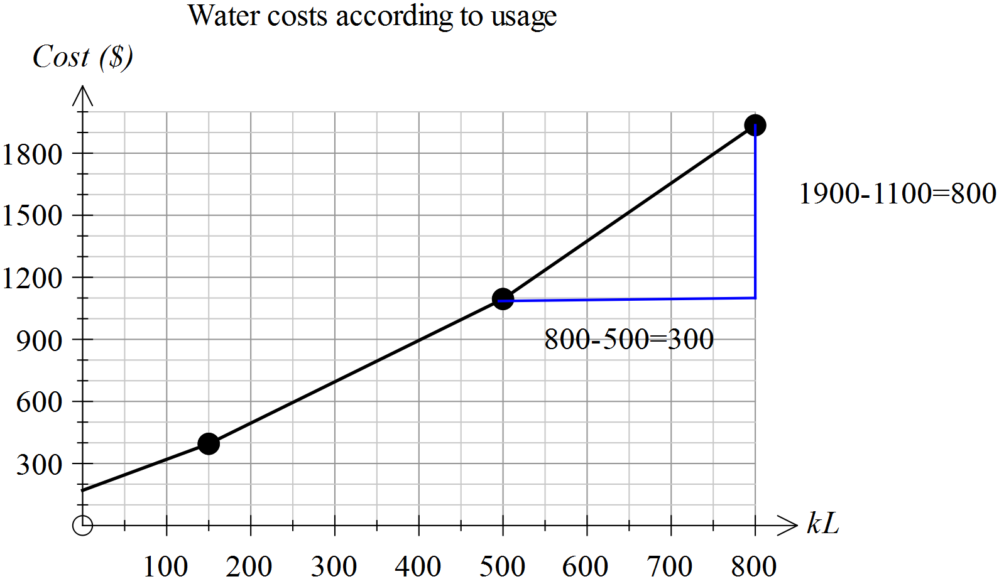(e)

Rate = 800 ÷ 300 = $2.7 per kL

(f) Vertical intercept = $180, gradient = (400-180) ÷ 150 ∼ 1.5
Cost = $1.5 x Number of kL + $180

(g) The cost per kL ~ $2 which is the gradient of the line in that section of the graph.

Linear with a difference

Extended investigation Part 2: In-class validation
Solutions

Question 1
Solution
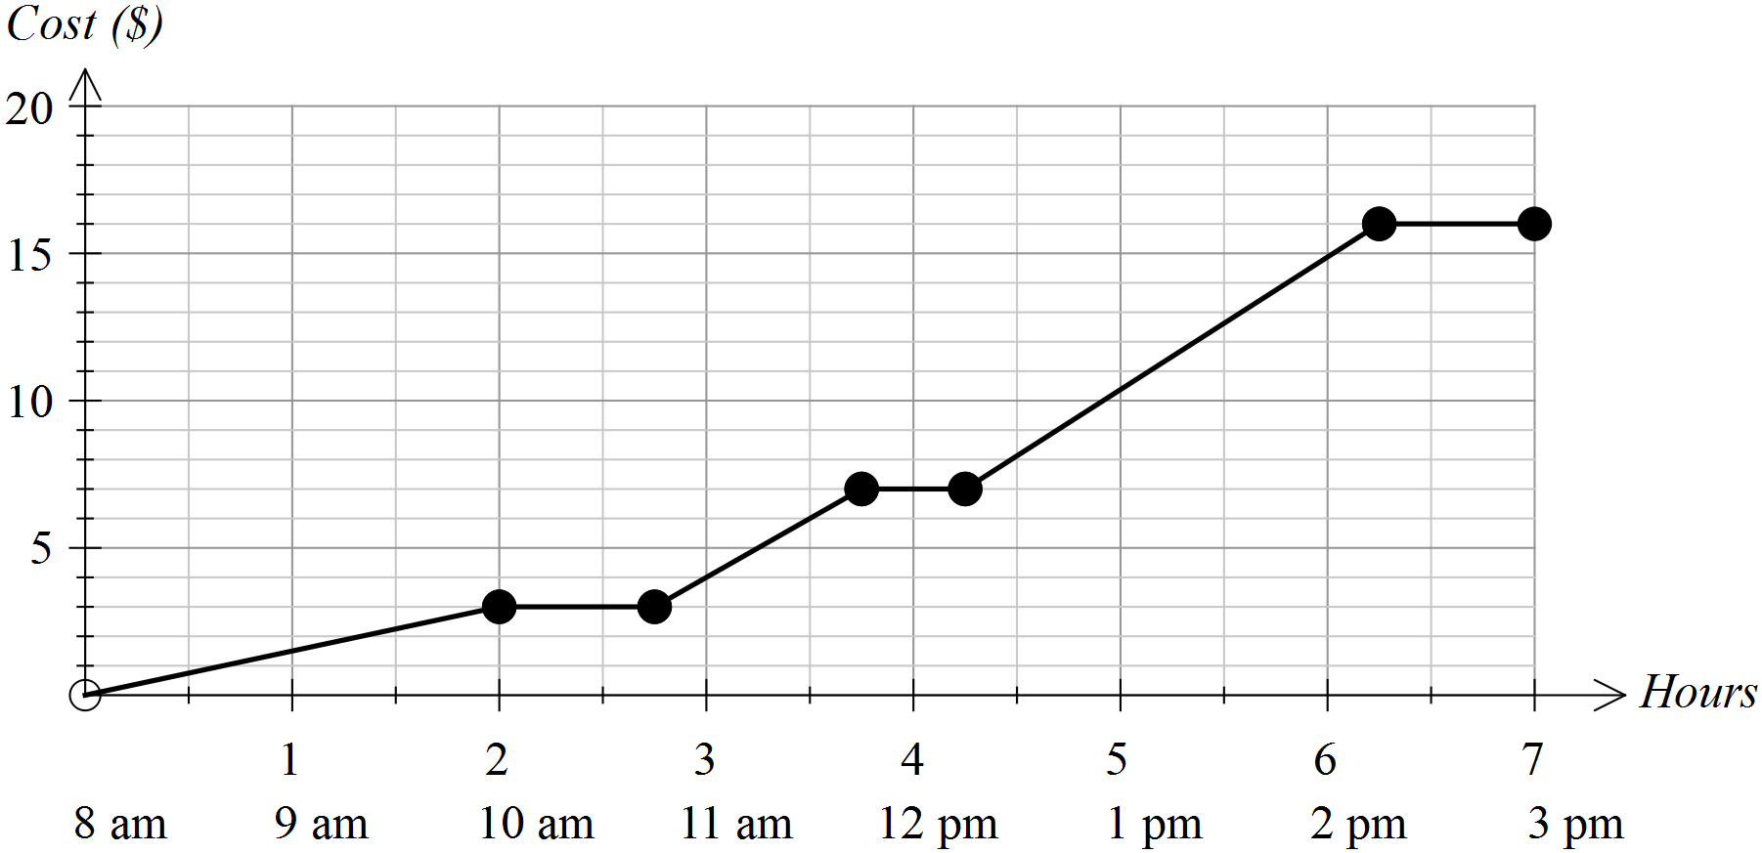

Marking key/mathematical behaviours | Marks
- Scales vertical axis  - Represents parking for 2 hours at $1.50 per hour  - Shows zero gradient for no change in costs (including to 3 pm)  - Draws rise of $4 for 1 hour  - Draws rise of $4.50 for 2 hours | 1  1  2  1  1

Question 2

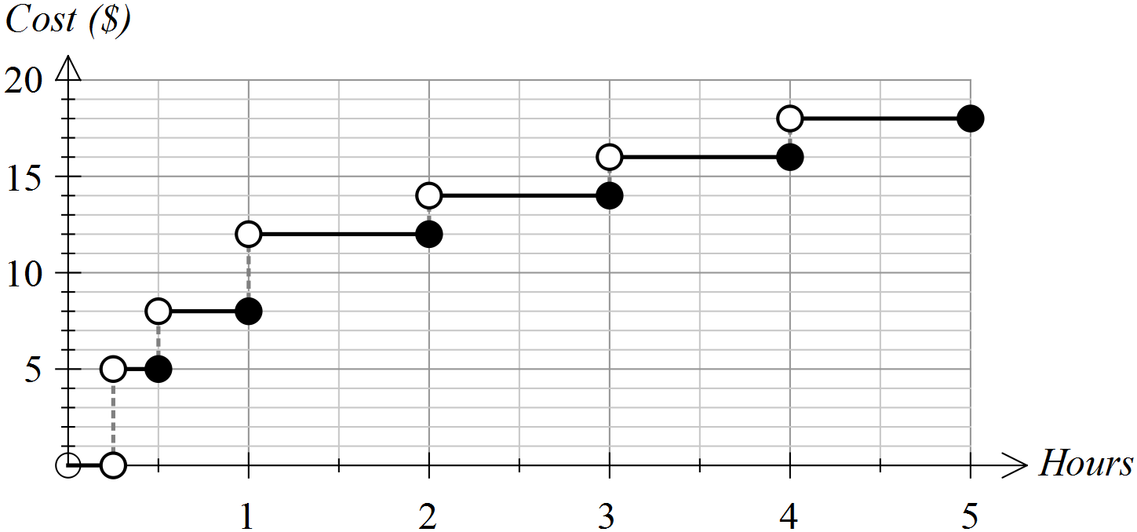Solution

Marking key/mathematical behaviours | Marks
- Scales vertical axis  - Shows the correct costs up to 2 hours  - Costs are matched to correct time periods  - Open and closed circles used correctly  - Increases hourly cost by 2 from 2-5 hours | 1  2  1  2  1
Question 3
 | Solution | Marking key/mathematical behaviours | Marks
(a) | $16 | - Reads graph correctly | 1
(b) | $16 | - Reads graph correctly | 1
(c) | 1.5 kg | - Interprets graph correctly | 1
(d) | Any weight up to and including 1 Kg | - Reads values from 0.5 to 1 kg  - Includes values from 0 to 0.5 kg | 1  1
(e) | See below | - Moves each line down 10 $  - Keeps weight ranges correct | 1  1
(f) | See below | - Moves each line down 50% in all ranges  - Keeps weight ranges correct | 2  1
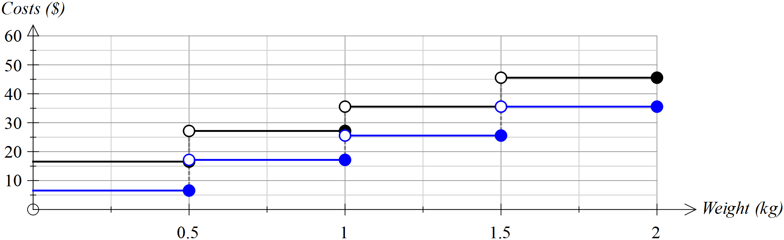(e)

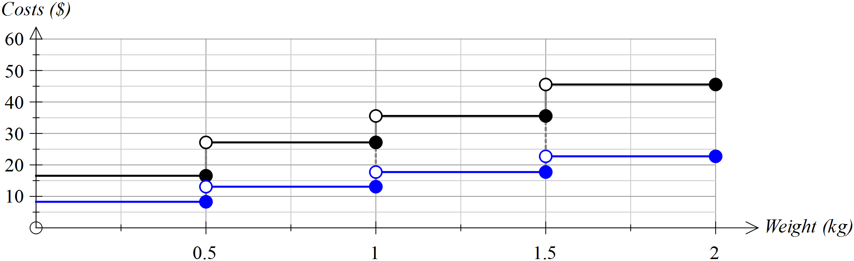(f)

Question 4
 | Solution | Marking key/mathematical behaviours | Marks
(a) | 200 km | - Interprets vertical intercept | 1
(b) | 6 hours | - Interprets horizontal intercept | 1
(c) | First hour  Steepest line segment | - Identifies highest speed  - Links speed to gradient | 1  1
(d) | 0.5 hours | - Interprets zero gradient - reads time  - Correct units | 1  1
(e) | 24 km/h  60 km ÷ 2.5 h = 24 km/h | - Determines speed  - Provides evidence of determination | 1  1
(f) | 120 km  Draws line (3,60) to (5, 22) | - Calculates distance  - Draws straight line | 1  1
Question 5
Station | Distance from city (km) | Cost  from the city | Time taken from city  (mins) | Time taken since last station  (mins) | Distance since last station  (km) | Cost since the last station | Cost /Km
1 | 7.3 | $2.90 | 6 | 6 | 7.3 | $2.90 | $0.40
2 | 11.7 | $4.40 | 9 | 3 | 4.4 | $1.50 | $0.38
3 | 13.8 | $4.40 | 11 | 2 | 2.1 | 0 | $0.32
4 | 20.5 | $5.30 | 16 | 5 | 6.7 | $0.90 | $0.26
5 | 32.9 | $6.30 | 23 | 7 | 12.4 | $1.00 | $0.19
6 | 37.39 | $6.30 | 29 | 6 | 4.49 | 0 | $0.17
7 | 43.2 | $7.80 | 33 | 4 | 5.81 | $1.50 | $0.18
8 | 47.6 | $7.80 | 36 | 3 | 4.4 | 0 | $0.16
9 | 70.19 | $10.30 | 48 | 12 | 22.59 | $2.50 | $0.15

 | Solution | Marking key/mathematical behaviours | Marks
(a) | See table | - Calculates differences in time  - Calculates differences in cost | 2  2
(b) | (i) 6  (ii) 47.5 km  (iii) Move all lines with open and closed circles up by 1 unit  (iv) Graph lines would be lowered by increasing amounts  (v) The lines would shrink horizontally and circles would move left. | - Interprets horizontal values  - Reads differences in vertical values  - Identifies vertical translation up 1 unit  - Identifies downwards movement  - Indicates amount of movement varies  - Interprets horizontal changes  - Indicates vertical values remain | 1  1  2  1  1  1  1
(c) | Piece-wise linear  The gradient is constant but not 0 between time periods | - Identifies correct type of graphs  - Indicates understanding of variation in gradients | 1  1
(d) | Generally true  Shows decreasing costs – see table above | - Concludes correctly  - Provides evidence to support conclusion  - Provides several pieces of evidence to support conclusions | 1  1  1

TASK 17: Applying linear relationships

In-class investigation

Unit 2

Topic 2.3: Linear equations and their graphs

Course-related information

The skills and concepts developed in this in-class investigation relate to the following dot points within the WA Mathematics Applications syllabus:
2.3.2 develop a linear formula from a word description and solve the resulting equation
2.3.3 construct straight-line graphs both with and without the aid of technology
2.3.4 determine the slope and intercepts of a straight-line graph from both its equation and its plot
2.3.5 construct and analyse a straight-line graph to model a given linear relationship; for example, modelling the cost of filling a fuel tank of a car against the number of litres of petrol required.
2.3.6 interpret, in context, the slope and intercept of a straight-line graph used to model and analyse a practical situation
2.3.7 solve a pair of simultaneous linear equations graphically or algebraically, using technology when appropriate
2.3.8 solve practical problems that involve determining the point of intersection of two straight-line graphs; for example, determining the break-even point where cost and revenue are represented by linear equations

Background information

In their earlier years students would have had the opportunity to develop the mathematical skills and understandings covered in this investigation.

Task conditions

Access to calculators with graphing capabilities is not necessary.

Applying linear relationships

In-class investigation (50 marks)

Introduction
Some students are planning to set up a babysitting service in clients’ homes and they start by investigating existing businesses.

Question 1 (5 marks)

In the first business the students investigate there are three payment plans for the employees. The plans include a petrol allowance (a fixed amount to help with the cost of travelling to the work location) plus an hourly rate. The plans are summarised in the following table.

Payment plans
Plan | Petrol allowance ($) | Hourly rate ($)
A | 0 | 20
B | 10 | 18
C | 15 | 16

(a) Use the table above to determine the total payment to a babysitter for up to 6 hours at one time under each plan. Record your results in the table below. (4)

Total payments

 | Number of hours
Plan | 2 | 3 | 4 | 5 | 6
A | $40
B |  | $64
C |  |  |  |  | $111

(b) If graphs are drawn showing the total payments as the number of hours increases for each plan, they will be linear. Give two reasons to explain how you know, from the information given in these tables, that the graphs will be linear. (2)

Question 2 (6 marks)

In the second business the students investigate, the payment for the babysitters is again a petrol allowance plus an hourly rate and the information is set out in the tables below. For each table, write the rule to calculate the payments using P ($) to represent the total payments and h to represent the number of hours of babysitting.

(a) Plan M

Hours of babysitting(h) | 1 | 2 | 3 | 4 | 5
Payment to employee (P) | $15 | $30 | $45 | $60 | $75

(b) Plan N

Hours of babysitting(h) | 1 | 2 | 3 | 4 | 5
Payment to employee (P) | $35 | $55 | $75 | $95 | $115

(c) Plan Q

Hours of babysitting(h) | 1 | 2 | 3 | 4 | 5
Payment to employee (P) | $30 | $45 | $60 | $75 | $90

Question 3 (8 marks)

The third business has its payment plans represented by the graph given below.
Again, there was a petrol allowance plus an hourly payment.
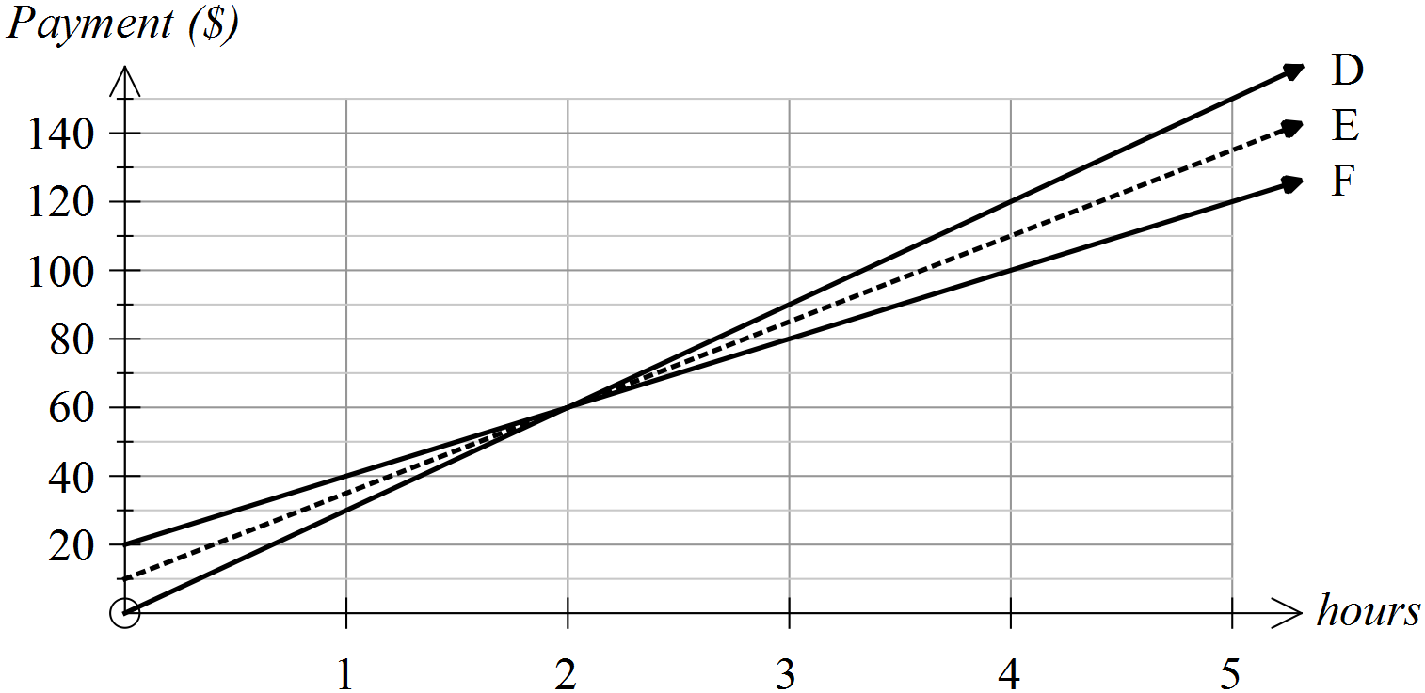

(a) From the graph determine the total payments for working for 2, 4 and 5 hours and use these results to complete the table below. (3)

Total payments
 | Number of hours of babysitting
Plan | 2 | 4 | 5
D
E
F

(b) What is the petrol allowance under (3)

(i) Plan D

(ii) Plan E

(iii) Plan F

(c) Plan D has the highest hourly rate. From what information on the graph can you draw this conclusion? (1)

(d) What feature of these graphs shows that payments can be equal when hours worked are equal? (1)

Question 4 (4 marks)

Consider all the businesses described in Questions 1-3. State the

(a) maximum petrol allowance

(b) minimum petrol allowance

(c) highest hourly rate

(d) lowest hourly rate

Question 5 (7 marks)

Another business shows its payment schedules for four different plans (i.e., W, X, Y, Z) as graphs. The payments consist of a petrol allowance and an hourly rate.

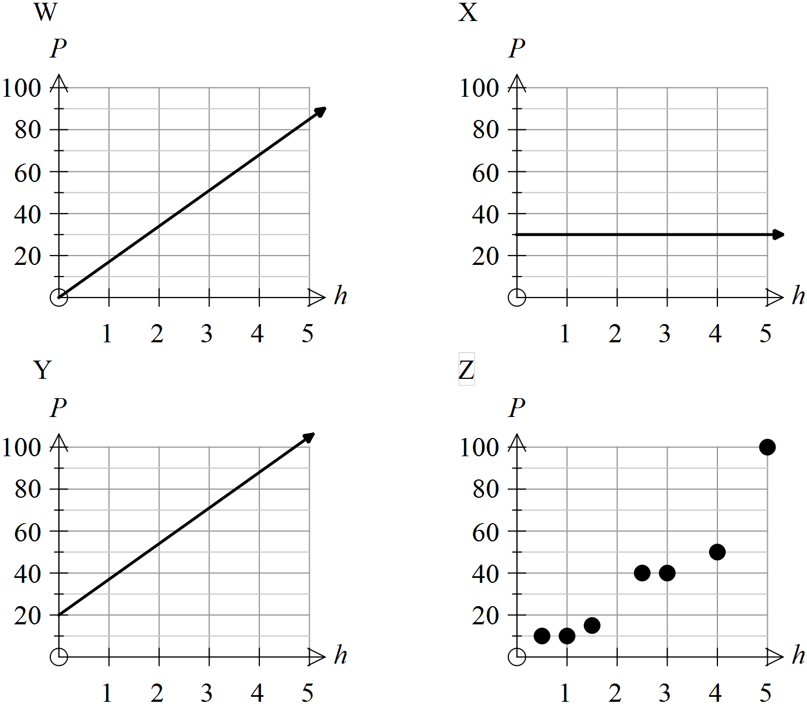

Use the letters of the graphs (i.e., W, X, Y, Z) to name the plans with the following features.
(i) The plans for which the hourly rate is the same.

(ii) The plan which shows that total payment is not linearly related to the number of hours worked.

(iii) The plan(s) for which the payment for 1 hour of babysitting is the highest.

(iv) The plan(s) in which payments can be the same for different numbers of hours worked.

(v) The plan(s) for which there is no petrol allowance.
Question 6 (19 marks)

The students decided to set up a sliding scale of payments based on the number of years experience in babysitting. Their schedule is as follows.

Business schedule of payment
No. years experience | Hourly rate | Petrol allowance | Rule to calculate  Payment | Payment for 5 hours work
0 | 10 | 10
1 | 15 | 10
2-5 | 20 | 25
>5 | 25 | 30

(a) Complete the table. Let K represent total payment ($) and r the time (number of hours) worked (6)

(b) On the axes provided below, draw graphs to represent the total payments, for up to 5 hours of babysitting according to years of experience. (6)
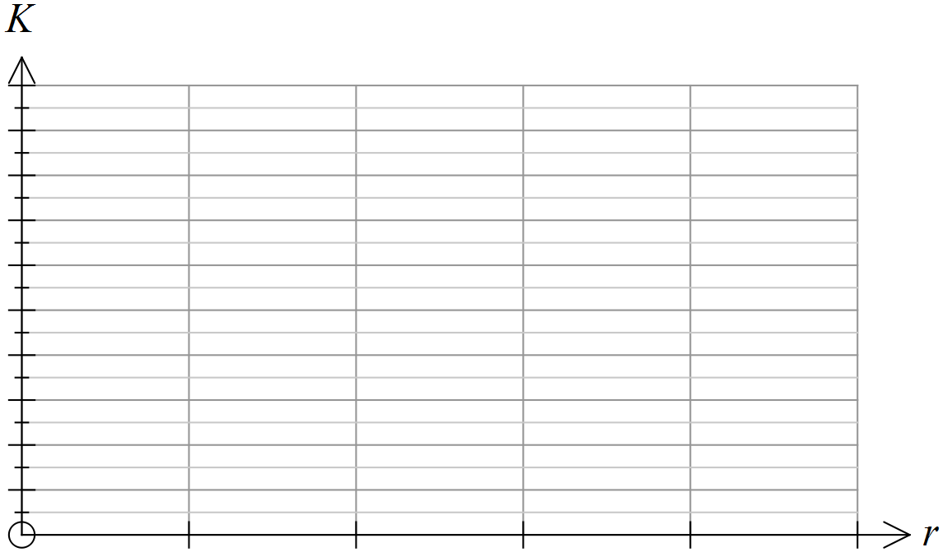

(c) According to the students’ schedule, how much should have been paid out when the following work was done? (3)

(i) Joel has had 3 years of babysitting experience and he worked both Friday and Saturday nights, each for 3 hours.

(ii) Billy is new to babysitting and he did 2 hours work on Sunday afternoon.

(iii) Brooke has over 10 years experience with babysitting and she worked on Saturday night for 4 hours.

(d) The total amount paid out one week was $1000. Describe how this could have happened with Joel, Billy and/or Brooke working with this schedule of fees. (4)

End of questions
Applying linear relationships

In-class investigation Solutions and marking key
Question 1
(a) Solution
Total payments
 | Number of hours
Plan | 2 | 3 | 4 | 5 | 6
A | $40 | $60 | $80 | $100 | $120
B | $46 | $64 | $82 | $100 | $118
C | $47 | $63 | $79 | $95 | $111

Marking key/mathematical behaviours | Marks
- Calculates total payments for each of the three options  - Accuracy throughout | 3  1

Question 1
 | Solution | Marking key/mathematical behaviours | Marks
(b) | The hourly rate is constant  The payments increase by a constant amount as the hours increase by 1 | - Refers to hourly rate in first table  - Refers to increase in second table | 1  1

Question 2
 | Solution | Marking key/mathematical behaviours | Marks
(a)  (b)  (c) |  | - Uses variables provided  - Formats rule correctly  - Identifies hourly rate for all tables  - Identifies constants in all tables | 1  1  2  2

Question 3
 | Solution | Marking key/mathematical behaviours | Marks
(a) | Number of hours of child minding  Plan 2 4 5  D $60 $120 $150  E $60 $110 $135  F $60 $100 $120 | - Reads payment for 2 hrs  - Reads payment for 4 hrs  - Reads payment for 5 hrs | 1  1  1
(b) | (i) 0 (ii) 10 (iii) 20 | - Reads y-intercept | 3
(c) | D has the steepest line | - Links gradient to rate | 1
(d) | Intersect at the same point | - Identifies intersection as point of equality | 1
Question 4
 | Solution | Marking key/mathematical behaviours | Marks
(a) | $20 | - Use data from various sources to identify largest value | 1
(b) | 0 | - Use data from various sources to identify least value | 1
(c) | $30 | - Use data from various sources to identify largest value | 1
(d) | $15 | - Use data from various sources to identify least value | 1

Question 5
 | Solution | Marking key/mathematical behaviours | Marks
 | (i) W and Y  (ii) Z  (iii) Y  (iv) X and Z  (v) A (and D) | - Identifies same gradient  - Identifies lack linearity  - Reads graph to determine value  - Read graph to determine values  - Identifies 0 as vertical intercept | 1  1  1  2  2

Question 6

 | Solution | Marking key/mathematical behaviours | Marks
(a) | Rule to calculate payment Payment for 5 hours work  K=10r + 10 $60  K=15r + 10 $85  K=20r + 25 $125  K=25r + 30 $155 | - Uses variables given  - Identifies constant  - Identifies hourly rate  - Presents formula correctly  - Uses formulae to determines payments  - Presents values with $ | 1  1  1  1  1  1
(c) | Joel $170  Billy $30  Brooke $130 | - Uses correct rule from table  - Uses correct rule from table  - Uses correct rule from table | 1  1  1
(d) | Billy: Total of 7 hours on 3 different nights = $100  Brooke: 3 nights of 4 hours = $390  Joel does 6 nights, each of 3 hours = $510 | - Total adds to $1000  - Indicates number of petrol allowances  - Indicates number of hours  - Correct scheduling for each person | 1  1  1  1

Question 6 (b)
Solution
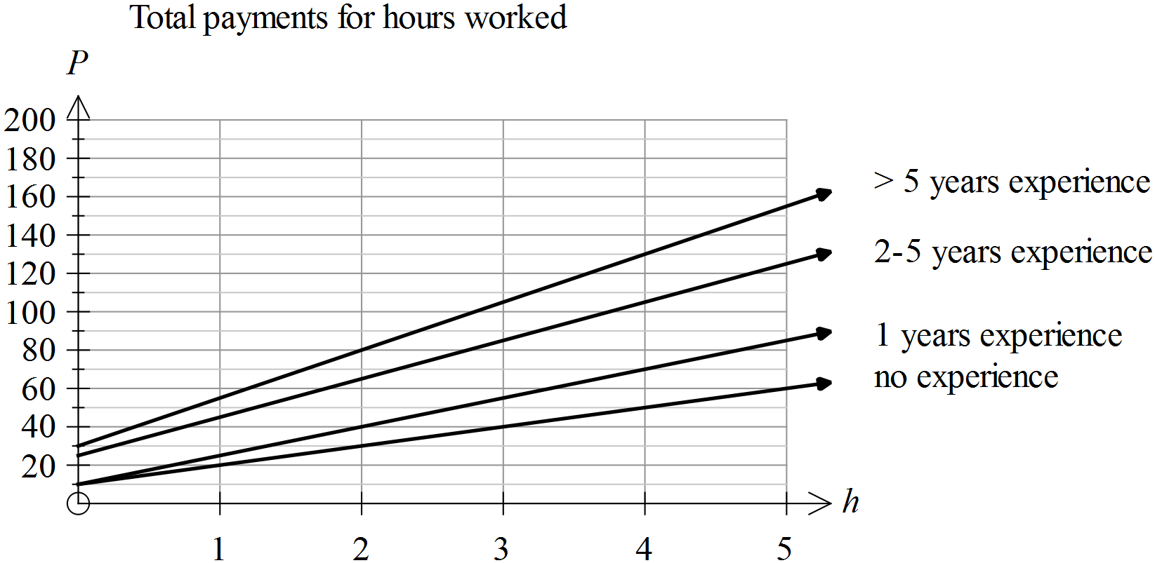

Marking key/mathematical behaviours | Marks
- Places correct scale on both axes  - Selects appropriate title  - Correctly plots P when h = 5  - Correctly plots petrol allowance  - Draws line between points  - Labels each graph | 1  1  1  1  1  1  1

TASK 18

Investigative questions

Unit 2

Topic 2.3: Linear equations and their graphs

Course-related information
The concepts and skills included in these investigative questions relate to relate to the following dot points within the WA Mathematics Applications syllabus:
2.3.7 solve a pair of simultaneous linear equations graphically or algebraically, using technology when appropriate
2.3.8 solve practical problems that involve determining the point of intersection of two straight-line graphs; for example, determining the break-even point where cost and revenue are represented by linear equations

The ability to choose and use appropriate technology to enhance and extend concept development is also required for some of the items.

Background information
It is expected that students have had experience in writing and solving linear equations; including simultaneous equations. They should have had the opportunity to use technology to graph and solve such equations.

Task conditions
These questions are independent of each other and are written so that they may be incorporated into a test or examination. Student access to a graphical/CAS calculator is assumed. The time required to complete each question is left to the discretion of the teacher but the intention is that each question may be completed within 15 minutes.

Investigative questions for Topic 2.3

Question 1 (9 marks) (6 marks)
The relationship between cost and the number of kilometres of road constructed is linear.
Roadco charged $141 million for constructing a 20 km stretch of highway and $267 million for constructing a 40 km stretch in a different location using the same construction process.
Consad charged $167.5 million for constructing a 25 km stretch of highway and $338.5 million for constructing a 55 km stretch in a different location using the same construction process.

(a) The construction cost per km for Roadco is $6.3 million. Determine the construction cost per km for Consad. Show how you determined this value. (2)

(b) The cost of setting up the projects is fixed for each company. For Roadco, the fixed cost is $15 million. Determine the fixed cost for Consad. Show how you determined this value. (2)

(c) The graph provided shows the construction costs according to the length of road constructed for each company.
Label the graph and indicate the values of key points on the graph. (5)

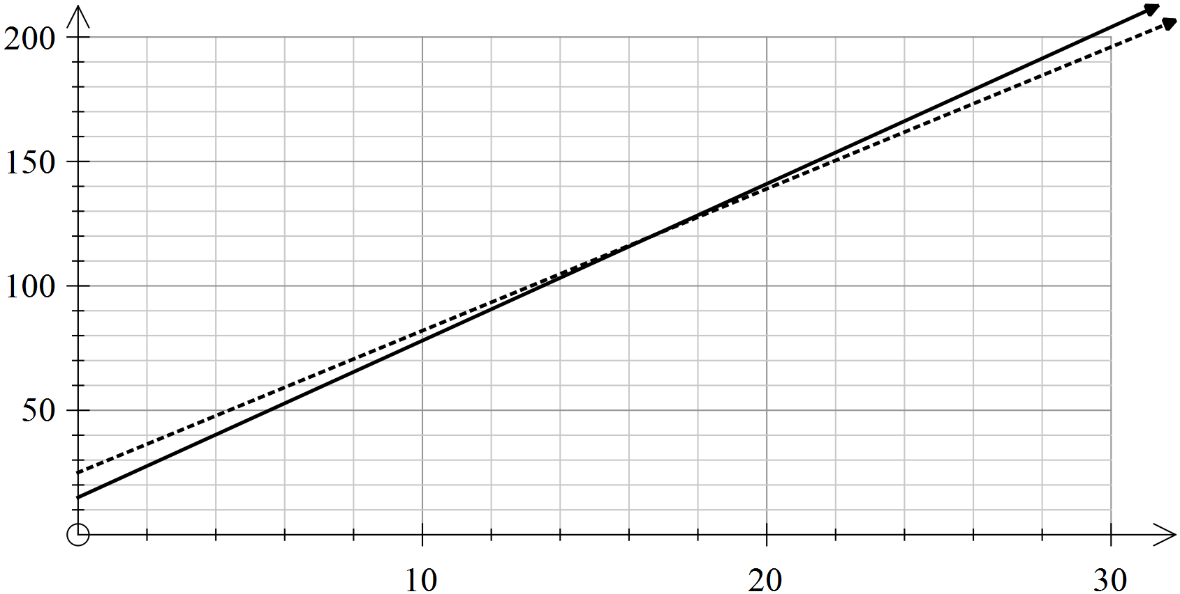

Question 2 (10 marks)
Megan is applying to two companies, Go Computers and Ace Software, for a position selling computer software. The weekly salary paid by each company is determined as follows.
Go Computers: $425 per week plus 12% of the total value of her sales for the week.
Ace Software: $280 per week plus 18% of the total value of her sales for the week.

(a) If Megan’s weekly salary is W dollars per week and the total value of her sales of software for the week is x dollars, state the equation for her weekly salary, in terms of W and x, with
(4)
(i) Go Computers

(ii) Ace Software

(b) If she were to sell software worth $1000 in one week, how much would she earn that week with
(2)
(i) Go Computers?

(ii) Ace Software?

(c) For what values of sales, to the nearest $10, would Megan earn more in a week with Go Computers than with Ace Software? Explain how you determined your answer. (4)

Question 3 (10 marks) (6 marks)
Which copier is best? Under what conditions?
There are two copiers, A and B, that are available for lease (rent).

The cost of leasing each of these copiers is stated below.
Copier A: an annual fee of 649 euros and 1 A4 page costs 0.01 euros
Copier B: an annual fee of 749 euros and 1 A4 page costs 0.009 euros

Most paper is bought in reams. A ream of paper has 500 A4 sheets.
Assume other costs are covered in the annual fee.

(a) How much does it cost per ream of paper when using Copier B? (1)

(b) If a business uses 350 reams of paper in one year, what would be the annual cost of using Copier A? (3)

(c) Draw a labelled graph to show the costs of using each copier for up to 400 reams of paper in any one year. (5)

(d) Explain how the graph can help a company decide which copier is cheaper. (1)

Investigative questions in Topic 2.3
Solutions and marking key

Question 1
 | Solution | Marking key/mathematical behaviours | Marks
(a) | Cost per km = (338.5-167.5)÷30  =$5.7 million | - Uses difference between costs  - States answer in millions | 1  1
(b) | 167.5=25x5.7+fixed cost  Fixed cost = $25 million | - Sets up equation  - Solves equation | 1  1

Question 1(c)
Solution
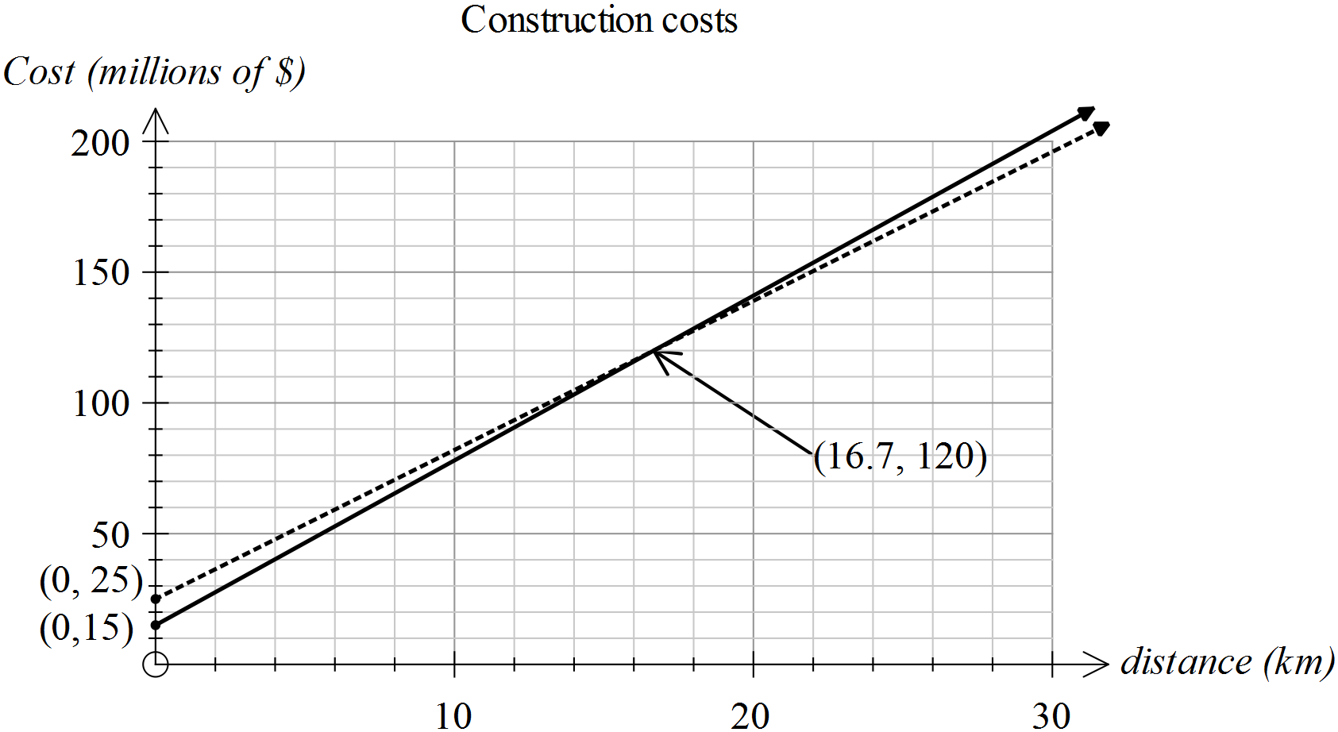

Marking key/mathematical behaviours | Marks
- Provides title for graph  - Labels intersection point  - Labels horizontal axis  - Labels vertical axis  - Labels vertical intercepts | 1  1  1  1  1

Question 2

 | Solution | Marking key/mathematical behaviours | Marks
(a) | (i)  (ii) | - Uses variable provided  - Formats equation correctly  - Identifies retainer  - Identifies rate of commission | 1  1  1  1
(b) | (i)  (ii) | - Determines W in (i) and (ii) for x = $1000 | 1  1
Question 2 (cont’d)

(c) | For sales of $2410 and below  Either  Earns more with A for x less than this value because A starts with higher retainer  Or  See graph below | - Identifies intersection  - Recognises range of values  - Solves equations  - Checks for range where A gives more  OR  - Plots graphs of each function and indicates intersection.  - Shows where A has a higher value | 1  1  1  1  1  1

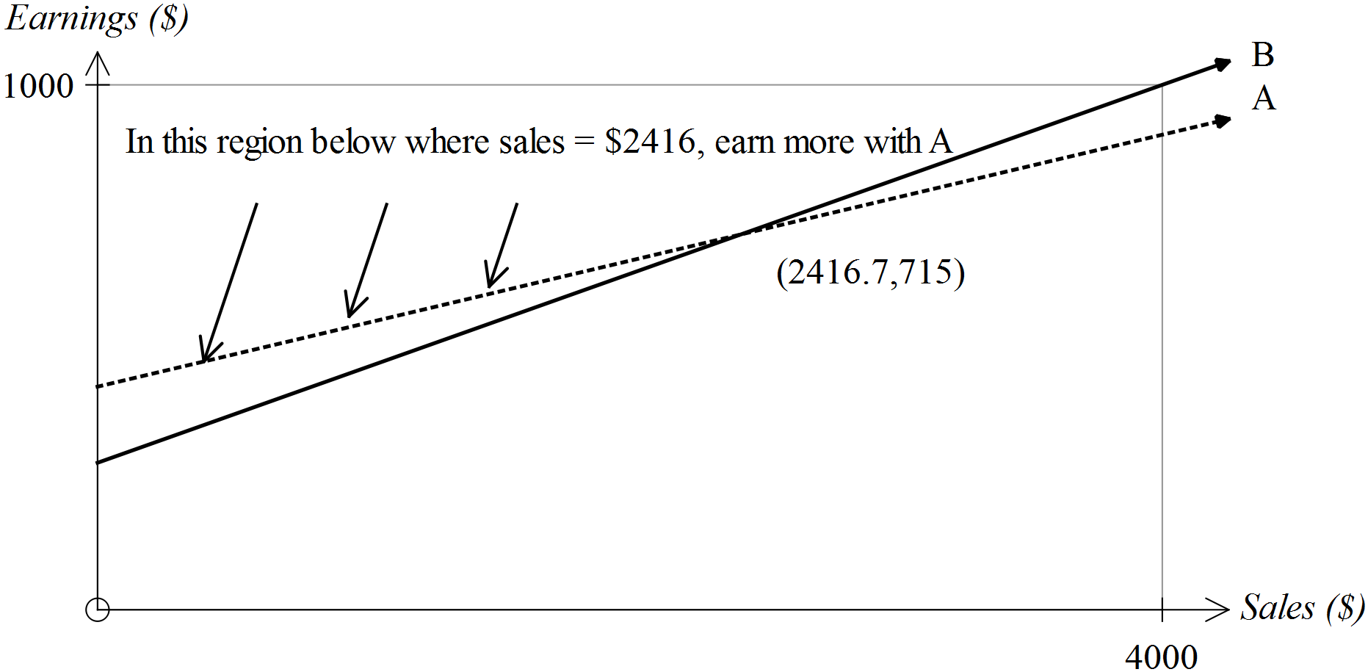

Question 3

 | Solution | Marking key/mathematical behaviours | Marks
(a) | 500 x 0.009 = 4.5 euros | - Calculates cost for 1 ream | 1
(b) | 350 x 500 x 0.01+649  =2399 euros | - Includes fixed cost  - Considers 350 reams  - Correct calculation for 1 ream | 1  1  1
(c) | See below | - Provides suitable title  - Labels both axes  - Scales both axes  - Sketches relationship for each  - Labels graphs | 1  1  1  1  1
(d) | Can determine where one option is cheaper by locating where one graph is lower than the other | - Refers to relative location of graphs | 1

Question 3 (cont’d)
(c)
